MEDIA RELEASE
CONTACT: Steven MacEwan
media@nsf.org

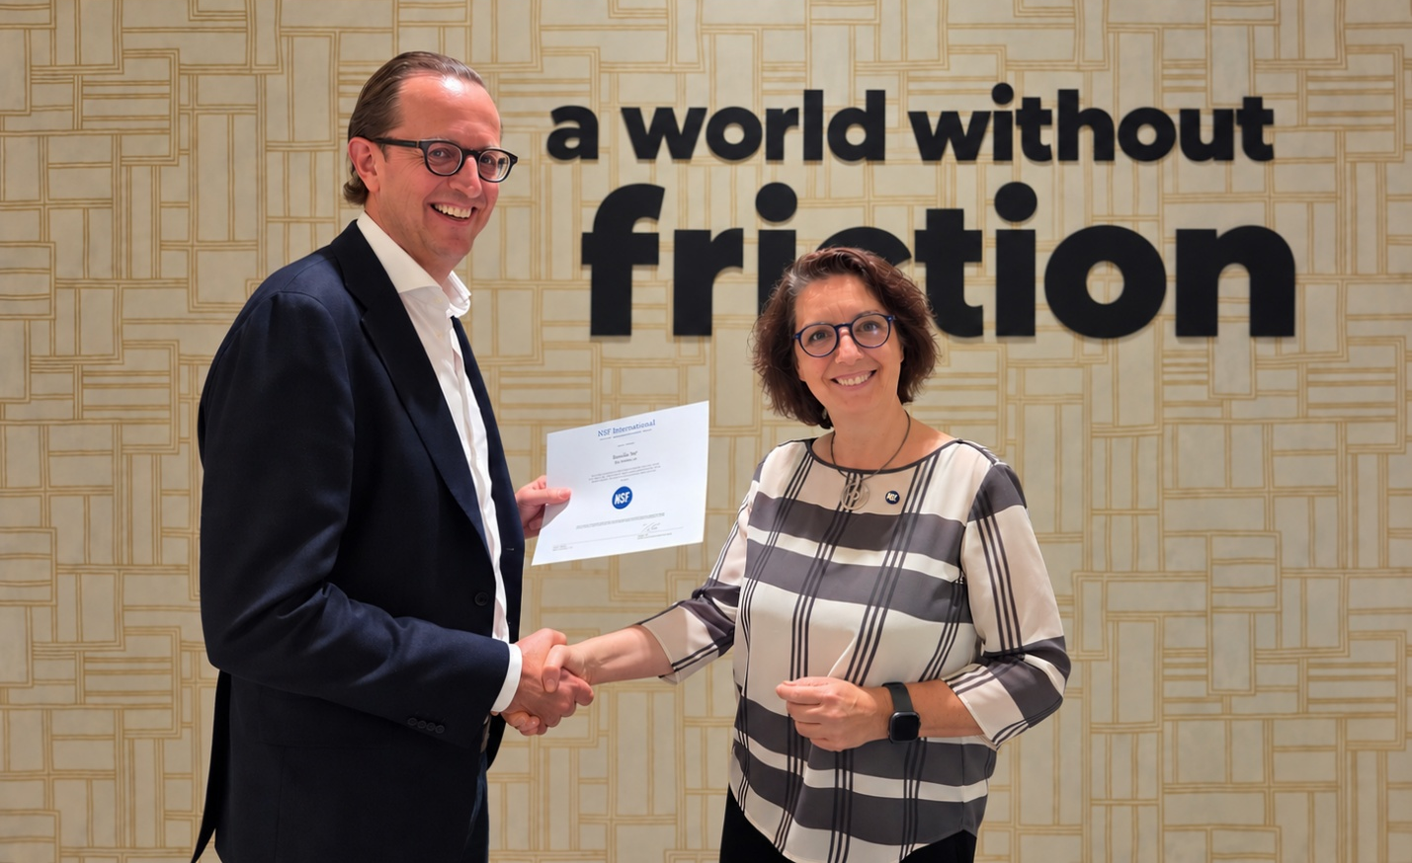
Frédéric Mus, CEO, Interflon, Ann Willems, Business Lead Food Equipment, Europe & Africa, NSF (left to right)
NSF Awards World’s First NSF 538 MOAH-Free Certification to Interflon
New NSF 538 certification provides independent verification for food-grade lubricants against the mineral oil contaminant now subject to EU maximum limits.
OXFORD, 23 September 2026 – NSF, a global public health organisation, today announced that Interflon has become the first company in the world to achieve NSF’s MOAH-Free certification.
The certification independently verifies that over 30 of Interflon’s certified food-grade lubricants meet the requirements of NSF Certification Guideline 538, MOAH-Free Products for Nonfood Compounds and Food Equipment Materials (NSF 538).
Mineral oil aromatic hydrocarbons (MOAH) can enter food from several sources, including raw materials, processing aids, machinery lubricants, environmental contamination and food-contact materials. The European Food Safety Authority has identified genotoxicity and carcinogenicity concerns associated with MOAH containing three or more aromatic rings.
Under NSF 538, products undergo formulation review and laboratory analysis. To qualify, a product must contain less than 100 ppm MOAH, as defined by the guideline, and contain no intentionally added mineral oil, paraffin, naphthenes, polycyclic aromatic hydrocarbons or wax. Manufacturers must also maintain documented procedures designed to minimise contamination. Certified products are subject to annual attestation and retesting.
“MOAH contamination is one of the defining food safety issues facing manufacturers in Europe, and businesses are under growing pressure to understand and control potential sources across their supply chains and production facilities,” said Sam Cole, Global Director of Food Contact Evaluation at NSF. “NSF 538 provides independently verified, publicly accessible evidence that a certified lubricant or food equipment material meets MOAH-Free requirements. As the first company in the world to achieve this certification, Interflon is demonstrating how suppliers can respond proactively to evolving regulatory and customer expectations.”
The certification comes as the European Union prepares to introduce legally binding maximum levels for MOAH in a range of foods from 1 January 2027. Although NSF 538 certification does not certify finished food against EU maximum levels, it can help food businesses assess and document one potential source of MOAH within their processing environments.
“We set out to be ready before the regulation arrived, rather than trying to catch up afterwards,” said Frédéric Mus, CEO of Interflon. “Achieving the world’s first NSF 538 certification gives our customers independently verified evidence that the certified products meet NSF’s MOAH-Free requirements. For food manufacturers supplying increasingly regulated markets, that provides a transparent and verifiable way to strengthen supplier approval, risk assessment and contamination-control programmes.”
Many of the certified products also carry NSF 537 PFAS-Free certification and ISO 21469 certification. NSF 537 verifies that products meet the guideline’s requirements concerning intentionally added PFAS and total organic fluorine, while ISO 21469 addresses hygiene requirements for lubricants with incidental product contact.
“Being first in the world to achieve NSF 538 certification is a significant milestone, not only for Interflon but for the wider food-grade lubricant industry,” added Cole. “Buyers increasingly want claims to be independently assessed and publicly verifiable. That is the assurance certification is designed to provide.”
NSF 538 MOAH-Free certification is available worldwide to manufacturers of eligible nonfood compounds and food equipment materials. Nonfood compounds must already hold NSF registration or NSF certification to ISO 21469. Eligible food equipment materials must be certified to NSF/ANSI 51. Certified NSF 538 products can be found in the NSF White BookTM. Further information is available at nsf.org.
---ENDS---

About NSF
For more than 80 years, NSF has helped businesses and consumers navigate complexity with confidence through science-driven standards, rigorous testing, certification, research and advisory services across food, water and wellness. Guided by its purpose to protect and advance public health, NSF works to strengthen trust in the products, systems and services people rely on every day. From scientific expertise and standards development to testing and certification, NSF helps organisations raise the bar for quality, safety, transparency and compliance around the world.
About Interflon
Interflon is a global specialist in friction reduction, developing and manufacturing premium lubricants, cleaners, tools, and lubrication systems for demanding industrial applications. With more than 45 years of experience, Interflon serves over 100,000 customers in more than 50 countries across a wide range of industries. A global team of over 500 skilled Technical Advisors works closely with customers on-site to professionalize lubrication management and unlock measurable improvements in cost, output, and compliance. Powered by unique MicPol® technology, advanced lubrication systems, and services such as Lubrication as a Service and the ILAC® digital platform, Interflon delivers proven reductions in friction, energy use, and maintenance effort while supporting sustainability and regulatory requirements.

