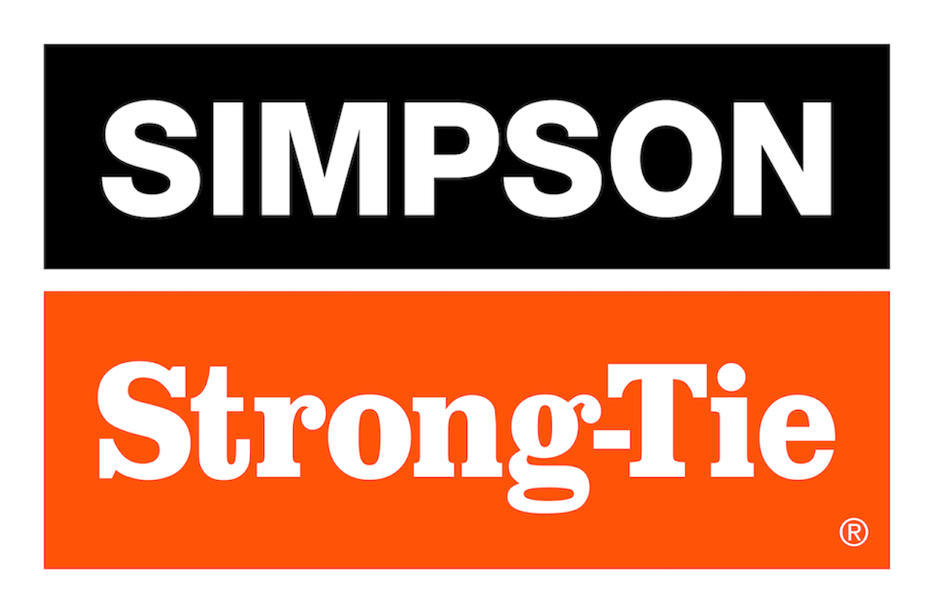
FOR IMMEDIATE RELEASE
September 17, 2026

Maureen Inouye-Harrison
minouyeharri@strongtie.com
Simpson Strong-Tie Donates $20,000 to Aid Nepal Flood Relief and Recovery Efforts

PLEASANTON, Calif., September 17, 2026 — Simpson Strong-Tie announced a $20,000 donation to support the American Red Cross and All Hands & Hearts as they provide relief and recovery assistance following the devastating flash floods that struck Nepal on August 26, 2026.
The company’s donation includes $10,000 to the American Red Cross, which will direct funding to the Nepal Red Cross Society, and $10,000 to All Hands & Hearts, which is supporting immediate response and long-term recovery efforts in affected communities. The flooding was triggered by a landslide of ice, mud and rock into a Himalayan river near the Nepal-China border and has caused widespread damage across affected districts.
“We’re making this contribution to support organizations that are helping people in Nepal with immediate needs and long-term recovery,” said Mike Olosky, president and CEO of Simpson Strong-Tie. “We’re grateful to be able to support the people affected by this disaster and the organizations providing practical assistance on the ground.”
The donation reflects the long-standing commitment of Simpson Strong-Tie to giving back and helping communities prepare for, respond to and recover from disasters. It also aligns with the company’s broader mission to support safer, stronger and more resilient housing and infrastructure through engineering, education and community partnership.
The American Red Cross will direct funding to the Nepal Red Cross Society in support of emergency shelter, cash assistance, healthcare, family restoration support and psychosocial needs. The Nepal Red Cross Society has been providing clean water, shelter, first aid and emergency supplies to affected communities.
All Hands & Hearts, which has worked alongside communities in Nepal since 2015, is responding in Nuwakot and surrounding areas with immediate relief while also supporting long-term recovery, including disaster-resilient rebuilding and recovery efforts for schools and local communities.
Those interested in supporting relief and recovery efforts can learn more or donate directly through the American Red Cross and All Hands & Hearts.

About Simpson Strong-Tie Company Inc.
Simpson Strong-Tie is the world leader in structural solutions — products and technology that help people design and build safer, stronger homes, buildings, and communities. As a pioneer in the building industry, we have an unmatched passion for problem solving through skillful engineering and thoughtful innovation. Our structural systems research and rigorous testing enable us to design code-listed, value-engineered solutions for a multitude of applications in wood, steel, and concrete structures. Our dedication to pursuing ever-better construction products and technology and to surrounding our customers with exceptional service and support has been core to our mission since 1956. For more information, visit strongtie.com and follow us on Facebook, Twitter, YouTube and LinkedIn.

