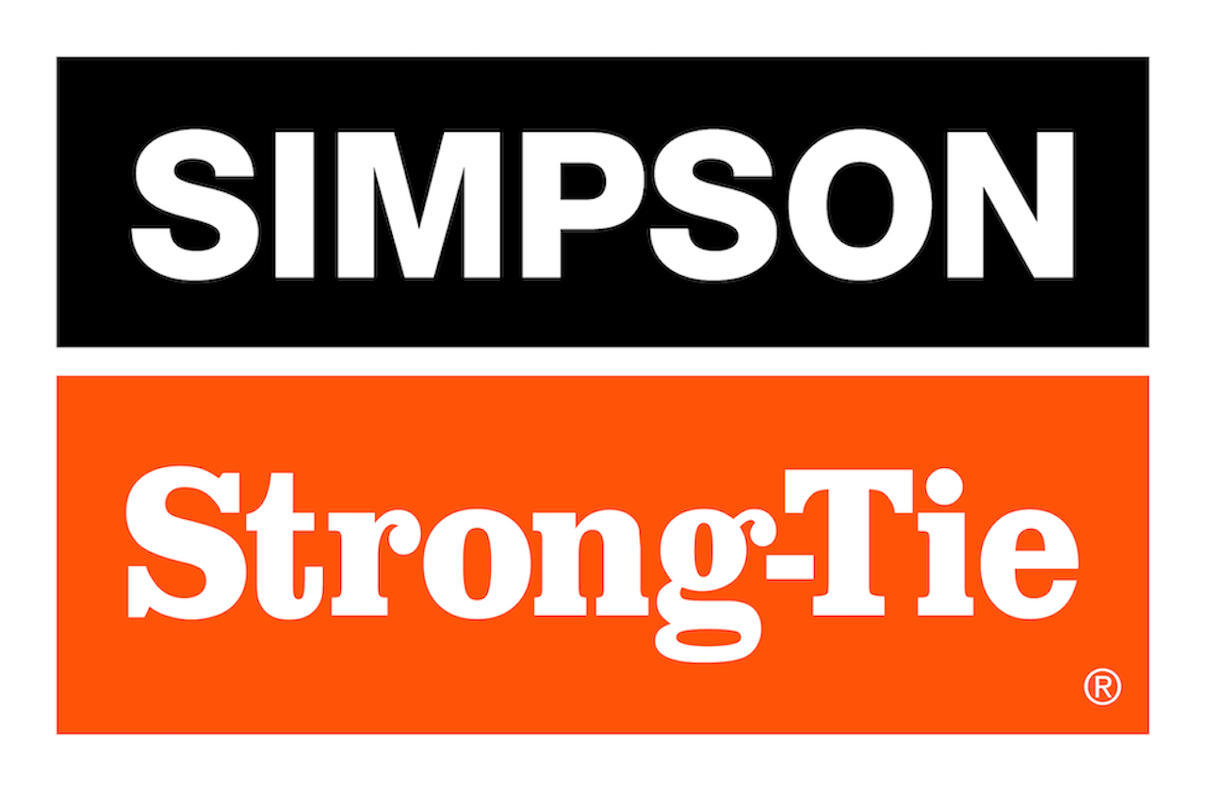
FOR IMMEDIATE RELEASE
September 16, 2026
Maureen Inouye-Harrison
minouyeharri@strongtie.com

Simpson Strong-Tie Expands Outdoor Accents Decorative Hardware Line
with New Button-Head Connector Screw
PLEASANTON, Calif. — September 16, 2026— Simpson Strong-Tie, the leader in engineered structural connectors and building solutions, today announced the launch of the Outdoor Accents® button-head connector screw, a new fastener designed to help pros and DIYers complete outdoor living projects with strength, style and efficiency.
Designed for use with Outdoor Accents decorative hardware, the new patent-pending screw features a low-profile button head that delivers a clean, finished appearance while helping installers create attractive wood connections for pergolas, patio covers, decks, fences and other outdoor structures. Its stylish, one-piece design is simple to install and offers an engineered alternative to the bolted look of the Outdoor Accents structural wood screw and hex-head combo.
"Consumers continue to invest in outdoor living spaces that reflect the same attention to detail and design found inside the home," said Scott Park, Director, Product Development - Connectors, Lateral, and Steel. "The Outdoor Accents button-head connector screw provides a decorative fastening solution that complements the overall look of a project, helping builders and homeowners achieve a refined, modern appearance with details that make a lasting impression."
The Outdoor Accents button-head connector screw is engineered to install Outdoor Accents structural connectors in the Mission Collection® and Avant Collection™. The button-head screw features an innovative under-head cone-shaped geometry that is specifically sized to fill the holes on Outdoor Accents connectors. Its black double-barrier coating gives a premium look, while providing exterior-grade corrosion resistance.

Key features include:
- Button-head design for a clean, decorative finished look
- Compatible styling with Outdoor Accents decorative hardware
- Black finish that complements outdoor wood connections
- Ideal for visible fastening applications in outdoor living projects
- Designed for pros and DIYers seeking both performance and curb appeal
The new screw expands the Outdoor Accents offering and gives installers another option for creating strong, attractive connections in outdoor living spaces. From backyard upgrades to larger structural wood projects, Outdoor Accents products are designed to help make it easier to build with confidence and achieve a professional-looking finish.
The Outdoor Accents button-head connector screw is now available through select Simpson Strong-Tie distributors and retailers. For more information, visit strongtie.com/buttonhead.
About Simpson Strong-Tie Company Inc.
Simpson Strong-Tie is the world leader in structural solutions — products and technology that help people design and build safer, stronger homes, buildings, and communities. As a pioneer in the building industry, we have an unmatched passion for problem solving through skillful engineering and thoughtful innovation. Our structural systems research and rigorous testing enable us to design code-listed, value-engineered solutions for a multitude of applications in wood, steel, and concrete structures. Our dedication to pursuing ever-better construction products and technology and to surrounding our customers with exceptional service and support has been core to our mission since 1956. For more information, visit strongtie.com and follow us on Facebook, Twitter, YouTube and LinkedIn.

