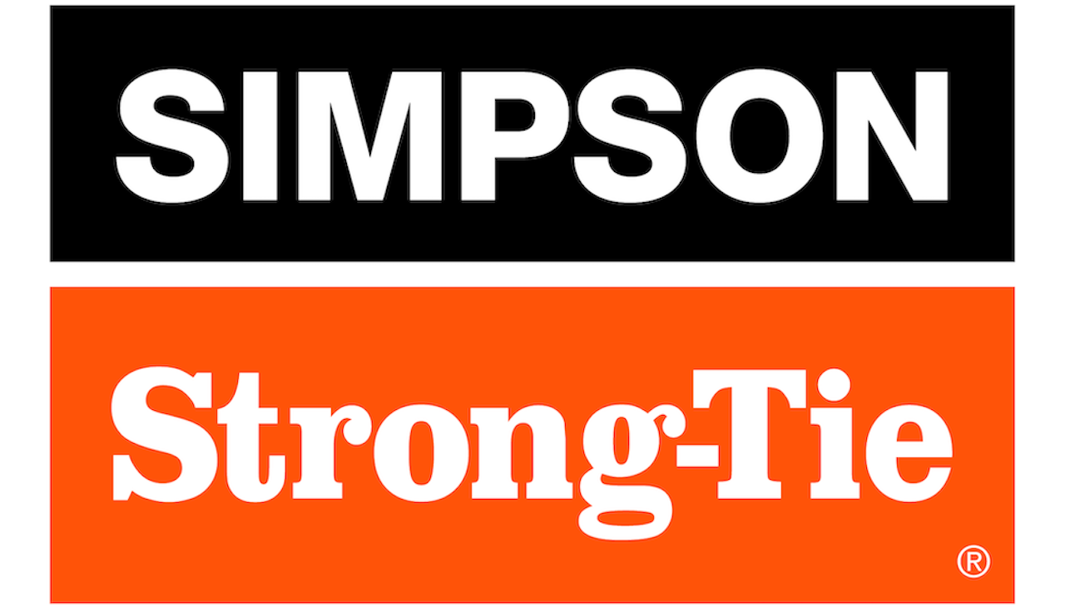
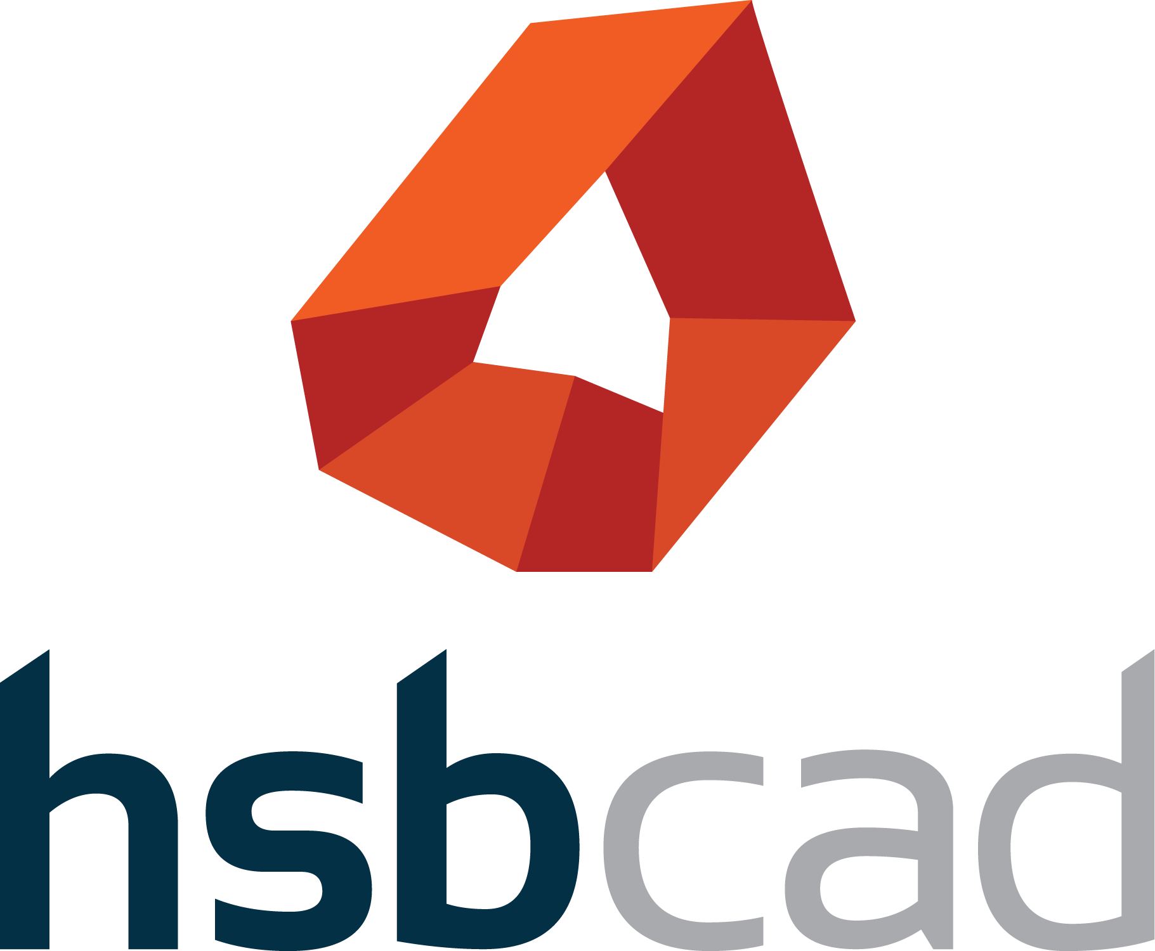
FOR IMMEDIATE RELEASE  September 13, 2026 | For More Information:  Maureen Inouye-Harrison  minouyeharri@strongtie.com  Maria Magallanes  maria.magallanes@hsbcad.com

Simpson Strong-Tie and hsbcad Bring Advanced Wall-Framing Technology to CS Cornerstone™ Wall Software
New wall-framing solution will be showcased alongside Simpson Strong-Tie® Component Solutions® software and equipment at BCMC 2026
PLEASANTON, Calif. — Simpson Strong-Tie, the leader in engineered structural connectors and building solutions, and hsbcad, a leading global provider of design, manufacturing and assembly software solutions for offsite timber construction, are bringing advanced digital wall-framing capabilities to component manufacturers through CS Cornerstone™ Wall software, powered by hsbcad technology.
Available since June 2026, CS Cornerstone Wall software combines building modeling with structural wood-component design and analysis. The solution will be demonstrated during the Building Component Manufacturers Conference (BCMC), September 14–18, in Columbus, Ohio, at Simpson Strong-Tie Booth 901, with hsbcad also exhibiting at Booth 113.
The collaboration brings hsbcad’s established wall-framing technology into the IntelliCAD environment, giving IntelliCAD designers and manufacturers access to the same powerful wall-framing capabilities behind hsbcad’s hsbDesign for Revit® and AutoCAD® solutions. At the core of the solution are hsbcad’s parametric detailing technology, configurable framing styles and framing engine, enabling detailed, production-ready wall models to be created more efficiently.
“What makes this especially valuable is the amount of repetitive work we can take out of the process. Parametric details adapt automatically as wall dimensions, angles or timber sizes change, while framing styles let manufacturers define their preferred configurations once and apply them consistently across multiple walls. That means less manual detailing and a more reliable path from design to production,” said Kris Riemslagh, technology architect at hsbcad.
The technology behind CS Cornerstone Wall software builds on multiple generations of hsbcad wall-detailing development and its experience supporting timber manufacturers around the world.
“This collaboration is about bringing together complementary expertise to give manufacturers better tools for the way they design and build today,” said Hilde Sevens, CEO of hsbcad. “Together with Simpson Strong-Tie, we’re making our proven technology accessible to a broader part of the industry and helping move timber construction toward more connected, efficient and sustainable ways of working.”
The collaboration also extends beyond wall modeling. CS Cornerstone Wall software customers benefit from additional hsbcad technologies that support downstream workflows, including hsbView, which provides access to digital shop drawings and production information, and hsbcad’s validation technology, which applies configurable, rule-based checks to help ensure models meet design, structural and production requirements, such as stud spacing, sheathing edge support and nail-line requirements.
For manufacturers looking to connect digital models further into production, hsbcad’s exporters can support the transfer of manufacturing data to leading CNC machines and shop-floor environments. Simpson Strong-Tie also serves as an hsbcad reseller for selected machine-connectivity solutions, extending the relationship between the two companies beyond the CS Cornerstone Wall software platform.
At BCMC 2026, attendees will be able to see CS Cornerstone Wall software alongside the broader Simpson Strong-Tie® Component Solutions® software and equipment portfolio.
Highlights at Simpson Strong-Tie Booth 901 will include:
- CS Cornerstone™ Wall software: The new all-in-one platform combines building modeling with structural wood-component design and analysis, powered by hsbcad.
- CS Cloud Director™: The new cloud-based management platform is designed to improve visibility, streamline operations and support profitability. Schedule a live demo to experience these innovations and the full suite of Component Solutions® software.
- CS® Producer™ truss production management software: The newest addition to the Component Solutions® software suite, this cutting-edge, cloud-based software gives floor and roof truss manufacturers powerful ways to schedule and manage daily operations.
- Happy hour: Join the Simpson Strong-Tie team for happy hour on Wednesday, September 16, from 6 p.m. to 9 p.m. at Stories on High rooftop bar.

Highlights at hsbcad Booth 113 will include:
- hsbDesign for Revit® and AutoCAD®: See hsbcad’s latest timber design and detailing capabilities for creating detailed, production-ready models.
- hsbMake: Explore hsbcad’s CAM/MES solution for managing and optimizing production on the shop floor, including CNC machine connectivity.
- Sign up for hsbNext 2026: For those interested in exploring hsbcad’s wall-framing technology and developments further, hsbNext 2026 will feature two live online sessions focused on design and production, taking place on September 17 and September 21, respectively. Attendees can register for free online and learn more at the booth: https://bit.ly/hsbNext2026.
- Meet the team: Connect with Randy Laplante and Jared Flores from hsbcad’s North America team to discuss how hsbcad technology can support your design and production workflows.

About Simpson Strong-Tie Company Inc.
Simpson Strong-Tie is the world leader in structural solutions — products and technology that help people design and build safer, stronger homes, buildings and communities. As a pioneer in the building industry, we have an unmatched passion for problem solving through skilled engineering and thoughtful innovation. Our structural systems research and rigorous testing enable us to design code-listed, value-engineered solutions for a variety of applications in wood, steel and concrete structures. Our dedication to pursuing ever-better construction products and technology and to surrounding our customers with exceptional service and support has been core to our mission since 1956. For more information, visit strongtie.com and follow us on Facebook, X, YouTube and LinkedIn.

About hsbcad
With more than 35 years of experience, hsbcad develops software solutions that connect design, manufacturing and assembly for the offsite timber industry. Its solutions automate framing, generate production-ready data, drive CNC machinery and support manufacturing operations, helping manufacturers reduce manual work, improve accuracy and shorten project lead times.
Driven by its purpose, “We reshape today’s construction industry into a sustainable and innovative tomorrow,” hsbcad develops technology that helps offsite manufacturers work more efficiently and make better use of materials and data.
Headquartered in Ghent, Belgium, hsbcad has a global team of more than 80 people across subsidiaries in Germany, the Netherlands, the U.K., the U.S., Canada, Japan, Ecuador and Australia. For more information, visit www.hsbcad.com.

