UNESCO and the Omenaa Foundation partner to advance education, culture and the creative economy across the world
8 September 2026
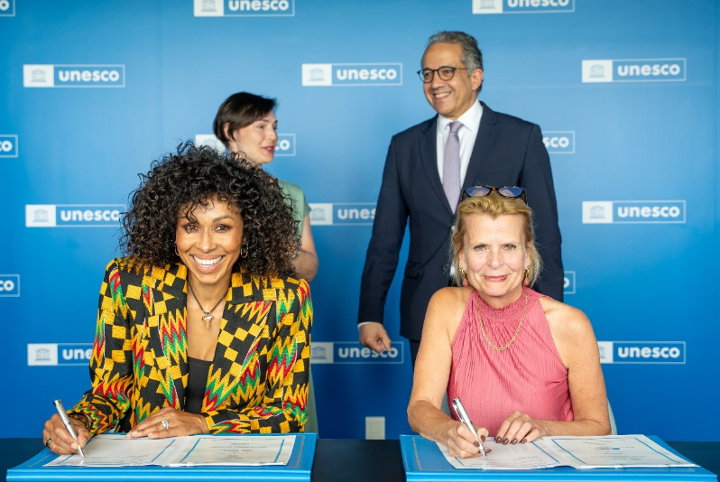
Copyright: UNESCO / Saskia Maitrepierre
Deputy Director-General Åsa Regnér met with Omenaa Mensah, Founder of the Omenaa Foundation, at UNESCO, in the presence of Director-General Khaled El-Enany and Ms. Maja Wawrzyk, Permanent Delegate of the Republic of Poland, to sign a new 3-year Framework Agreement under which the Omenaa Foundation has pledged EUR 1 million to UNESCO, supporting education, culture, heritage and the creative economy as drivers of sustainable development.
The partnership was made possible due to the support of the Polish permanent delegation, making Omenaa Foundation the first Polish private foundation to partner with UNESCO.

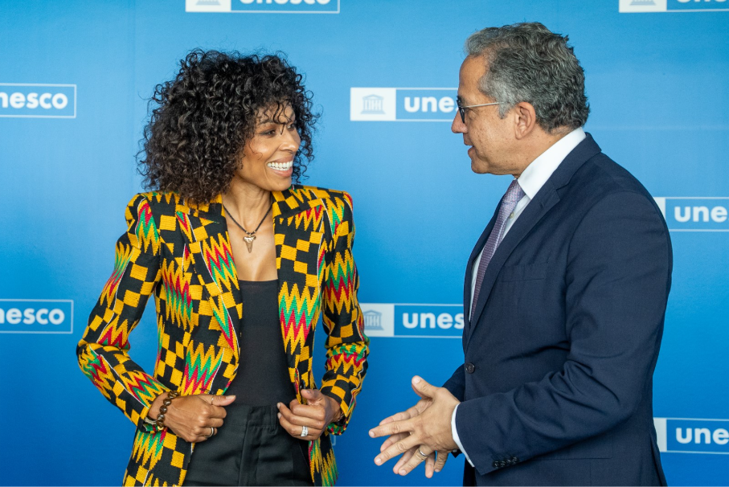
Copyright: Alex Dolny
"Foundations like Omenaa Foundation show the importance of innovative cooperation between the public and private sectors to promoting global solidarity. This agreement strengthens UNESCO's ability to turn shared values into concrete action for the people we serve.”

UNESCO Director-General, Khaled El-Enany
Founded in 2014 by Omenaa Mensah, who is a Polish philanthropist of Ghanaian descent, the Omenaa Foundation is a philanthropic network whose mission bridges culture, art and education, using them as instruments of social change to counter discrimination and advance the rights of children and vulnerable groups. Central to its work is a commitment to building bridges between Europe, Africa and the world at large, commissioning contemporary artistic interventions at major heritage sites and supporting artists, creators, children and young people through scholarships, residencies, mentorship and educational partnerships in Poland, Ghana and beyond.

Its work aligns closely with UNESCO's Global Priorities on Africa and Gender Equality and makes the Foundation a natural partner in advancing these priorities through education, culture, heritage and the creative economy. Following the signing ceremony, UNESCO and Omenaa Foundation teams met to discuss the implementation of the partnership and its next steps over the coming three years.

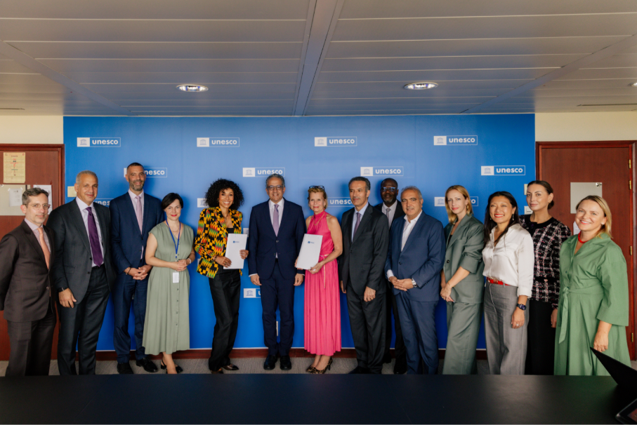
Copyright: Alex Dolny
''Today, we want to build Europe-Africa relations not only through charity. We want to build cultural, artistic, educational and business bridges based on partnership and mutual respect. For me, that is hugely meaningful, because it shows that together we can create a new model of relations between continents.”
- Founder of Omenaa Foundation, Omenaa Mensah.

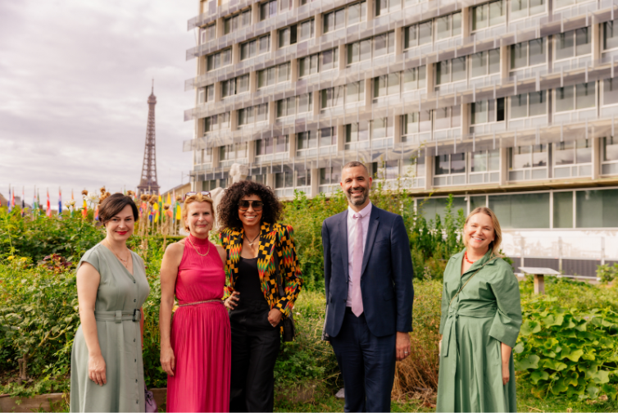
Copyright: Alex Dolny

The partnership seeks to strengthen culture and arts education for children and young people, support the revitalization of heritage sites and promote contemporary African art and artists. It will act as a driver for culture and arts education to promote human rights and counter discrimination, in line with the UNESCO Framework for Culture and Arts Education adopted at the 2024 World Conference on Culture and Arts Education.
“This partnership connects innovation with culture, young people and Africa, one of UNESCO's priorities. Over the next three years, I look forward to seeing this collaboration open doors for young people and create lasting opportunities for the communities we serve together."
UNESCO Deputy Director-General, Åsa Regnér

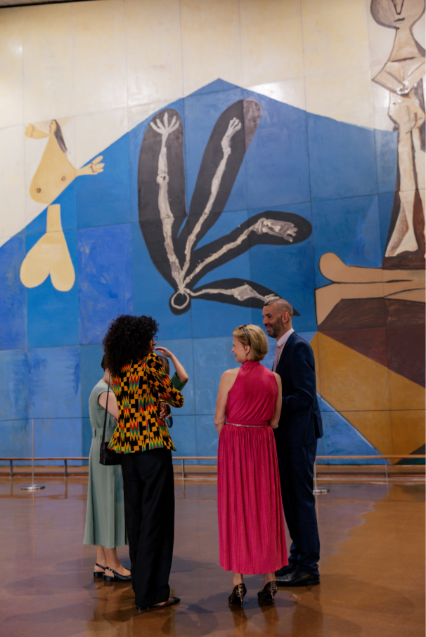
©UNESCO Works of Art / Pablo Picasso
Copyright: Alex Dolny
About Omenaa Foundation
The ecosystem built by Omenaa Mensah today includes Omenaa Foundation, OmenaArt Foundation, Rafał Brzoska Foundation, TOP CHARITY and the Philanthropic Consortium, a platform that also brings together a broad network of foundations and social organisations from Poland and around the world.

This enables individual organisations, private donors, entrepreneurs, artists and international partners to combine resources around shared, long-term projects. Since 2022, TOP CHARITY has raised more than EUR 55 million and supported 238 projects.
About UNESCO
With 194 Member States, the United Nations Educational, Scientific and Cultural Organization contributes to peace and bringing people together by leading multilateral cooperation on education, science, culture, communication and information. Headquartered in Paris, UNESCO has offices in 53 countries and employs over 2500 people. UNESCO oversees more than 2260 World Heritage sites, Biosphere Reserves and Global Geoparks; networks of over 1500 Creative, Learning, Inclusive and Sustainable Cities; and more than 13 000 associated schools, university chairs, training and research institutions, with a global network of 201 National Commissions. Its Director-General is Khaled El-Enany.
“Since wars begin in the minds of men, it is in the minds of men that the defences of peace must be constructed” – UNESCO Constitution, 1945.
More information: www.unesco.org

For additional information, interview requests or further materials, please contact:
Justyna Komorek
Head of Founder Communications
+48 534 108 802
justyna.komorek@omiimage.com

Dagmara Tarka
PR Specialist
+48 665 063 345
dagmara.tarka@omenaafoundation.com

