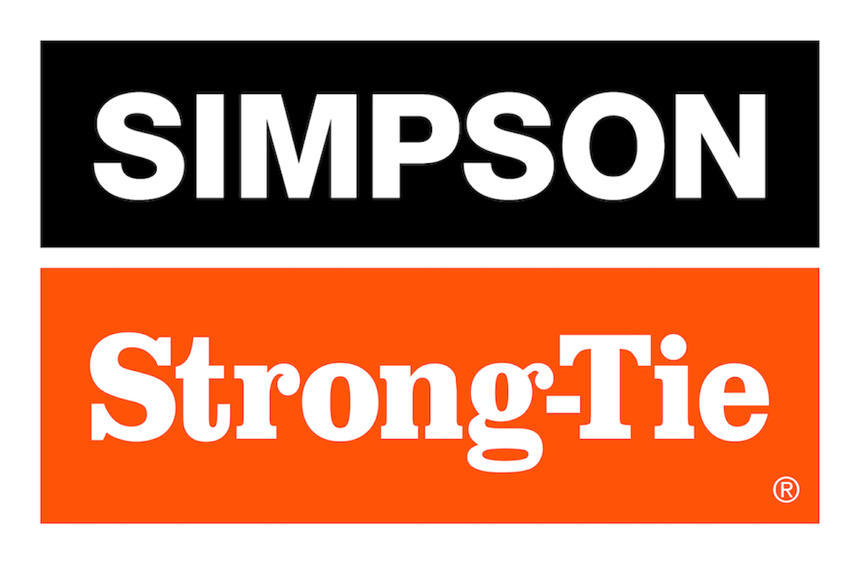
FOR IMMEDIATE RELEASE
September 3, 2026
Maureen Inouye-Harrison
minouyeharri@strongtie.com
Simpson Strong-Tie Joins the Lowes Building Futures Skilled Trades Coalition to Help Strengthen America's Construction Workforce
PLEASANTON, Calif., Sept. 1, 2026 – Simpson Strong-Tie, the leader in engineered structural connectors and building solutions, announced it has joined the Building Futures Skilled Trades Coalition as a founding member, partnering with more than 75 organizations committed to helping train and develop one million people for skilled trades careers by 2035.
The coalition, launched by the Lowe's Foundation, brings together educators, businesses, workforce organizations and industry leaders to address one of America's most pressing workforce challenges. The United States could face as many as 2.1 million unfilled skilled trades positions by 2030, creating significant impacts across the construction and broader economy.
For Simpson Strong-Tie, supporting the next generation of skilled trade professionals aligns with the company's mission and values. Every day, contractors, builders, framers, installers, and other construction professionals rely on skilled craftsmanship to create safe, resilient structures and strong communities. As demand for housing, infrastructure and resilient construction grows, developing a skilled workforce is critical to the future of the building industry.
“Skilled tradespeople are essential to the homes, buildings and infrastructure our communities depend on every day,” said Mike Olosky, president and CEO of Simpson Strong-Tie. “Expanding pathways into the trades will help develop the next generation of skilled workers, meet future demand and support the long-term growth of the construction industry. At Simpson Strong-Tie, we help create those pathways by investing in hands-on training, certification programs, mentorship and employee engagement initiatives that connect more people with rewarding careers in the skilled trades.”
The coalition will focus on three key priorities: changing perceptions of skilled trades careers, connecting and scaling proven training and credentialing solutions, and measuring progress from training to employment. Coalition members will share knowledge, identify successful approaches and work together to expand access to rewarding career opportunities across the skilled trades.
Simpson Strong-Tie brings decades of experience supporting the construction industry through innovation, education and partnerships that help professionals build safer, stronger structures. Through participation in the coalition, the company will collaborate with organizations across the skilled trades ecosystem to help address workforce challenges and strengthen the talent pipeline for the future.
The Building Futures Skilled Trades Coalition is the nation's largest cross-sector skilled trades coalition and includes more than 75 founding members representing businesses, educators, workforce organizations and industry stakeholders.

About Simpson Strong-Tie Company Inc.
Simpson Strong-Tie is the world leader in structural solutions — products and technology that help people design and build safer, stronger homes, buildings, and communities. As a pioneer in the building industry, we have an unmatched passion for problem solving through skillful engineering and thoughtful innovation. Our structural systems research and rigorous testing enable us to design code-listed, value-engineered solutions for a multitude of applications in wood, steel, and concrete structures. Our dedication to pursuing ever-better construction products and technology and to surrounding our customers with exceptional service and support has been core to our mission since 1956. For more information, visit strongtie.com and follow us on Facebook, Twitter, YouTube and LinkedIn.

