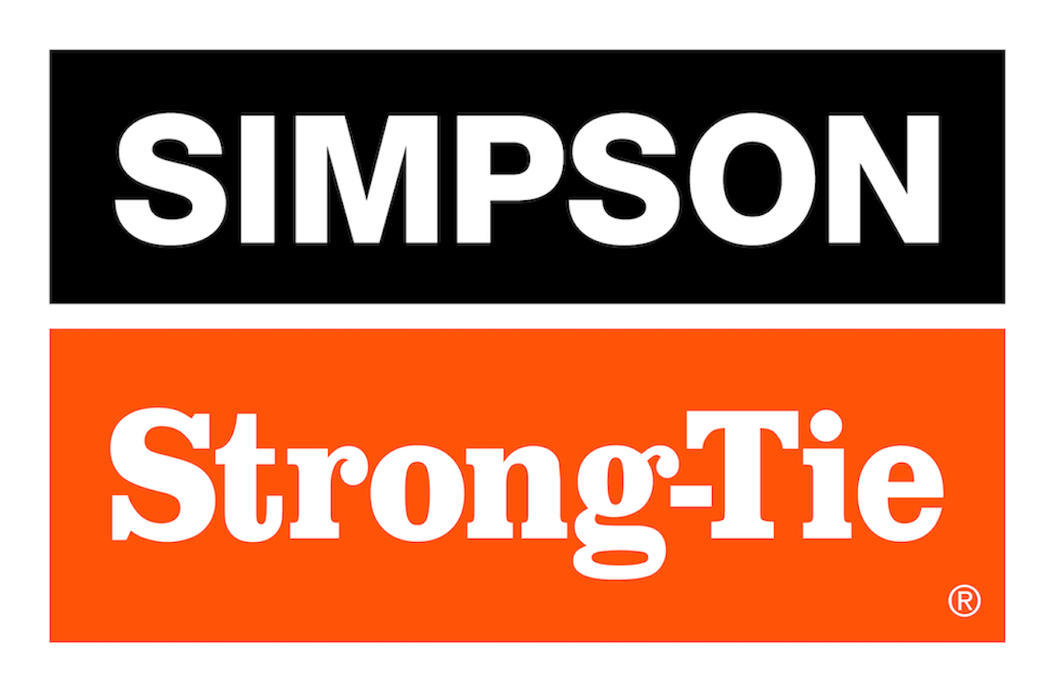

FOR IMMEDIATE RELEASE For More Information:
September 3, 2026 Maureen Inouye-Harrison
minouyeharri@strongtie.com

Simpson Strong-Tie to Unveil New Software and Equipment Solutions
at 2026 Building Component Manufacturers Conference

Pleasanton, Calif. — Simpson Strong-Tie, the leader in engineered structural connectors and building solutions, will introduce several new products and demo its lineup of component software and equipment during this year’s Building Component Manufacturers Conference (BCMC), September 14–18 in Columbus, Ohio. During the show, attendees can browse products, experience live demonstrations and meet with Simpson Strong-Tie specialists at Booth 901. They also can schedule personalized software demonstrations in advance here.

“With cutting-edge equipment, innovative technology options and an extensive range of hardware, Simpson Strong-Tie offers component manufacturers a package of solutions for every stage of the job,” said Josh Fitzgerald, vice president – Component Manufacturing for Simpson Strong-Tie. “We’re looking forward to connecting with customers and potential customers at BCMC to explore how we can help streamline their business and boost efficiencies.”

Software Solutions
Simpson Strong-Tie will showcase new software solutions and demo many others, including:
- CS® Cornerstone™ Wall: The new all-in-one platform combines building modeling with structural wood component design and analysis.
- CS Cloud Director™: The new cloud-based management platform is designed to improve visibility, streamline operations and support profitability.
- CS Producer™: This cutting-edge, cloud-based truss production management software gives floor and roof truss manufacturers powerful ways to schedule and manage daily operations.
- Demo suite: Attendees also can visit the Simpson Strong-Tie demo suite for a personal tour of CS Truss Studio™, CS Director™, CS EWP Studio™ and the iStruct® software suite.

“Our cloud-native portfolio of component software and differentiated services uniquely positions us to help the construction industry lead its next era of productivity, precision and scalable growth,” said Chief Technology Officer Udit Mehta. “As part of our commitment to customers, partners and the broader industry, we continue to accelerate investments in AI, digital solutions and modernized platforms, helping customers deliver higher-quality products faster and with improved accuracy, greater consistency and more efficient execution.”

Fabrication Equipment in Action
Explore new and innovative equipment, including:
- Expanded truss fabrication equipment line: Roof, floor and jack truss gantry tables; vertical stackers; finish rollers; and exit conveyors.
- Monet DeSauw DeSawyer: Fully computerized, five-bladed truss saw.
- EasyFrame™ automated marking saw (updated): Our upgraded platform combines precision cutting, automated printing, advanced routing capabilities and software integration into a single production system that improves throughput, accuracy and operational efficiency.

Code-Listed Hardware Solutions
Explore the latest Simpson Strong-Tie connectors, fasteners, anchors and component hardware, and talk with our team about solutions for your operation.

Happy Hour
Join the Simpson Strong-Tie team for happy hour on Wednesday, September 16, from 6 p.m. to 9 p.m. at Stories on High rooftop bar. Stop by the booth for details.

For more information, visit www.strongtie.com.

About Simpson Strong-Tie Company Inc.
Simpson Strong-Tie is the world leader in structural solutions — products and technology that help people design and build safer, stronger homes, buildings, and communities. As a pioneer in the building industry, we have an unmatched passion for problem solving through skillful engineering and thoughtful innovation. Our structural systems research and rigorous testing enable us to design code-listed, value-engineered solutions for a multitude of applications in wood, steel, and concrete structures. Our dedication to pursuing ever-better construction products and technology and to surrounding our customers with exceptional service and support has been core to our mission since 1956. For more information, visit strongtie.com and follow us on Facebook, Twitter, YouTube and LinkedIn.

###

