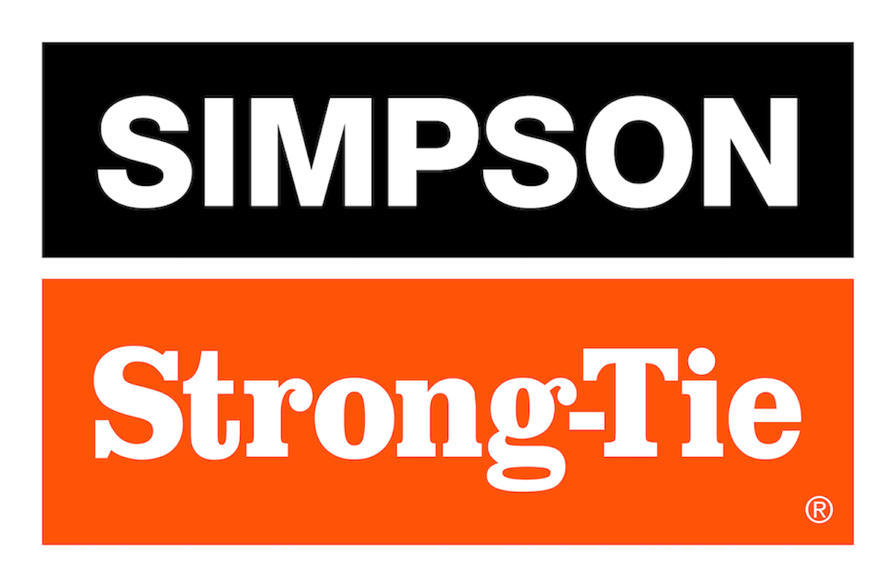

FOR IMMEDIATE RELEASE For More Information:
September 1, 2026 Maureen Inouye-Harrison
minouyeharri@strongtie.com

Simpson Strong-Tie Donates $25,000 for Wildfire Relief
and Recovery in Washington and Canada
Pleasanton, Calif. — Following the recent wildfires in Eastern Washington and across Canada, Simpson Strong-Tie has donated $25,000 toward relief, recovery and rebuilding efforts in both regions. The donations comprise $15,000 to the Innovia Foundation in Washington and $10,000 to the Canadian Red Cross.

Innovia Foundation is a community foundation serving Eastern Washington and Northern Idaho. The nonprofit’s Spokane Complex Wildfire Response Fund is supporting immediate relief efforts as well as long-term recovery and rebuilding needs for individuals and families impacted by the multiple fires this summer.

Funds for the Canadian Red Cross will go toward the Canadian Wildfire Fund in support of immediate response and long-term recovery. The Fund is also used to enhance readiness and response to escalating wildfire risks.

“Our hearts continue to go out to all of those impacted by the wildfires across Washington and Canada this summer, our own customers among them,” said Simpson Strong-Tie President and CEO Mike Olosky. “The work that the Innovia Foundation and the Canadian Red Cross are doing to provide relief now, and in the months and years to come, is critically important, and we’re grateful to be able to contribute to those efforts.”

Along with the initial donation, Simpson Strong-Tie will match employee donations made to either organization. Simpson Strong-Tie employees impacted by the wildfires can also request grant assistance through the company’s Simpson Strong-Tie Team Member Relief Fund.

The wildfire relief donations are part of the company’s ongoing commitment to aid in disaster relief and recovery efforts around the world. To donate, visit https://innovia.org and www.redcross.ca.

About Simpson Strong-Tie Company Inc.
Simpson Strong-Tie is the world leader in structural solutions — products and technology that help people design and build safer, stronger homes, buildings, and communities. As a pioneer in the building industry, we have an unmatched passion for problem solving through skillful engineering and thoughtful innovation. Our structural systems research and rigorous testing enable us to design code-listed, value-engineered solutions for a multitude of applications in wood, steel, and concrete structures. Our dedication to pursuing ever-better construction products and technology and to surrounding our customers with exceptional service and support has been core to our mission since 1956. For more information, visit strongtie.com and follow us on Facebook, X, YouTube and LinkedIn.

###

