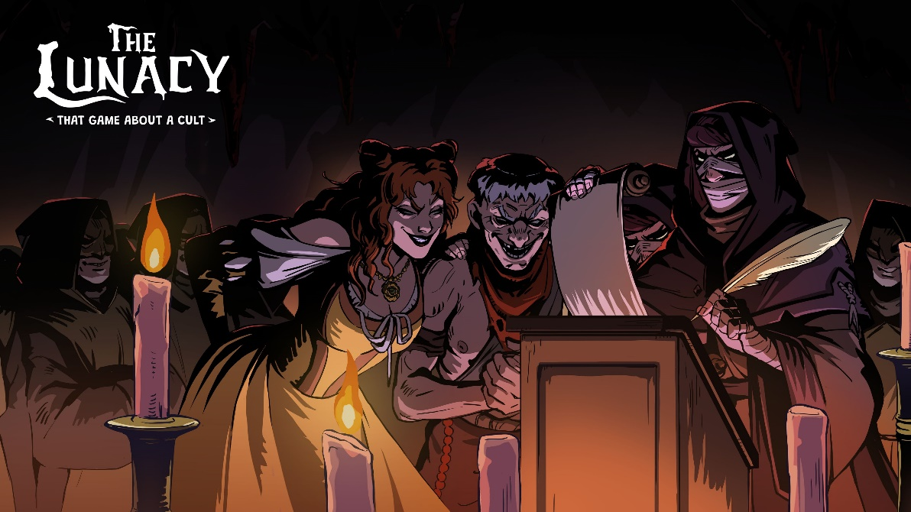

Nobody expects the Spanish Inquisition! The Lunacy: That Game About a Cult – a dark-comedy stealth-management game – has been revealed in its first trailer. Did they just say that the pope stinks?

Above the Desk – the team behind the well-received Above the Snow – is proud to announce its new game and present its first trailer. The Lunacy: That Game About a Cult is a dark-comedy cult-management game set in Inquisition-era Spain, where a possibly delusional prophet builds a cult devoted to ancient gods whose existence even the player cannot be sure of.

What does it take to become a prophet? Sometimes, hitting your head hard enough might be all it takes to start hearing ancient gods! Then, you just need a few followers, and you can begin your journey as the one and only Chosen One. In The Lunacy: That Game About a Cult, players will be blessed with the chance to build and manage their own cult in a time when Spain was ruled by the merciless Inquisition. Hidden deep beneath the city, players will construct an Underground Temple that will become the heart of an upcoming rebellion – of course, only if everything goes according to the gods' plans!

The Lunacy: That Game About a Cult – watch the announcement trailer

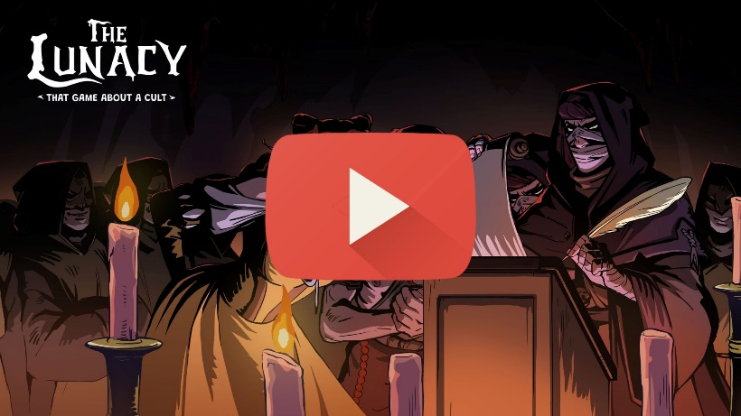
https://youtu.be/cU43KEl-e3c

Now, think about what might keep your followers happy, loyal, and devoted… Altars, relics, and a cursed library, or perhaps endless barrels of wine and a fine secret tavern? The choice is yours – you decide the fate of your cult! The key is to never give up. While your followers toil and pray in the hidden temple, send Acolytes on sacred missions into the city to sneak through bustling streets, preach, steal, spy, fish (really? Fish?! What fish? Holy fish? Nevermind…), and take part in hundreds of handcrafted events with unexpected outcomes!

Each expedition offers a chance to learn more about the city and its inhabitants – and when you pull the strings from the shadows, knowledge is more valuable than gold! As your cult grows, so do the ways you can manipulate everything and everyone. What starts as a desperate struggle to survive in secret can eventually turn into an open rebellion, with entire districts waiting to be challenged and claimed. The Lunacy: That Game About a Cult combines cult management, RPG-style urban expeditions, and handcrafted comic events in a world where faith can be a weapon, a business, or simply a very dangerous misunderstanding.

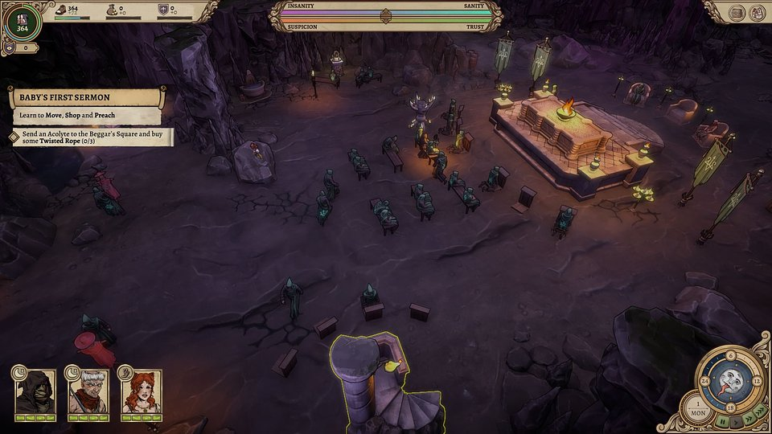

Being a cult prophet might sound like the darkest job ever, but The Lunacy: That Game About a Cult breaks that grim image with a healthy dose of humor – just be careful, as that might also put you on the Inquisition’s radar! In this game, your goal is simple: spread your influence, use your knowledge to spark a revolt, challenge the Inquisition, and seize the city, district by district.

The Lunacy: That Game About a Cult - Key Features:

● Build Your Underground Temple: Use a gridless building mode to furnish your temple - build shrines, set pews, place skull piles and organise spaces around the needs of your followers.

● Run a Growing Cult: Assign work, craft resources and maintain the growing congregation by preaching and performing sermons. Unlock features with blasphemous rituals.

● Operate Inside a Living City: Send Acolytes into the Renaissance streets to explore, gather resources and pursue opportunities while outwitting the Inquisition and other goons.

● Witness absurd Events: Preach, steal, spy and encounter hundreds of handcrafted ridiculous events

● Learn, Influence and Conquer Districts: Understand the city’s layout, build influence and prepare for a revolt against religious tyranny.

● Walk the Line Between Revelation and Delusion: Experience the world evolving together with your sanity. Both the visuals, and the gameplay are influenced by the state of the Prophet.

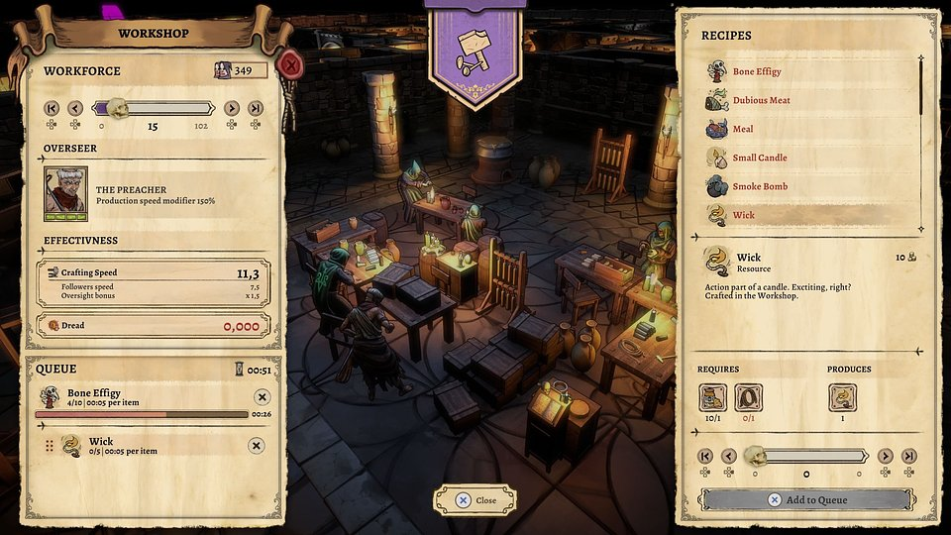

Players brave enough to face the Spanish Inquisition in The Lunacy: That Game About a Cult can already add the game to their wishlist on Steam. To stay up to date with the latest news, be sure to follow the game’s and studio’s profiles on Instagram, TikTok, and X, and join the community server on Discord.

Full press kit is available here.

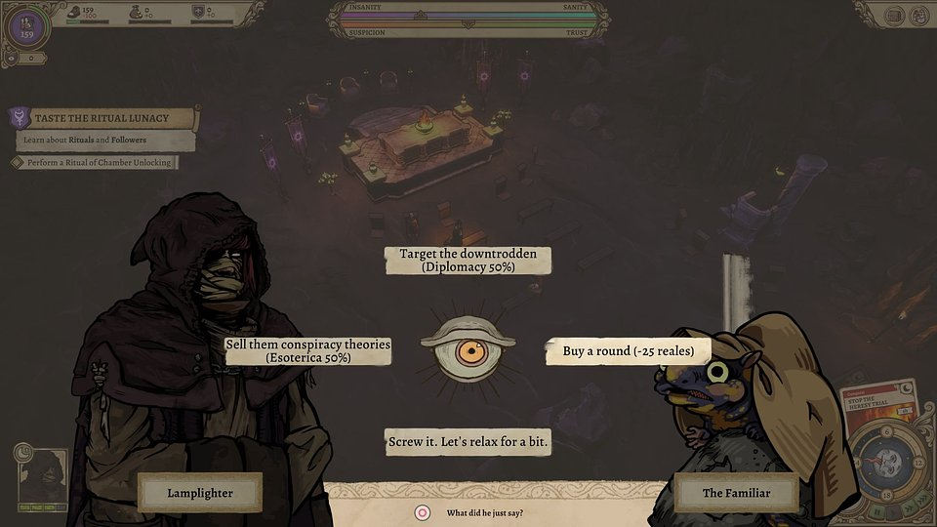

About Above the Desk:

Above the Desk is an independent game studio built by a small but passionate team, a mix of seasoned industry veterans and bold new talent. We believe that this blend of perspectives, skills and creative energy is our greatest strength. In 2026 we released our first game - Above the Snow.

Our mission is to craft games that stand out with original ideas, engaging mechanics, and a sharp sense of humor. We don’t cut corners. We focus on originality, quality, and fresh takes on familiar formulas. More you can find on our website: https://abovethedesk.games/about

