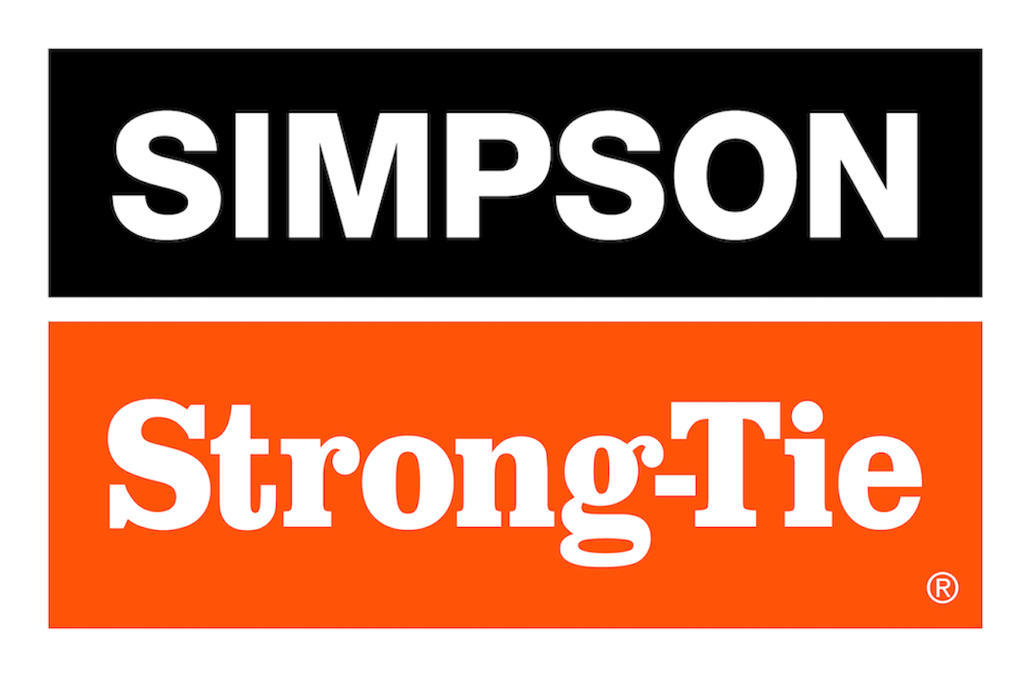

FOR IMMEDIATE RELEASE For More Information:
August 18, 2026 Allison Block
ablock@strongtie.com

Simpson Strong-Tie Surpasses $3 Million in Student Scholarships, Awards $360,000 to Future Industry Leaders
Pleasanton, Calif. — For nearly three decades, Simpson Strong-Tie, the leader in engineered structural connectors and building solutions, has invested in developing the next generation of engineers, architects and construction professionals through its Student Scholarship program. This year, the company reached a significant milestone, surpassing $3 million in total scholarships since the program began, including $360,000 awarded this year to 120 college juniors and seniors pursuing degrees in architecture, civil or structural engineering, and construction management.

The Student Scholarship program is part of the company’s Strong-Tie Undergraduate Fellowship, a program designed to help students successfully transition from the classroom to the workforce. In addition to financial support, scholarship recipients gain access to professional development opportunities, industry connections, training, job leads, and a network of peers that help prepare them for careers building safer, stronger communities.

Many scholarship recipients also participate in the annual Student Scholarship Trip, where they connect with Simpson Strong-Tie leaders and employees, tour company facilities, engage in professional development and networking opportunities, and gain firsthand insight into careers across the engineering, construction and manufacturing industries.

“Supporting future building, design and engineering professionals is critical to ensuring the construction industry continues to thrive and innovate, and we’re proud to be a part of those efforts year after year,” said Mike Olosky, CEO of Simpson Strong-Tie. “The Student Scholarship program has been a pillar of our community outreach efforts for nearly three decades; I know passing the $3 million milestone means a lot to all of us who work here, just as our efforts in getting there have to the students who’ve benefited.”

Since launching the Student Scholarship program in 1999, Simpson Strong-Tie has awarded more than $3.1 million in scholarships to support 1,300+ students across the U.S. Together with the Strong-Tie Undergraduate Fellowship, the program reflects the company’s longstanding commitment to strengthening the construction industry by investing in the next generation of design, engineering and construction professionals.

The full list of 2026 scholarship recipients and their respective schools can be viewed on the company’s website at www.strongtie.com/about/company/scholarships-recipients.

The Simpson Strong-Tie Student Scholarship is administered by Scholarship America, the nation’s largest designer and manager of scholarship and tuition reimbursement programs for corporations, foundations, associations and individuals.

About Simpson Strong-Tie Company Inc.
Simpson Strong-Tie is the world leader in structural solutions — products and technology that help people design and build safer, stronger homes, buildings, and communities. As a pioneer in the building industry, we have an unmatched passion for problem solving through skillful engineering and thoughtful innovation. Our structural systems research and rigorous testing enable us to design code-listed, value-engineered solutions for a multitude of applications in wood, steel, and concrete structures. Our dedication to pursuing ever-better construction products and technology and to surrounding our customers with exceptional service and support has been core to our mission since 1956. For more information, visit strongtie.com and follow us on Facebook, X, YouTube and LinkedIn.

###

