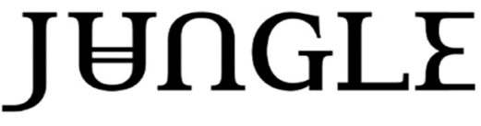

SHARE THE NEW SINGLE ‘SOMEDAY, SOMEWHERE’
LISTEN HERE / WATCH THE VIDEO HERE

FROM THE NEW ALBUM ‘SUNSHINE’, OUT AUGUST 14TH
PRE-ORDER / PRE-SAVE HERE

WORLD TOUR ACROSS NORTH AMERICA, EUROPE, UK, AUSTRALIA AND LATIN AMERICA STARTS IN SEPTEMBER

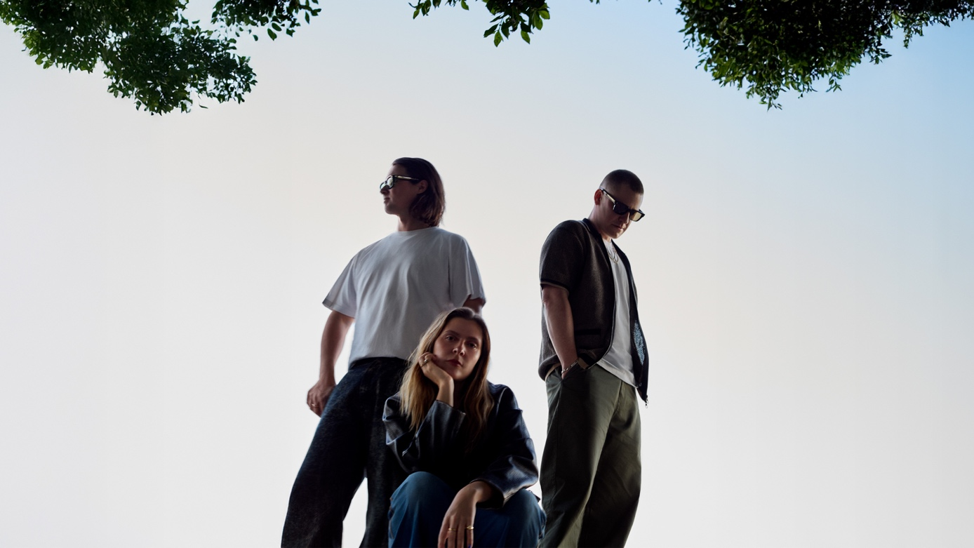
Credit: Mason Rose

BRIT Award-winning and global arena headliners Jungle share ‘Someday, Somewhere’, the third single from their forthcoming album ‘Sunshine’, which follows on August 14th.The track which premiered as Radio 1’s Hottest Record, continues the build-up to the new album following ‘Carry On’ and ‘The Wave’ - both of which earned strong support across BBC Radio 1, Radio 2 and Virgin Radio.

Jungle - J Lloyd, Tom McFarland and Lydia Kitto - first teased ‘Someday, Somewhere’ during Tom McFarland’s recent surprise DJ set at Paris’ Bus Palladium. The track blends sun-soaked rhythms with sleek electronic production and Lydia Kitto’s effortlessly soulful vocal, radiating warmth, optimism and a sense of euphoric possibility.

Of the track, Jungle said, “Someday, Somewhere is about holding onto that feeling that something better is coming. It’s got that late-summer Jungle optimism, a little bit of longing, a little bit of escape, and hopefully something people can lose themselves in.”

The ‘Sunshine’ album is available to pre-order HERE. Physical formats include 180-gram black vinyl, Desert Peach vinyl and a translucent brown marble vinyl - all packed as single gatefold LPs - as well as a digipak CD.

The world tour in support of the album begins in September, taking in arena dates across North America, Europe, UK, Australia and Latin America through to spring 2027. The tour includes two homecoming shows at London’s The O2 and a sold-out show at Colorado’s legendary Red Rocks Amphitheatre.

Remaining tickets for the dates listed below are available HERE.

SEPTEMBER
9th - Minneapolis, MN - The Armory
10th - Chicago, IL - United Center
12th - Toronto, ON - Scotiabank Arena
13th - Montreal, QC - Place Bell
15th - Boston, MA - Agganis Arena
17th - Washington, DC - The Anthem
19th - New York, NY - Barclays Center
21st - Nashville, TN - The Pinnacle
23rd - Houston, TX - 713 Music Hall
24th - Austin, TX - Moody Center
25th - Dallas, TX - Texas Trust CU Theatre
27th - Denver, CO - Red Rocks Amphitheatre (SOLD OUT)
28th - Denver, CO - Red Rocks Amphitheatre (ADDED DATE)

OCTOBER
1st - Portland, OR - Veterans Memorial Coliseum
2nd - Vancouver, BC - Pacific Coliseum
3rd - Seattle, WA - Climate Pledge Arena
6th - San Francisco, CA - Greek Theatre (SOLD OUT)
7th - San Francisco, CA - Greek Theatre (ADDED DATE)
9th - Santa Barbara, CA - Santa Barbara Bowl (SOLD OUT)
10th - Los Angeles, CA - Crypto.com Arena
24th - Lisbon - MEO Arena
26th - Madrid - Movistar Arena
28th - Barcelona - Palau Sant Jordi
30th - Paris - Accor Arena
31st - Brussels - Forest National

NOVEMBER
3rd - Amsterdam - Ziggo Dome
5th - Hamburg - Barclays Arena
6th - Copenhagen - Royal Arena
8th - Berlin - Uber Arena
10th - Łódź - Atlas Arena
12th - Munich - Olympiahalle
13th - Vienna - Wiener Stadthalle
15th - Milan - Unipol Forum
18th - Dublin - 3Arena
21st - Leeds - First Direct Bank Arena
22nd - Cardiff - Utilita Arena
24th - London - The O2 (ADDED DATE)
25th - London - The O2
27th - Manchester - Co-op Live
28th - Glasgow - OVO Hydro

MARCH 2027
2nd - Brisbane - Entertainment Centre
4th - Sydney - Qudos Bank Arena
6th - Melbourne - Rod Laver Arena
10th - Perth - RAC Arena
17th - Guadalajara, MX - Auditorio Telmex
19th - Mexico City, MX - Palacio de los Deportes
22nd - Monterrey, MX - Auditorio Banamex
24th - Lima, PE - Costa 21
27th - Bogotá, CO - Movistar Arena Bogotá
30th - São Paulo, BR - Espaço Unimed

APRIL 2027
1st - Buenos Aires, AR - Movistar Arena Buenos Aires
3rd - Santiago, CL - Movistar Arena Santiago

About Jungle
Jungle were formed in London in 2013 by Tom McFarland and J Lloyd, before their regular collaborator Lydia Kitto became an official member of the group in 2024. Matching a euphoric concoction of modern disco, soul and hip-hop with exemplary visual content defined by world-class choreography, they shot to attention with their self-titled UK Top 10 debut album in 2014. Their rise continued with another Top 10 with 2018’s ‘For Ever’ and then ‘Loving In Stereo’ which hit #3 in 2021.

2023 saw Jungle become a global force with ‘Volcano’. Reaching #3 in the UK, the album featured their biggest hit to date in the shape of ‘Back On 74’ which has been certified Platinum in both the UK and US. The campaign saw Jungle rise to sell-out arenas all over the world, playing to hundreds of thousands of fans across 2023/24 with highlights including The O2 in London, Coachella and headlining All Points East. To date, Jungle have amassed an incredible 4 billion streams.
Follow JUNGLE:
Official site | Spotify | YouTube | Instagram | TikTok
For further info, please contact phoebe.sinclair@appetitepublicity.com

