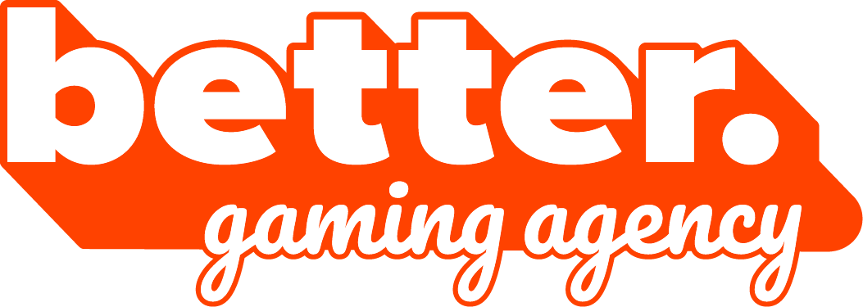

Biuro prasowe better. gaming agency
bettergamingagency.prowly.com

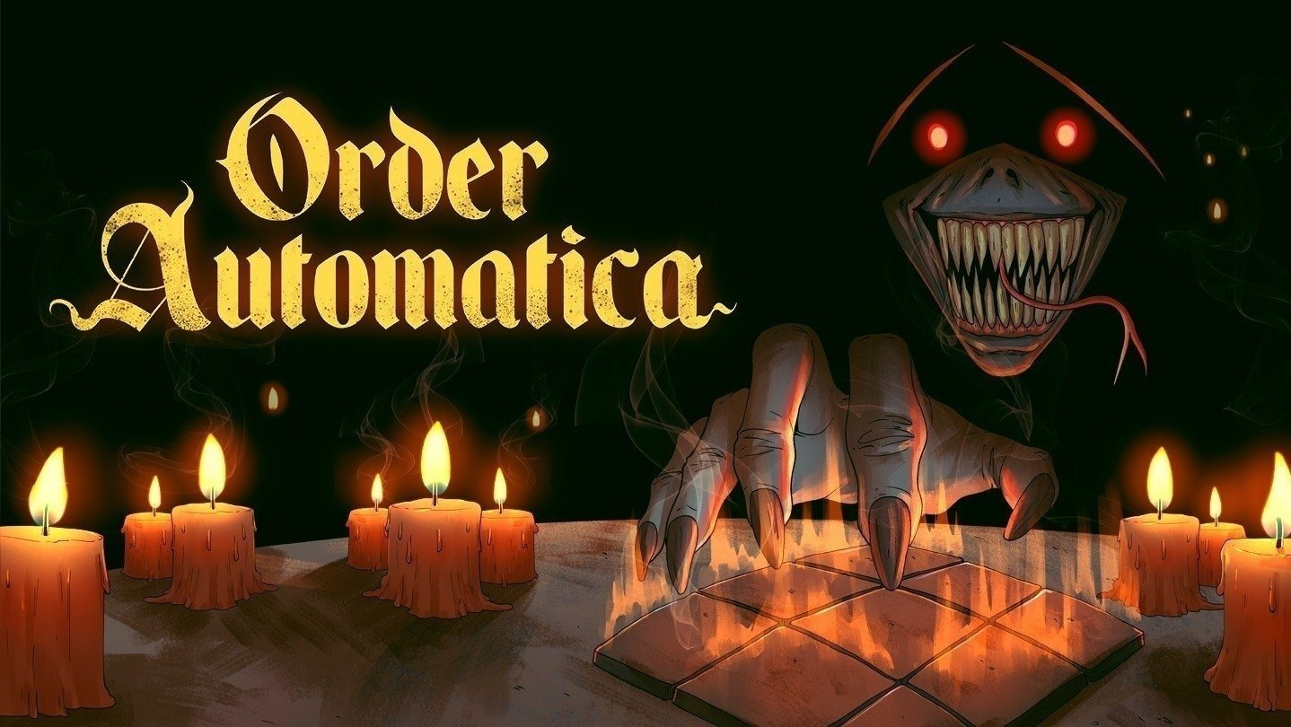

Don’t let it possess you… the dark auto-battler Order Automatica launches September 4 on all platforms

The cursed tactical roguelite from New Beings and better. publishing will launch in early September on PC, Nintendo Switch, Xbox, PlayStation, and mobile platforms – iOS and Android.

Light the ritual candles… the demons have been waiting for you here for centuries.

Independent studio New Beings and better. publishing have officially announced the release date for Order Automatica – a project born out of love for the auto-battler and tactics genres. The game will launch on September 4 across all major platforms.

Every ritual needs its worshippers – dare to take a look at the latest teaser

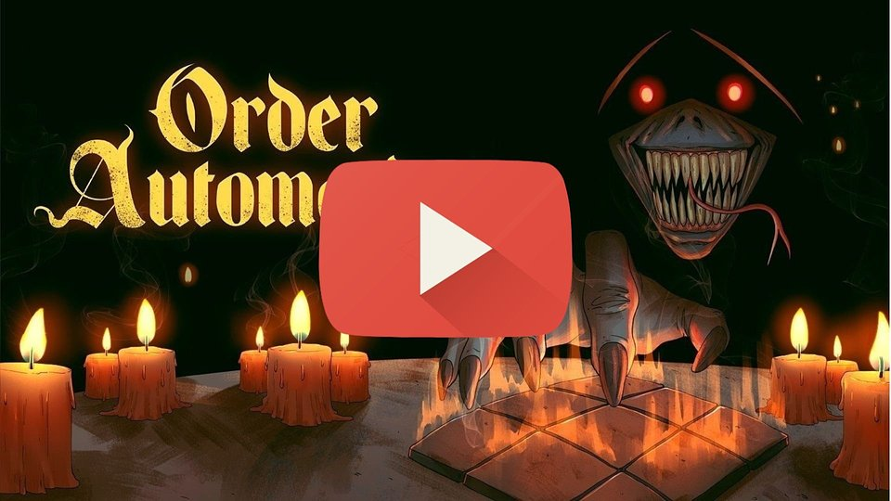
https://youtu.be/YOXCfbeeEd0

Order Automatica is a tactical auto-battler with roguelite elements, where battles are won or lost before they even begin. Players take part in a demonic ritual and must stop it at all costs by snuffing out every candle burning in the name of dark forces. However, with each candle blown out, the enemies become more and more powerful.

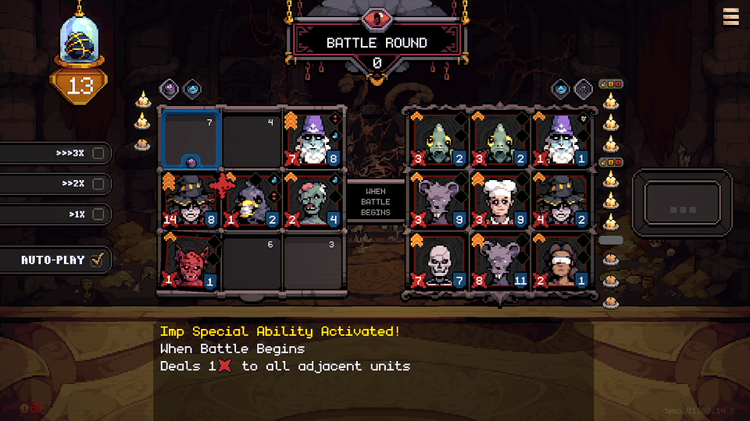

Demonize the demons – but they won’t make it easy

Battles unfold automatically on 3x3 boards, leaving players to focus on selecting and positioning their units. Their choices determine the order of attacks and the pace of the rituals. Those who have already ventured into the world of Order Automatica often describe the game as chess with demons.

Available units vary in many ways, from passive traits to active skills that can be triggered by players or demonic forces. The rules of this dark game limit how fighters can be deployed, but within those boundaries, players’ creativity is put to the ultimate test. Success lies in powerful combinations, clever tactics, and knowing when to unleash curses and demonic abilities.

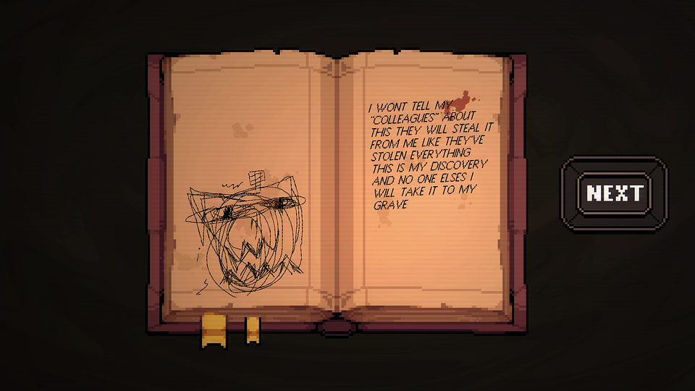

A good understanding of the rules and the possibilities offered by each unit can give players an advantage on every step. But there is never enough time to rest on their laurels – a strategy that works in one run may not be enough for the battles to come, with enemies growing stronger with every encounter. Cunning and adaptability are the keys to reaching the end of the ritual.

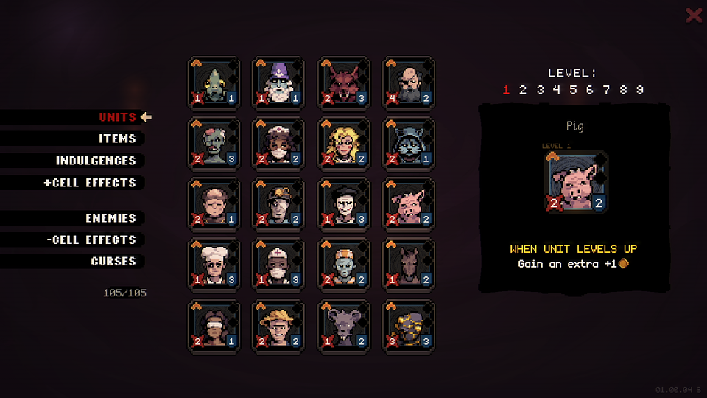

Order Automatica will launch on PC (Steam and GOG), Nintendo Switch, Nintendo Switch 2, Xbox One, Xbox Series X|S, PlayStation 4, PlayStation 5, as well as iOS and Android.

The game will be priced at $5.99. To celebrate the launch, a special 20% discount will be available for two weeks starting September 4 on PC, Nintendo Switch, and Xbox, as well as through the App Store and Google Play. The iOS version is already available for pre-order.

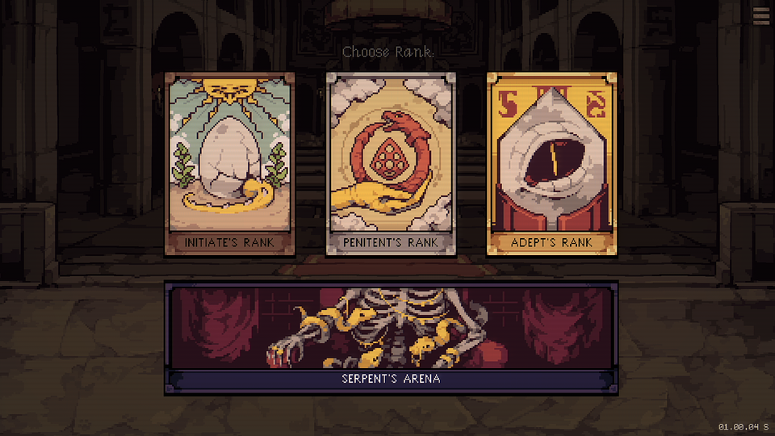

Steam users interested in Order Automatica can also look forward to special bundles featuring titles that share its dark themes, including Death Howl, Inscryption, Arms of God and Backpack Hero. For more information about Order Automatica, visit the official game page on Steam or check out its store pages on Nintendo, Xbox, PlayStation, App Store, and Google Play.

Order Automatica will launch in less than a month, on September 4. To stay up to date with all the demonic rituals, follow the game’s official social media accounts on Instagram, X, TikTok, and BlueSky.

The console ports were developed by Draw Distance, while Pixel Perfect Dude was responsible for the iOS release.

The press kit is available HERE.

About New Beings:

New Beings is a solo development studio run by Mickey Sanchez, based in Portland, Oregon. Mickey gained industry experience by working on indie titles such as Big Hops, Wizard With a Gun, and The Wild at Heart. He has also shared his expertise in game development through teaching at the Pacific Northwest College of Art and Portland Community College. Mickey has released many small but captivating experimental games on itch.io with a focus on turn-based strategy and roguelikes. With help from several talented collaborators, he is now focused on his most ambitious project to date – Order Automatica, a pixel-art auto-battler set for release on September 4, 2026

About better. publishing:

better. publishing draws on the extensive experience of better. gaming agency, which has provided PR and marketing support to publishers and developers of all sizes since 2018. Launching a publishing label was a natural next step, allowing the team to engage more deeply with projects and fully leverage the knowledge and expertise gained over the years. Every game tells a different story, follows a different journey, and meets a different need. The label believes in small teams, big ideas, and collaboration built on trust. It has been created for those who know how challenging game development can be – and how rewarding it is.

Currently, better. publishing is working on three titles: Don't Wake the Beast, Void Dungeon, and Order Automatica.

