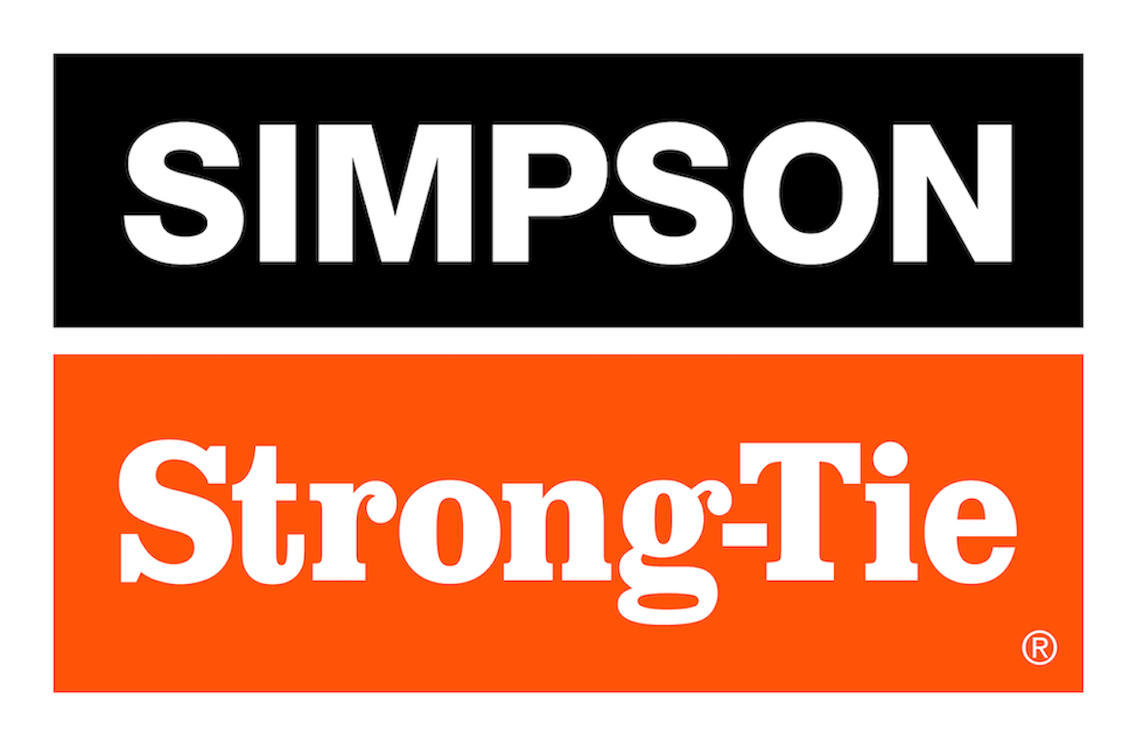

FOR IMMEDIATE RELEASE For More Information:
August 5, 2026 Maureen Inouye-Harrison
minouyeharri@strongtie.com

New Simpson Strong-Tie High-Strength Steel Shearwall:
Stronger Shearwall. Simpler Installation.
Pleasanton, Calif. — Simpson Strong-Tie, the leader in engineered structural connectors and building solutions, introduces the Strong-Wall® high-strength steel shearwall (SSWH™). Designed to handle some of the highest load capacities of any prefabricated shearwall on the market, the SSWH also features a slimmer profile that frees up valuable space for greater design flexibility.

The prefabricated steel panel helps structures resist lateral forces in seismic and high-wind regions. It’s ideal for use alongside window and garage door openings in single-family and multifamily residential buildings with limited wall space, as well as for standard, portal, raised-floor and stacked applications using wood or steel beams.

“The SSWH provides exceptional strength while maximizing usable wall space,” said Damon Ho, senior product manager for Simpson Strong-Tie. “Like our popular WSWH™ high-strength wood shearwall, the code-listed SSWH utilizes a universal anchorage template and bolts that simplify and speed up installation while reducing the potential for field errors.”

The SSWH has a narrower profile than site-built shearwalls, requiring fewer shearwalls per project.

The Strong-Wall® high-strength steel shearwall is available in 12", 15", 18", 21" and 24" panel widths for 7'–13' heights.

For more information, visit www.strongtie.com.

About Simpson Strong-Tie Company Inc.
Simpson Strong-Tie is the world leader in structural solutions — products and technology that help people design and build safer, stronger homes, buildings, and communities. As a pioneer in the building industry, we have an unmatched passion for problem solving through skillful engineering and thoughtful innovation. Our structural systems research and rigorous testing enable us to design code-listed, value-engineered solutions for a multitude of applications in wood, steel, and concrete structures. Our dedication to pursuing ever-better construction products and technology and to surrounding our customers with exceptional service and support has been core to our mission since 1956. For more information, visit strongtie.com and follow us on Facebook, X, YouTube and LinkedIn.

###

