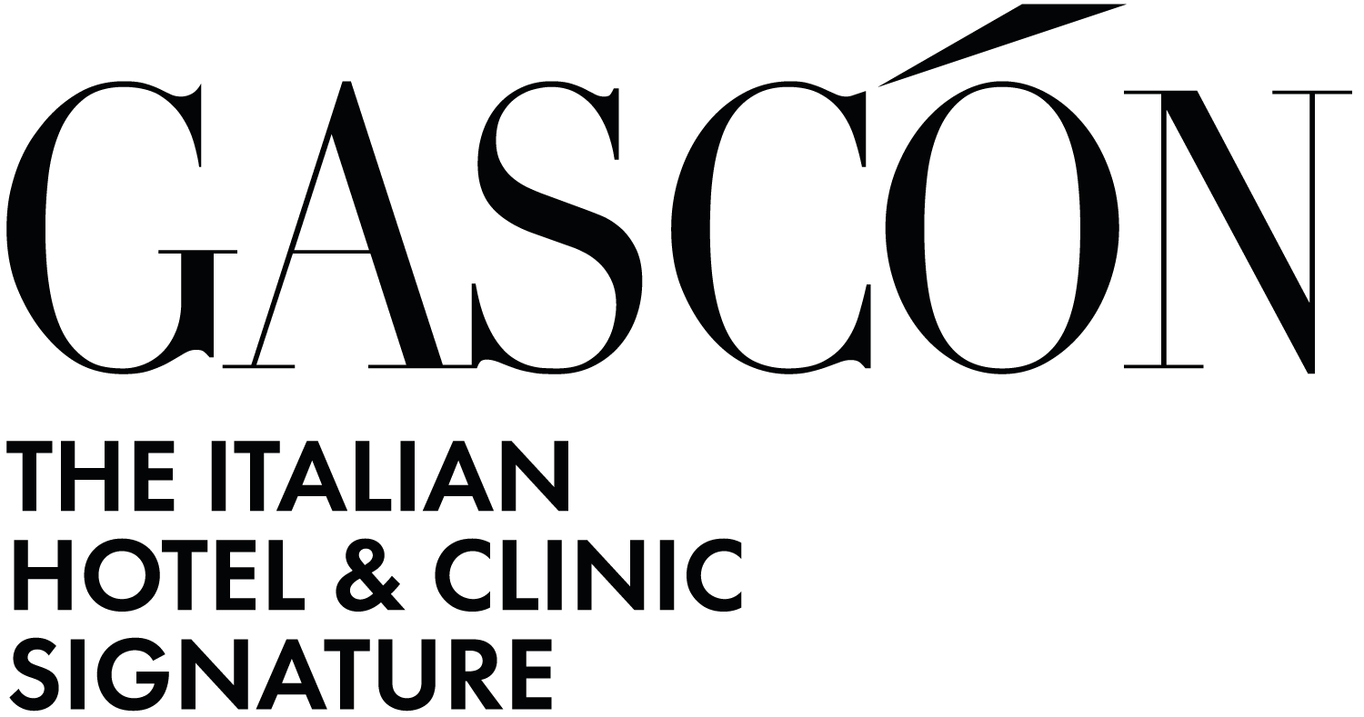

Habitat Lago Maggiore: Studio Gascón designs a dialogue between architecture, landscape, and wellness

In Piazzogna, on the shores of Lake Maggiore, a new model of dispersed hospitality reimagines living as a sensory experience, where light, materiality, and nature become fundamental design tools.

Piazzogna, June 30, 2026 — Studio Gascón presents Habitat Lago Maggiore, a dispersed hotel project immersed in the light and landscape of Lake Maggiore. Delivered and completed across 600 sqm, the project was conceived from the desire to create an intimate relationship between architecture, nature, and well-being, giving shape to a new approach to high-end hospitality living.

Located in Piazzogna, Switzerland, Habitat Lago Maggiore treats the landscape not as a mere backdrop, but as an active component of the design. Light, water, materiality, and silence become the foundational elements of the architectural experience, contributing to the creation of spaces designed to welcome, regenerate, and reconnect guests with their natural surroundings.

The concept is rooted in a clear principle: transforming living into a sensory experience. Every space has been conceived to integrate seamlessly with nature, gradually dissolving the boundaries between indoors and outdoors. Living areas, suites, and wellness spaces engage in a continuous dialogue with the landscape through generous openings, lake views, tactile materials, and a natural palette capable of conveying calm, continuity, and perceptual depth.

The interior design follows the principles of silent luxury: a discreet, understated elegance that is both refined and welcoming, grounded in authentic materials, visual balance, and a rich tactile experience. Local stone, light wood finishes, and natural surfaces create a measured atmosphere in which every detail contributes to an immediate and effortless sense of well-being.

At Habitat Lago Maggiore, technical elements recede quietly into the background, allowing the essence of the place to emerge. Functional components are seamlessly integrated so that the guest experience remains fluid, natural, and free from visual distractions. It is an architecture that does not seek to dominate the landscape, but rather to listen to it and reinterpret it as a living, inhabitable space. For Studio Gascón, Habitat embodies a manifesto of its design philosophy: bringing together aesthetics, functionality, sustainability, and economic value in a tangible and balanced way. Every decision stems from a dialogue between technical efficiency and formal research, between artistic sensitivity and operational requirements. It is an approach the studio defines as sensitive architecture, where emotion meets logic and beauty becomes part of a broader strategic vision.
The project included integrated architectural development, interior design, material selection, natural and artificial lighting design, and the artistic supervision of bespoke ArchTailor® furnishings. A comprehensive process conceived to ensure consistency between concept, spatial quality, functionality, and the unique identity of the place.

“Every project is born from the balance between technical efficiency, aesthetics, sustainability, and economic value. It is a design methodology dedicated to exceptional hospitality environments and healthcare facilities”, says Gabriele Gascón, founder of Studio Gascón.

Habitat Lago Maggiore is designed for those who envision the future of living as a fluid experience, where care, beauty, and nature merge into a single dimension. More than a building, it is a human-centered ecosystem capable of restoring and regenerating those who inhabit it, transforming a stay into a moment of reflection, tranquility, and reconnection.

With this project, Studio Gascón reaffirms its ability to interpret contemporary hospitality through bespoke interventions that generate not only aesthetic value, but also experiential and strategic impact. In a market increasingly focused on perceived quality, well-being, and a meaningful relationship with the surrounding territory, Habitat Lago Maggiore proposes a vision of luxury that is essential, profound, and naturally welcoming.

Project Details
Project: Habitat Lago Maggiore
Category: Hotel sparso
Location: Piazzogna, Svizzera
Area: 600 mq
Year: 2023/2025
Status: Completed
Scope: Integrated architectural design, interior design, material selection, natural and artificial lighting design, artistic direction, and bespoke ArchTailor® furnishings®

GASCÓN GROUP SA - ARCHITECTURE STUDIO
Main headquarters:
Via Carlo Frasca, 3 – Lugano, Svizzera
+41 (0) 91 910 97 50
info@gascon.ch
www.gascon.ch

Montreux headquarters:
Avenue des Alpes, 72 – Montreux, Svizzera
+41 (0) 21 961 10 66
info@gascon.ch
www.gascon.ch

Milano headquarters:
Corso Venezia, 23 – Milano, Italia
+39 02 8128 30 84
info@gascon.ch
www.gascon.ch

For press inquiries and personalized interviews:

OGS PR & COMMUNICATION
Via Koristka 3, Milano - Italia
+39 023450610
info@ogscommunication.com
www.ogscommunication.com
press.ogscommunication.com

