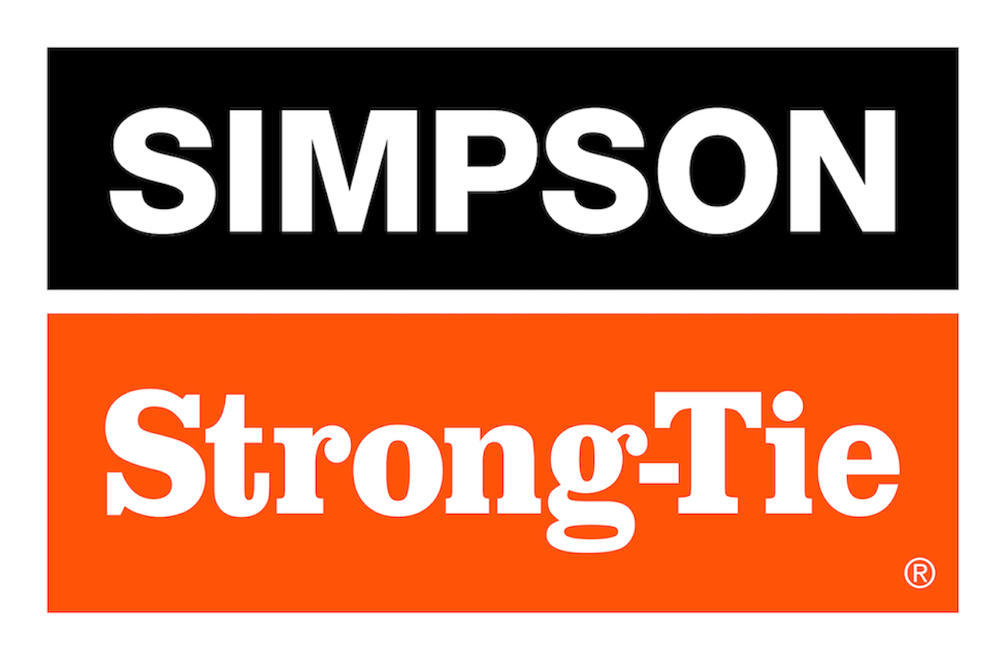

FOR IMMEDIATE RELEASE For More Information:
June 24, 2026 Jesse Russell
jrussell@strongtie.com
925-557-5324

New PFCB and PFC Post Frame Column Base Brackets and Angles Improve Installation Speed, Eliminate Through-Bolting

Pleasanton, Calif. — Simpson Strong-Tie, the leader in engineered structural connectors and building solutions, is expanding its post frame construction offerings with the PFCB and PFC post frame connector brackets and angles. These dry-set, shear-resisting post frame connector brackets require no through-bolting; instead, the connectors come with Simpson Strong-Tie Strong-Drive® SDS Connector screws for a better, more intuitive installation experience.

Featuring heavy-duty steel construction, large corner embossments/stiffeners and value-engineered anchorage tables, these connectors provide high-performance, tested and code-listed uplift and shear loads. They have a G90 galvanized coating for long-lasting corrosion protection.

“Offering a robust alternative to embedded and wet-set solutions, our new PFC and PFCB connectors are ideal for post frame construction where installation speed, corrosion resistance and structural reliability are critical,” said Randy Daudet, group product manager for Simpson Strong-Tie. “They deliver a reliable, corrosion-resistant, dry-set solution that simplifies post frame foundations while meeting modern structural demands.”

PFC and PFCB connectors come in a wide range of sizes for use with glulam, nail-lam, planed nail-lam and solid sawn posts. They feature built-in, hand-removable washers to help prevent loss or fumbling on the jobsite.

For more information, visit www.strongtie.com.

About Simpson Strong-Tie Company Inc.
Simpson Strong-Tie is the world leader in structural solutions — products and technology that help people design and build safer, stronger homes, buildings, and communities. As a pioneer in the building industry, we have an unmatched passion for problem solving through skillful engineering and thoughtful innovation. Our structural systems research and rigorous testing enable us to design code-listed, value-engineered solutions for a multitude of applications in wood, steel, and concrete structures. Our dedication to pursuing ever-better construction products and technology and to surrounding our customers with exceptional service and support has been core to our mission since 1956. For more information, visit strongtie.com and follow us on Facebook, Twitter, YouTube and LinkedIn.

###

