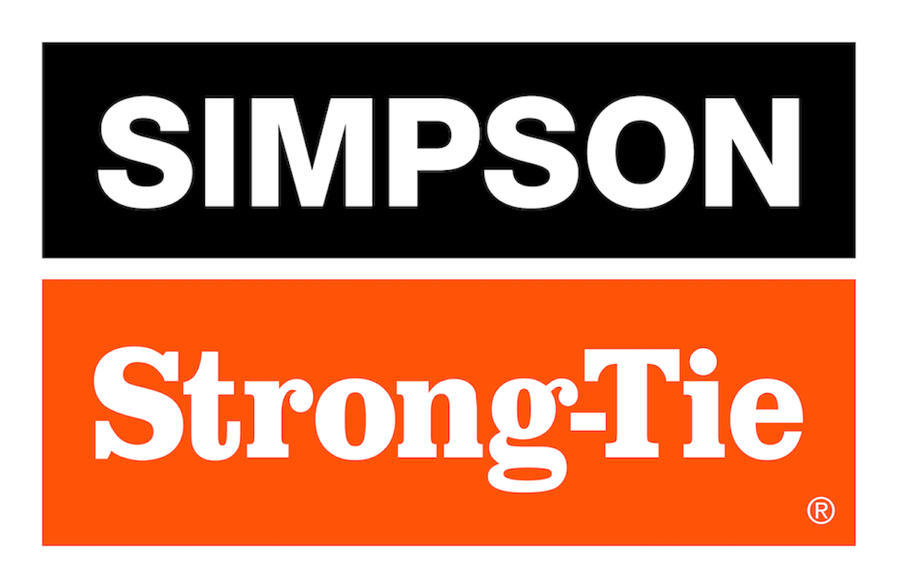

FOR IMMEDIATE RELEASE For More Information:
June 10, 2026 Jesse Russell
jrussell@strongtie.com
925-557-5324

Simpson Strong-Tie Adds More Options to Outdoor Accents® Essentials Collection of Outdoor Living Hardware

Pleasanton, Calif. — Simpson Strong-Tie, the leader in engineered structural connectors and building solutions, is further expanding its Outdoor Accents® Essentials collection of black powder-coated hardware with new post bases, joist hangers, screws and a deck tension tie. Load-rated, easy to install and readily available, Outdoor Accents Essentials hardware provides a complete system of structural connections while ensuring a clean, architectural appearance for custom decks, fences, pergolas and other outdoor structures.

The connectors are made of ZMAX®-galvanized steel for superior corrosion resistance and feature a stylish black powder-coat finish for added beauty. Color-matched screws ensure a seamless look.

The new products comprise:
- ABA44PC/ABA66PC adjustable post bases: These post bases secure 4x and 6x wood posts to existing concrete. They feature a built-in 1" standoff, which meets code requirements and helps prevent end-post rot, and their slotted base allows adjustment for precise positioning.
- DTT1PC Deck Tension Tie: Ideal for new construction or retrofits, this tension tie provides a code-compliant deck-to-house attachment without requiring access to interior floor joists. It can be used on the narrow or wide face of a single 2x member.
- LUS26PC/LUS28PC/LUS210PC light joist hangers: The new joist hangers quickly attach joists to beams or ledgers. Double-shear fastening provides for higher strength with fewer fasteners.
- SD9212DBB Outdoor Accents Connector screw: Like other connector screws in the Outdoor Accents Essentials lineup, the SD9212DBB #9 x 2 1/2" screw drives easily without predrilling and has a sharp point for fast starts. The screw’s black double-barrier coating complements the hardware’s premium look.

Other products in the collection include concealed flange hangers, post caps, hurricane ties, reinforcing angles and stringer connectors. Essentials hardware can be used in tandem with the Outdoor Accents Mission Collection®, Avant Collection™ or Sage System™ to create just about any outdoor structure.

To learn more, visit www.strongtie.com.

About Simpson Strong-Tie Company Inc.
Simpson Strong-Tie is the world leader in structural solutions — products and technology that help people design and build safer, stronger homes, buildings, and communities. As a pioneer in the building industry, we have an unmatched passion for problem solving through skillful engineering and thoughtful innovation. Our structural systems research and rigorous testing enable us to design code-listed, value-engineered solutions for a multitude of applications in wood, steel, and concrete structures. Our dedication to pursuing ever-better construction products and technology and to surrounding our customers with exceptional service and support has been core to our mission since 1956. For more information, visit strongtie.com and follow us on Facebook, Twitter, YouTube and LinkedIn.

###

