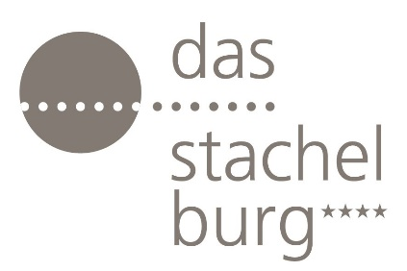

Hotel das stachelburg – Spa & Wellness

With the arrival of summer and its long, warm, sunny days, the desire for a refreshing holiday grows stronger, a place where the pleasant climate allows for exploration, adventure, and above all, relaxation. Mountain holidays are becoming increasingly popular, among Alpine peaks, fresh air, and unspoiled nature. Long walks through breathtaking landscapes, outdoor activities alternating with moments of wellness and relaxation. This is where Hotel das stachelburg comes in: an elegant 4-star hotel located in Parcines, just a few kilometers from Merano, in the heart of Südtirol. The property is an exclusive retreat for those seeking nature, fine gastronomy, and above all, well-being.

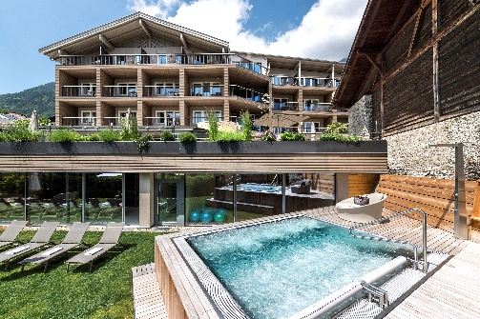

RELAX AND WELLNESS
Well-being lies at the heart of the Hotel das stachelburg experience. The SPA and relax areas, harmoniously integrated into the surrounding nature, create an atmosphere of balance and tranquility. The heated indoor pool, with direct access to the garden and sunbathing lawn, is complemented by an outdoor whirlpool, a panoramic Finnish sauna, a bio-sauna, and a steam bath. Relaxation rooms and spaces dedicated to individual treatments complete the experience, while massages and rituals with essential oils help regenerate both body and mind. Between pools, saunas, and moments of silence, every guest can find their own way to unwind and recharge.

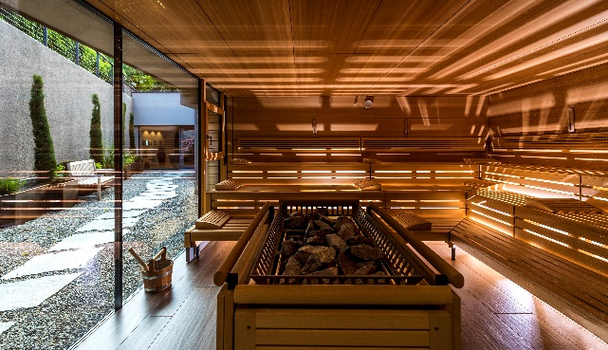

TREATMENTS & MASSAGES
At Hotel Das Stachelburg in Partschins, wellness is expressed through a selection of treatments designed to regenerate body and mind in harmony with the natural surroundings of Südtirol. Among the spa’s highlights are the sports massage for legs and back, ideal for relieving muscle tension, supporting recovery after outdoor activities, and stimulating microcirculation; and reflexology, a technique that uses targeted pressure on the feet to help restore balance to the body and recover vital energy.
For those seeking a more intensive experience, the detox treatment with alkaline peeling combines massage, cupping therapy, and an alkaline salt scrub to support body purification and restore the skin’s natural radiance. The wellness offering is completed by the traditional Südtirol hay bath, a ritual inspired by ancient Alpine practices that harnesses the beneficial properties of mountain herbs to relax, detoxify, and provide a deep sense of lightness and well-being.

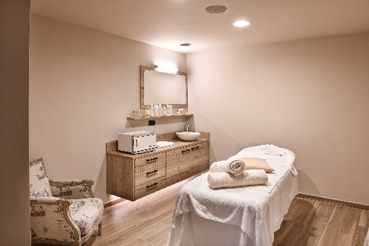

ACTIVITIES
For those who wish to stay active, hotel das stachelburg offers weekly yoga and fitness sessions that help harmonize body and mind. The yoga program ranges from gentle Hatha Yoga, ideal for beginners, to dynamic and rhythmic Vinyasa Yoga for those looking for a more intense workout during practice.

Contacts
Hotel das stachelburg
Via Cascata 7, I-39020 Parcines (BZ) - Alto Adige
www.hotel-stachelburg.com

For information and press inquiries:

OGS SRL PUBLIC RELATIONS & COMMUNICATION
Via Koristka 3, 20154 Milano (Italy)
Ph. +39 023450610
www.ogscommunication.com - press.ogscommunication.com
info@ogscommunication.com

