

Biuro prasowe better. gaming agency
bettergamingagency.prowly.com

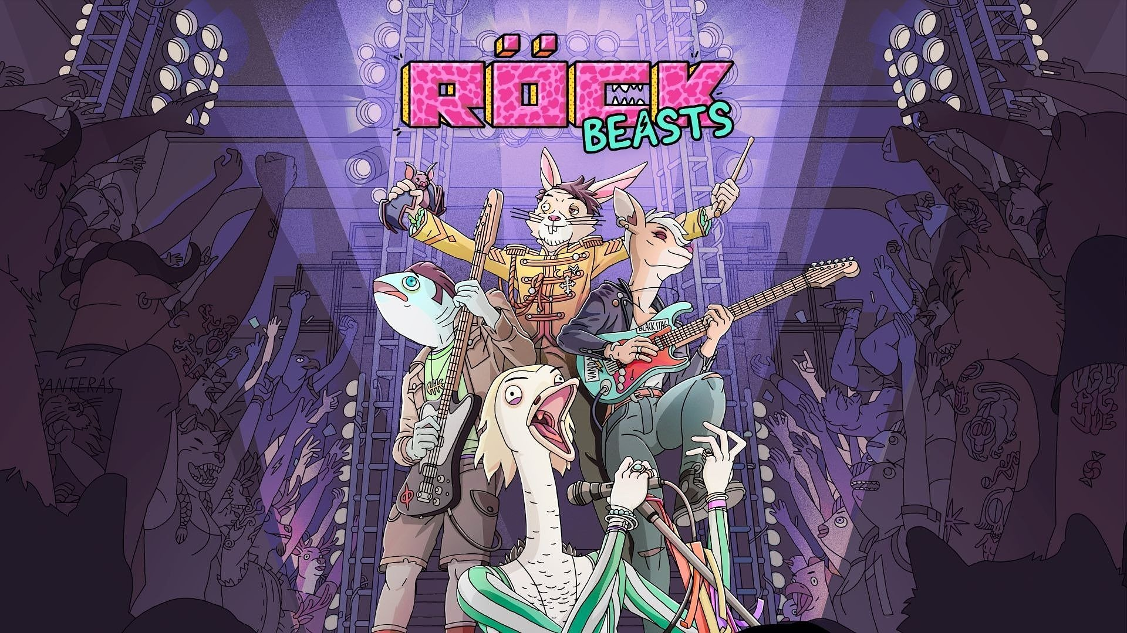

ROCKBEASTS – an ambitious RPG about managing a rock band – has been nominated at for the Tribeca Festival

Selected by the festival organizers as one of the 12 most creative works worldwide, ROCKBEASTS is a rock ’n’ roll RPG that stands out with its striking visuals, original soundtrack, and unique mix of gameplay & narrative.

The creators from an independent studio LICHTHUND are pleased to announce that ROCKBEASTS – a management-RPG in which players take care of a rock ’n’ roll band – has received a prestigious nomination at one of the most important events in the film and entertainment industry – the Tribeca Festival, held annually in New York City. ROCKBEASTS will be presented to festival guests visiting Pier 57 in Manhattan from June 10–14. The game’s release on PC, PlayStation 5, Xbox Series X|S, and Nintendo Switch is planned for 2026.

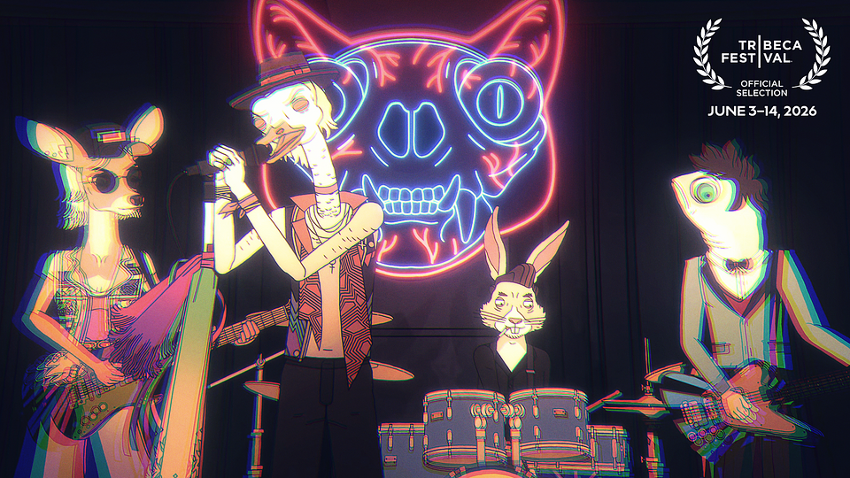

The Tribeca Festival is an event dedicated to supporting innovative approaches to storytelling across film, television, music, podcasts, and video games. Previous editions of the festival have featured indie hits such as Blue Prince, Dispatch, Cairn, and Neva. For years, the festival has served as an important platform for creators who aim to push the boundaries of traditional narrative forms and reach new audiences.

This is a huge honour for us and it strengthens our belief that we’re on the right path with ROCKBEASTS, staying true to the vision that has guided us from the very beginning. We’re incredibly excited that the organisers of such a prestigious event as the Tribeca Festival have recognised the artistic direction of our game. It’s a great reminder that there is still plenty of space in the market for ambitious and original independent games - said Rafał Zaręba, co-CEO & executive producer.

ROCKBEASTS is a management-RPG in which the story is written by the acclaimed Polish writer and bestselling author Jakub Szamałek, known for titles such as The Witcher 3 and Cyberpunk 2077. The gameplay focuses on managing a rock band, with the player being responsible for every aspect of the band’s operations – from organising rehearsals and concerts, to managing equipment and budget, negotiating with industry heavyweights, and resolving conflicts between musicians.

ROCKBEASTS - watch 12 minutes of developer-narrated gameplay

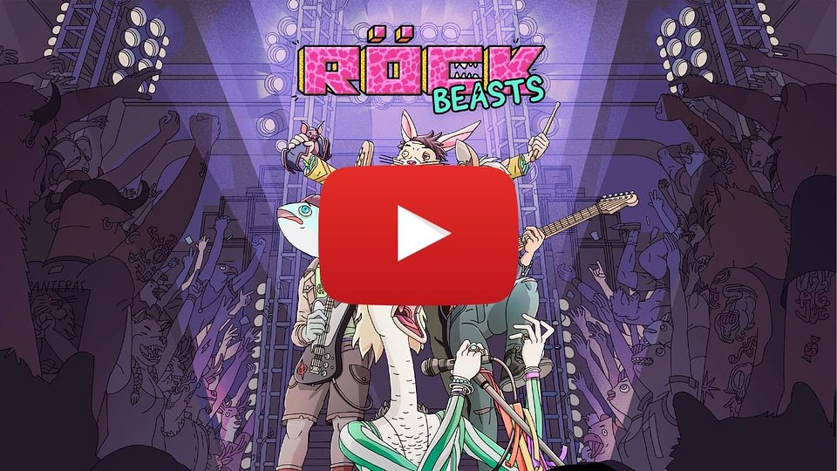
https://www.youtube.com/watch?v=ezK1PBenpzM&t

The game takes place in an alternative version of 1990s America, inhabited by colourful anthropomorphic characters. In their world, ambition and dreams clash every day with the brutal realities of the music industry. Achieving success requires not only talent, but also wit and thick skin, which help players withstand both the oversized egos of artists and the ruthlessness of industry sharks. Constant crises, limited resources, and rising expectations make the path to fame a demanding and unpredictable struggle for survival, where every decision affects relationships between characters, the band’s reputation, and how the narrative unfolds.

The visuals of ROCKBEASTS pay tribute to the MTV era and the iconic animated series of the 1990s, evoking associations with productions such as Daria, Beavis and Butt-Head, and BoJack Horseman. Hand-drawn characters, expressive animation, and a world full of personality make the game feel like a high-budget TV series about the music industry – one that players don’t just watch, but become part of.

Music is a key element of the experience. Seventeen original tracks were written and recorded specifically for the game, inspired by the sound of the 1990s and bands such as Pearl Jam, Alice in Chains, and Nirvana. The tracks are performed by the band vgbt.pl, which has also received recognition from one of the most influential music critics, The Needle Drop. Players will get a chance to play these songs during concerts in the game.

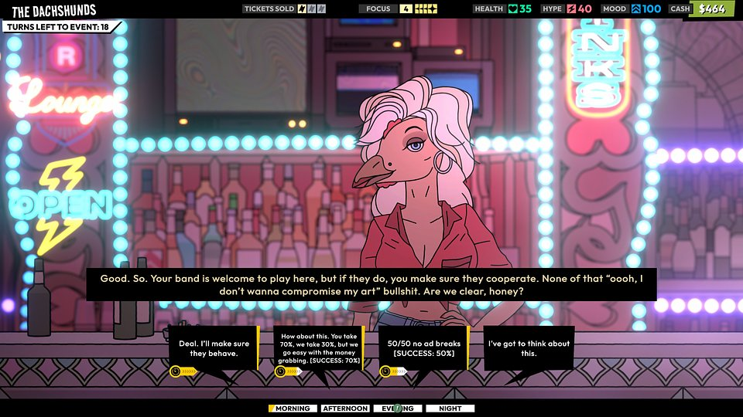

Key Features of ROCKBEASTS

🎸 Gameplay written in rock ’n’ roll - Manage a tight budget and the fragile egos of your musicians. Create setlists that will electrify the crowd. Repair instruments and then play them yourself on club stages. In this RPG, every triumph and every failure depends on your actions and decisions.

🎸 Build your legend - Negotiate hard with publishers, fight for your reputation, balance between artistic freedom and commercial success. Jaded clubgoers, slick marketers, and calculating businessmen – your future depends on how you deal with them.

🎸 Tame rock ’n’ roll - Decide how to spend your limited funds: food for the band, repairing damaged gear, or maybe booking a rehearsal room? Nothing comes easy. Keep your band grounded in everyday life – and give them wings on stage.

🎸 Rock the clubs and stages - Show what you’ve got. Strong setlists will highlight your talent, and the right equipment will amplify your sound. Only smart promotion will make clubs burst at the seams. Success tastes like money. Failure brings drama and conflict. Will you seize the moment – or waste it?

🎸 Back to the ’90s - Immerse yourself in a world where capitalism marches to the rhythm of MTV. ROCKBEASTS is a love letter to the era and aesthetics of the best independent animated series and films for adults. Legendary clubs, bars, shops, and radio stations are more than nostalgia – they’re a world overflowing with grunge. The original soundtrack will set the rhythm of your journey and may stay with you long after the game ends.

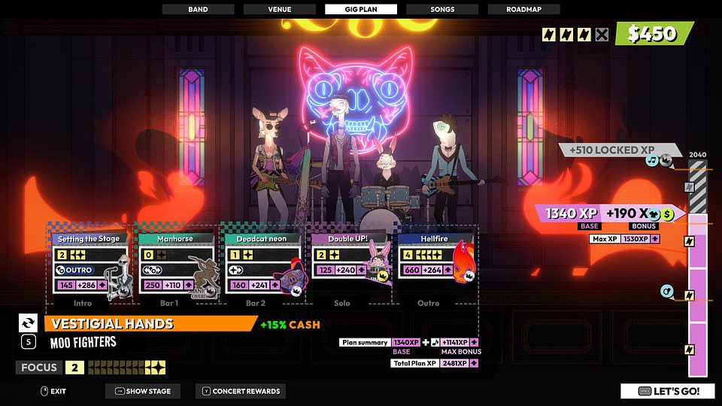

ROCKBEASTS is being developed for PC, PlayStation 5, Xbox Series X|S, and Nintendo Switch, and its release is scheduled for 2026. Everybody interested in this rock-infused experience can already add the game to their wishlist. To stay up to date with all the latest news about ROCKBEASTS, we encourage you to follow the game’s official X profile and join the community on Discord.

Press kit available HERE.

About Lichthund:

Founded in 2015 as a two-man effort, Lichthund quickly became an award-winning studio focused on unorthodox game ideas.Today we're a group of industry veterans focusing their creative might on building fresh and exciting experiences for a worldwide audience. Tight design, fresh art direction, and the courage to try new things are the core values of our team.

