
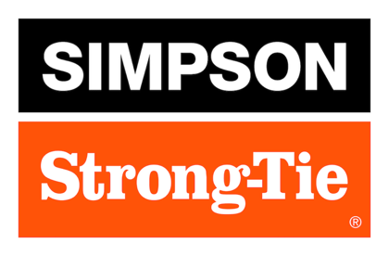

FOR IMMEDIATE RELEASE For More Information:
May 5, 2026 Jesse Russell
jrussell@strongtie.com
925-557-5324

Tools and Resources for Deck Safety Month

Pleasanton, Calif. — As outdoor living continues to top homeowners’ and homebuyers’ wish lists, deck safety practices are more critical than ever. Unfortunately, deck accidents are still far too common: According to the Consumer Product Safety Commission as reported in Consumer Reports, approximately 8,700 people were injured and two people died between 2020 and 2024 due to collapses or floors giving way on decks, porches and balconies.

Fortunately, most deck incidents are preventable if both contractors and consumers practice due diligence. For existing decks, homeowners should inspect deck surfaces and structures regularly for signs of deterioration or failure, including rotting wood, corroded fasteners and loose railings. For new decks, following code requirements and best practices is essential.

Education and support are available across the industry. Here are a few resources to help guide your installation and maintenance:

- NADRA Safety Tools: Simpson Strong-Tie is proud to be a Deck Safety Ambassador for the North American Deck and Railing Association (NADRA). The organization offers numerous resources on its Deck Safety Month portal, including a Deck Evaluation/Inspection Class for pro contractors and a 10-Point Deck Safety Checklist for consumers.

- Simpson Strong-Tie Deck Center: Our Deck Center web portal offers everything you need to build strong, safe, beautiful decks, from installation guides to our Deck Planner Software™ and “Build a Stronger Deck” video series.

- Deck Connection Fastening Guide: Download our Deck Connection and Fastening Guide for instructions on how to recognize defects and deficiencies in existing decks, plus guidance for building strong, safe, long-lasting deck structures. It also goes detail by detail through a typical deck and identifies relevant building code requirements and connection options.

Deck Safety Month is the perfect opportunity for contractors not only to verify their deck construction practices and ensure that their code knowledge is up to date, but also to educate clients on the importance of inspections and regular maintenance. Deck education is the first step toward long-term safety and enjoyment.

For more information, visit www.strongtie.com.

About Simpson Strong-Tie Company Inc.
Simpson Strong-Tie is the world leader in structural solutions — products and technology that help people design and build safer, stronger homes, buildings, and communities. As a pioneer in the building industry, we have an unmatched passion for problem solving through skillful engineering and thoughtful innovation. Our structural systems research and rigorous testing enable us to design code-listed, value-engineered solutions for a multitude of applications in wood, steel, and concrete structures. Our dedication to pursuing ever-better construction products and technology and to surrounding our customers with exceptional service and support has been core to our mission since 1956. For more information, visit strongtie.com and follow us on Facebook, Twitter, YouTube and LinkedIn.

###

