PRESS RELEASE
Warsaw, 8 May 2026

New acoustic guidelines: in offices, people – not decibels – should come first, and from September changes will also apply
to residential buildings

The year 2026 marks a period of legal changes regarding acoustic standards in buildings. New standards for office buildings have recently come into force, and from September new regulations for residential buildings will also apply. What will change? Human comfort is set to become the top priority.
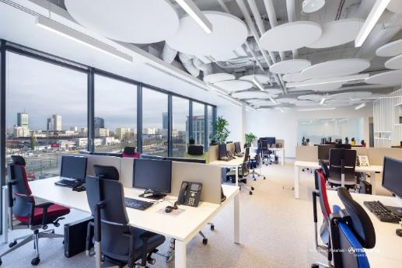
New office acoustic standards focus on well-being

Acoustics in offices is not a new topic in Poland. This applies not only to legal regulations, but also to the awareness of architects, building investors and companies leasing office space. However, the PN-ISO 22955 standard, which came into force in March 2026, changes a great deal in this area. It marks a departure from the traditional measurement of noise solely in decibels, as building regulations now focus on parameters that affect the well-being of interior users.

“Among the parameters to be measured are factors affecting concentration and speech sound levels. The new standard mainly concerns open-plan offices,” explains Patryk Urbaniak, Technical Advisor at Knauf Ceiling Solutions.

So, which indicators will now be taken into account? Sound level, meaning the traditional intensity measured in decibels, will still remain the main assessment parameter, as will reverberation time. However, speech decay and speech attenuation are also being introduced.
The PN-ISO 22955 standard defines six types of spaces, each assigned legally required technical parameters. These differ for call centres, shared workspaces such as conference rooms or lobbies, and other office interiors. The strictest requirements apply to areas where users are expected to work in concentration. This concerns not only noise and reverberation levels, but also the speech attenuation coefficient, i.e. DA,S dB. The regulations even include guidelines concerning noise generated by phone conversations.

“The ceiling is the most important sound-reflecting surface, which is why the standard recommends full ceiling coverage in open-plan offices using materials with the highest sound absorption coefficient αw 1.0. If the interior is designed with so-called ceiling islands, meaning smaller acoustic module surfaces in various shapes, the required coverage is at least 50–60% of the area above people’s heads using such acoustic solutions,” explains Patryk Urbaniak from Knauf Ceiling Solutions.
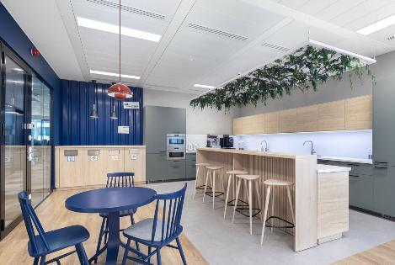
The new standard applies not only to open-plan zones, but also to other office areas, including canteens and employee dining spaces. On the left: the Muniak office in Warsaw (photo: Paweł Stelmach for Knauf Ceiling Solutions); on the right: the Hartwig office in the K2 office building in Gdynia (photo: Szymon Polanski for Knauf Ceiling Solutions).

The standard highlights not only the role of ceilings in creating user-friendly acoustics. Walls, which naturally reflect sound strongly, can also play a role. To reduce this effect, the installation of acoustic wall absorbers is recommended, especially near workstations adjacent to walls. Installation should take place at the ear height of seated people, i.e. approximately 1.2 m above the floor.
To carry out proper measurements, acoustic tests in existing offices should be conducted when at least 80% of workstations are occupied. The test itself must last a minimum of four hours.
This autumn: an end to noise problems also in residential buildings
From 20 September 2026, stricter acoustic regulations for apartments will also come into force in Poland. The new regulations, i.e. the technical conditions supplementing the PN-B 02151-3:2015-10 standard, will require developers to implement even more comfortable solutions for residential property owners: higher sound insulation for walls, floors and entrance doors.
The changes are intended to reduce noise in multi-family buildings, as well as in housing estates with terraced housing developments. Every building design will now have to include an acoustic analysis.
For doors, acoustic insulation will need to reach 37 dB to prevent sound from penetrating into stairwells. Floors between storeys will need to provide insulation at the level of 55 dB. New guidelines will also apply to window insulation and installation in order to prevent traffic noise from entering apartments.
All these parameters will not only have to be declared by developers in the design documentation, but also proven through measurements carried out in completed buildings.
Developers will also be required to include this data in the information prospectus forming part of the apartment sales process, as required under the current developer act. This is intended to protect apartment buyers, so that if a property turns out to be excessively noisy after moving in, they will have grounds to claim compensation or demand acoustic improvements.
As the representative of Knauf Ceiling Solutions notes, in the case of office acoustics there is generally no need to educate or encourage stakeholders about good acoustic design practices. However, the situation is much worse in residential buildings.

“Habits inherited from the extremely poor-quality housing construction of the communist era unfortunately still persist in Poland. We do not pay enough attention to the acoustic quality of apartments. The new technical requirements of the standard will help raise awareness that good acoustics positively affect both people’s mental and physical health,” says Patryk Urbaniak.

As he adds, acoustic ceilings and wall claddings are solutions not only for common areas in apartment buildings and residential blocks currently under construction, but also for existing buildings.

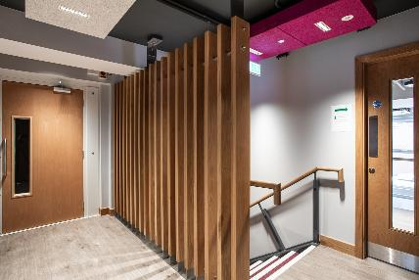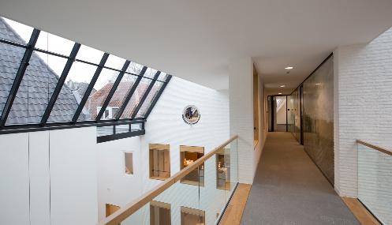
The new technical conditions for acoustic standards in multi-family buildings, coming into force from September 2026, focus on reducing noise. One possible solution is the installation of acoustic ceilings in existing circulation areas and stairwells. Pictured: a building in Belfast (left, photo: Elyse Kennedy for Knauf Ceiling Solutions, Heradesign panels); on the right: a smooth acoustic ceiling from the Eleganza line.

Heradesign wood wool ceiling and wall panels can acoustically and aesthetically enhance stairwells, entrances, corridors and lobbies in existing multi-family buildings. They effectively absorb noise and insulate sound, while also being environmentally friendly – they hold the Cradle to Cradle (C2C) certification, confirming that they are products aligned with the principles of the circular economy.

“This is just one of many available solutions. Both we and many other companies offer hundreds of solutions improving acoustics in residential buildings. Even partial installation of suspended ceilings absorbing reflected sound can significantly reduce the transmission of nuisance noise from stairwells and circulation areas into apartments,” says Patryk Urbaniak.

More information: https://knauf.com/pl-PL/p/produkty/sufity-i-absorbery-scienne-35568

Media contact:
Patrycja Rabińska, patrycja.rabinska@marielhaan.com, + 48 504 006 016

