

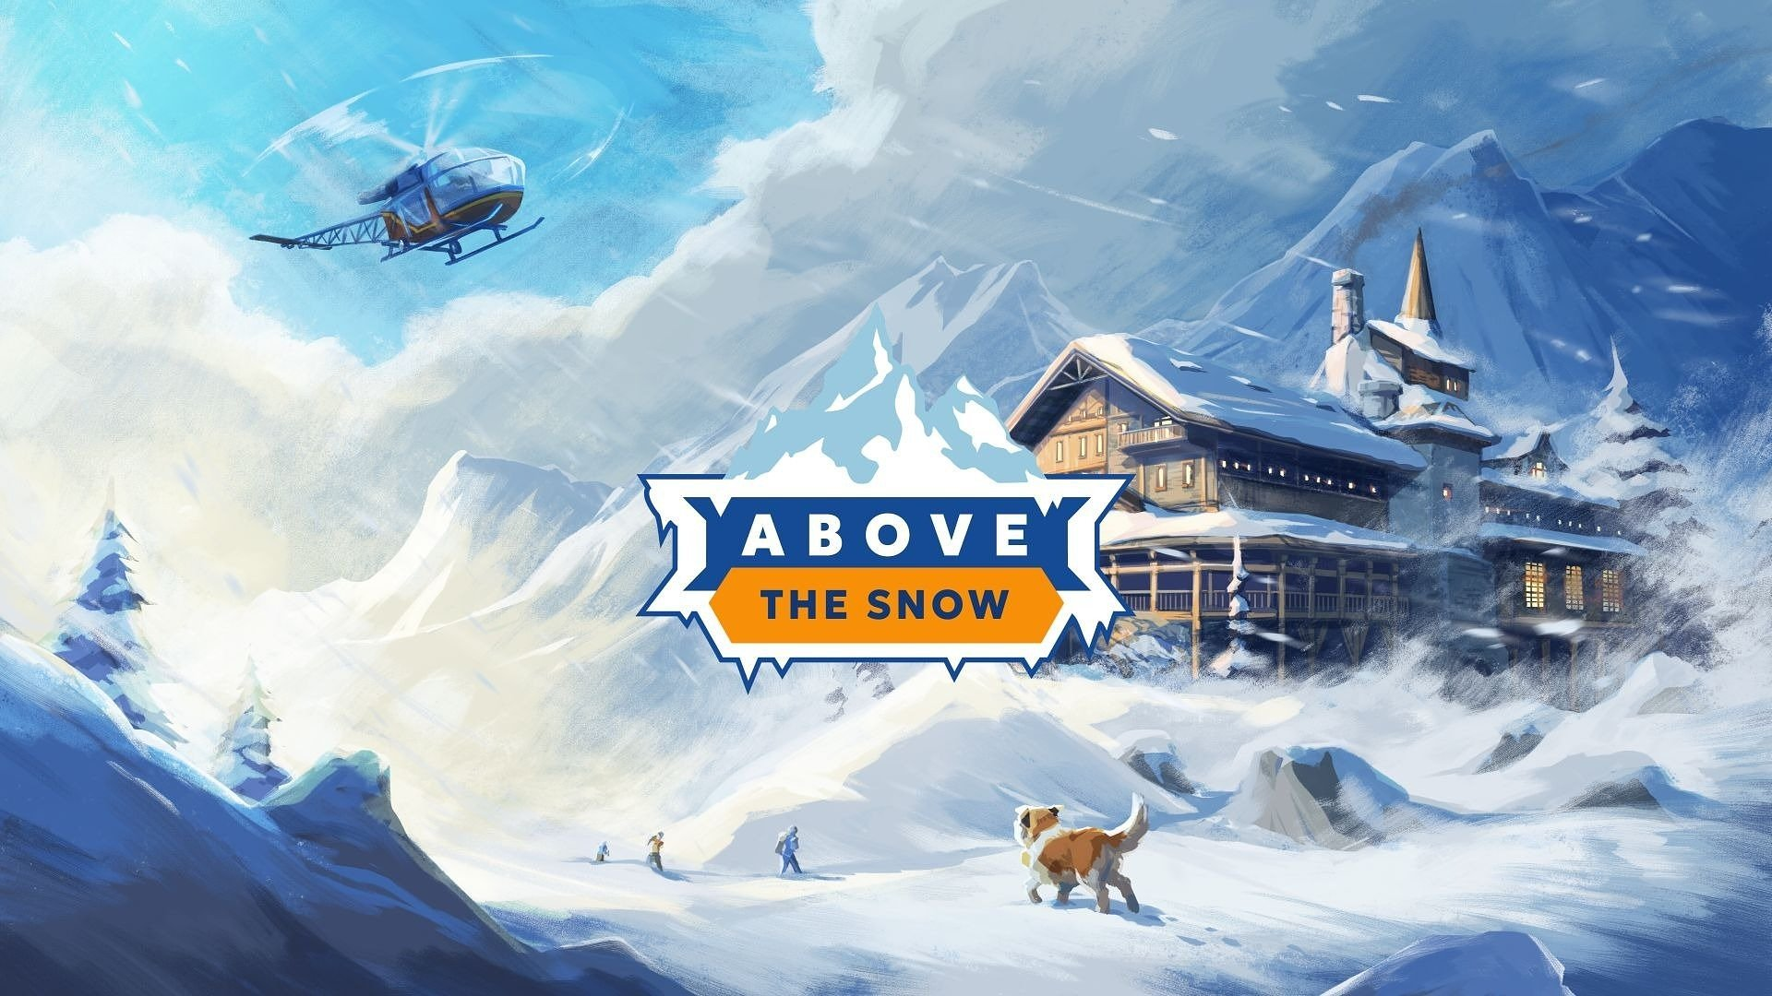

Roll up your sleeves and build the ultimate alpine lodge! Above the Snow is out now on Steam

Developers from an independent studio, Above the Desk, together with publisher Wandering Wizard, invite players on an adventure like no other. Above the Snow – a narrative-driven tycoon game about running a mountain shelter in the Alps – is available on Steam now. Its relaxing atmosphere, unique setting, and deeply immersive gameplay aim to steal players’ hearts. To celebrate the launch, the team has released a new trailer.

Above the Snow – watch the launch trailer

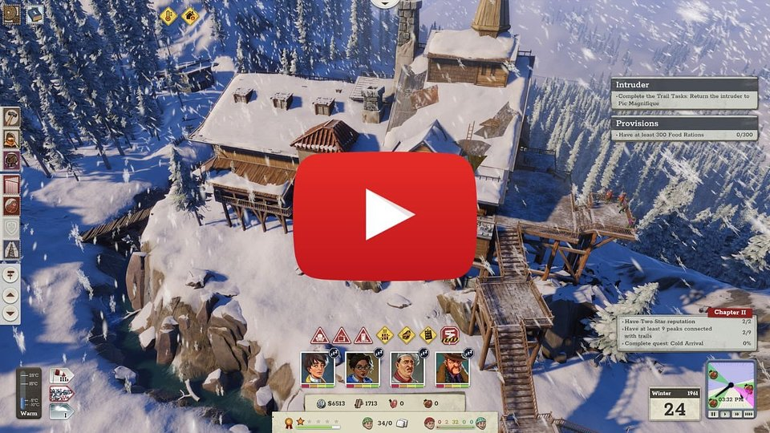

Above the Snow takes players back to the 1960s, dropping them into the snowy Alps where they can build a dream mountain resort. This may seem like a challenging task at first, but there is no need to be intimidated. The developers aimed to make Above the Snow a relaxing experience, driven by rewarding lodge management systems, breathtaking views, and the presence of charming characters. Among them are two legends of mountaineering: Marek Kamiński – the Polish mountaineer who was the first in the world to reach both poles without outside assistance – and Ed Viesturs – the American climber who has summited all 8,000-meter peaks without supplemental oxygen and completed the Crown of the Himalayas.

Our journey has reached its destination. The path to the release of Above the Snow was full of challenges and remained exciting until the very end. I hope this is not its final chapter. The entire team is now feeling the same sense of achievement as reaching a summit. We will proudly watch players build their own mountain shelters while immersing themselves in the atmosphere of the Alps. We are glad we were able to bring our love for the mountains to the screen, and we hope you will enjoy playing our game – says Michał Wasiak, head of the studio Above the Desk and developer of the game.

I would also like to thank the wonderful people and legends of mountaineering who helped us with the game’s development – Marek Kamiński and Ed Viesturs. Their presence in Above the Snow adds an extra layer of realism, much like equipment from well-known and recognizable brands such as Cortazu, Fjordfiesta, and Heywood-Wakefield – adds Wasiak.

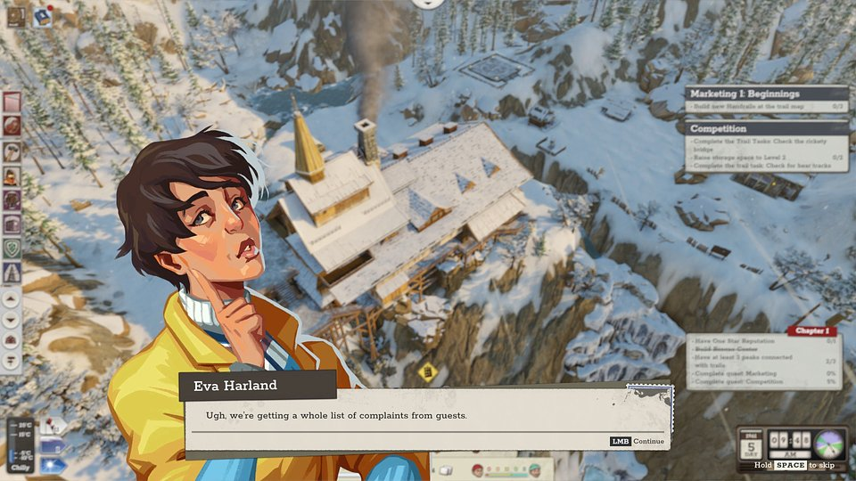

As an unexpected owner of a mountain lodge, the player is tasked with preparing the resort for arriving travelers – and this goes far beyond simply providing a warm place to sleep. Creating the right atmosphere is just as important, as is taking care of facilities and attractions that will encourage guests to return. The player is also responsible for managing the property’s finances – after all, every guest is a customer, and the income they generate is essential for maintaining and developing the business. Fresh supplies in the snow-covered Alps don’t appear out of nowhere, and sometimes even a helicopter is needed to deliver provisions.

Over time, the lodge can be expanded with additional buildings, gradually increasing its capabilities. But the experience goes far beyond simply decorating the resort’s warm interior. Players are also able to design their own hiking routes across the vast Alpine wilderness, tailoring each trail to guests’ skills and preferences. This includes placing campsites, avoiding dangerous sections, or guiding routes toward summits, ski slopes, landmarks, and other attractions.

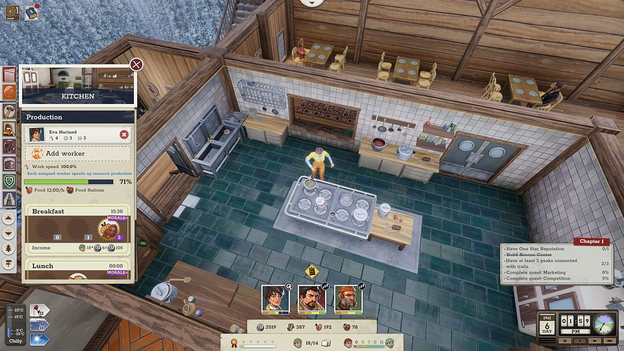

Above the Snow – key features:

⛰️ First footprint in the snow – Above the Snow is a narrative-driven tycoon game that lets you manage a mountain lodge. It’s a perfect fit for both strategy fans and lovers of mountain hiking.

⛰️ Postcard from the summit – imagine a mountain game without breathtaking scenery – impossible, right? Vast, impressive landscapes, combined with detailed graphics allow you to feel the power and beauty of the mountains.

⛰️ Create your second home – build, decorate, and manage. All to make your lodge renowned and attract climbers seeking both relaxation and adventure.

⛰️ Lead the way – create safe trails that lead climbers to the most beautiful vistas or the hardest-to-reach peaks.

⛰️Alps in the 60s – use gear and vehicles from that era to chart trails, run rescue missions, and transport supplies.

⛰️ Take it a deep breath – the developers at Above the Desk are creating a game that blends light economic challenges with a rich narrative layer. Their stories will be best enjoyed under a warm blanket, with a mug of hot chocolate.

Above the Snow is available on Steam now, and more details about the game can be found on its product page. To stay up to date with the latest news, be sure to follow the game’s profiles on Instagram or X and join the community server on Discord.

The full press kit is available HERE.

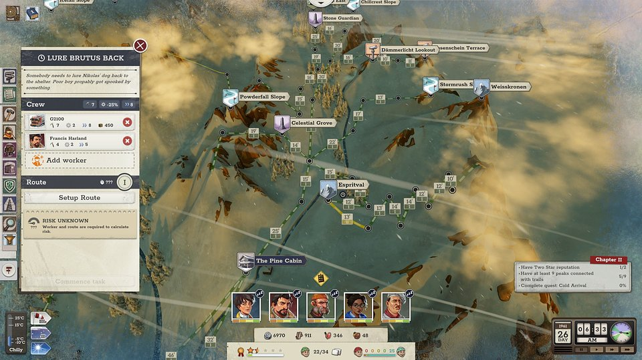

About Above the Desk:

Above the Desk is an independent game studio built by a small but passionate team founded by Michał Wasiak, an industry veteran, and a mix of seasoned industry veterans and bold new talent. We believe that this blend of perspectives, skills, and creative energy is our greatest strength. Our mission is to craft games that stand out with original ideas, engaging mechanics, and a sharp sense of humor. We don’t cut corners – we focus on originality, quality, and fresh takes on familiar formulas.

