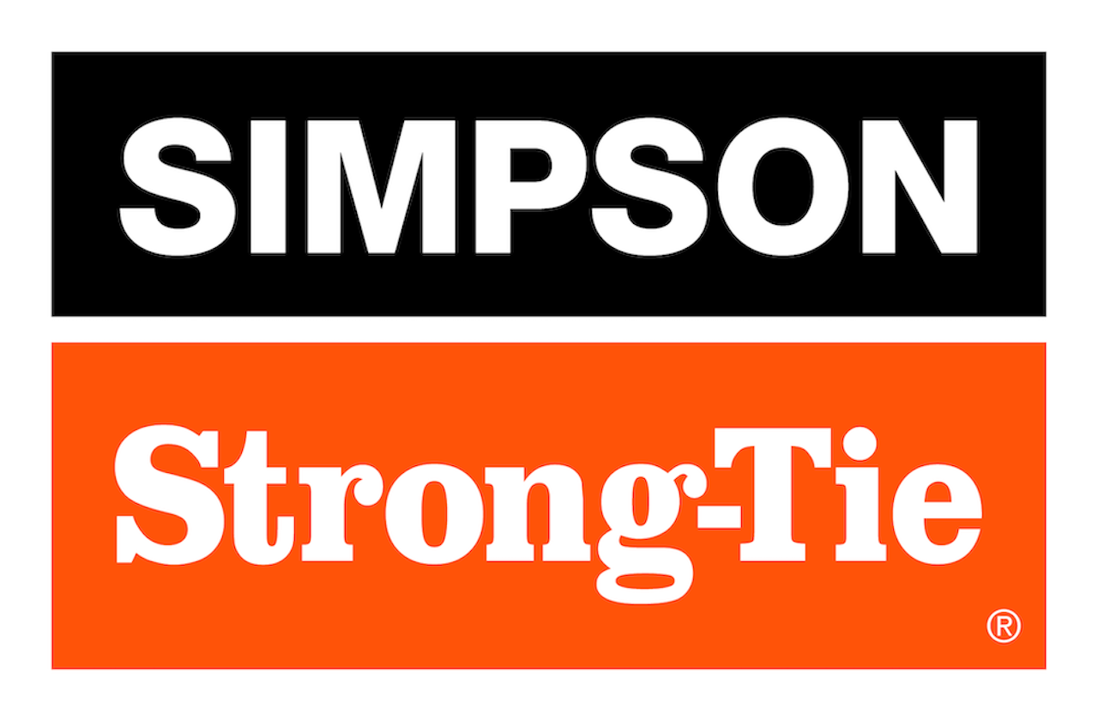

FOR IMMEDIATE RELEASE For More Information:
March 26, 2026 Jesse Russell
jrussell@strongtie.com
925-557-5324

Simpson Strong-Tie Expands Outdoor Accents® Essentials Collection of Easy-to-Install Hardware for Decks, Pergolas and More

Pleasanton, Calif. — Simpson Strong-Tie, the leader in engineered structural connectors and building solutions, is expanding its Outdoor Accents Essentials collection of decorative hardware with a range of new black powder-coated connectors and fasteners. Designed for easy installation, the connectors and fasteners allow pros and DIYers alike to build all sorts of outdoor structures, including decks, fences, patio covers and pergolas.

New products in the Essentials collection include joist hangers, stair stringer connectors, angles, post bases and caps, hurricane ties and other connectors made of ZMAX®-galvanized steel for superior corrosion resistance and now available with a stylish black powder-coat finish for added beauty. The new additions also include fasteners that have a double-barrier black coating for corrosion protection.

Essentials hardware can be used in tandem with the Outdoor Accents Mission Collection®, Avant Collection™ and Sage System™ to create just about any outdoor structure.

“Our Outdoor Accents hardware collections have become a favorite among pros and DIYers alike because they simplify deck and pergola construction by providing a complete system of structural connections — without sacrificing a clean, architectural appearance,” said Scott Park, director of product development for Connectors and Lateral Systems at Simpson Strong-Tie. “Expanding the Essentials collection adds more connection options, giving builders the ability to complete a broader range of structural connections while maintaining a coordinated Outdoor Accents look.”

The new Essentials offerings include:

AC4PC/AC6PC adjustable post cap
- Provides a secure connection between a beam and a post (installs in pairs)
- Ideal for new or retrofit applications where structural support is needed
- Accommodates either 4x or 6x nominal lumber

H1APC hurricane tie
- Connects nominal 2x trusses or rafters to walls or beams
- Helps resist wind and seismic forces
- U-shape design allows for faster installation compared to installing two single-sided ties

H2.5APC hurricane tie
- Single-sided hurricane tie connects truss, rafter or joist to the beam or wall for resisting lateral and uplift forces
- Attaches to one side of the lumber member, allowing for use with multiple lumber widths

L70PC/ L90PC L-shaped reinforcing angle
- Multipurpose utility connector
- Load-rated angles featuring a durable construction and versatile fastening options

LCE4PC light post cap for end condition
- Connects beam ends to posts (installs in pairs)
- Fits 4x and 6x lumber
- Suitable for new or retrofit construction
- Tested and approved for mitered end conditions

LSCPC adjustable stringer connector
- Concealed connection between stair stringer and header/rim board
- Eliminates costly framing
- Field slopeable to all common stair stringer pitches; suitable for solid or notched stringers
- Reversible for left- or right-hand installation

ML24PC/ML26PC medium angle
- Strong and versatile connector
- Staggered fastener holes reduce wood splitting
- Opposing hole patterns enables back-to-back installation

RPBPC retrofit post base
- Reinforces existing posts
- Fits any post size from double 2x4 or larger
- Strengthens new post-base connections for carports, patio covers, decks and other similar structures

TA9PC, TA10PC staircase angle
- Load-rated connector ties stair tread to stringer
- Eliminates the need for time-consuming stringer notching

Outdoor Accents connector screw and Outdoor Accents heavy-duty connector screw
- Both screws reduce installation time by driving easily without predrilling
- Black double-barrier coating offers a premium look while providing a medium level of corrosion resistance for many outdoor applications
- Two different head options: hex head and new wafer-head, which offers low-profile finishes
- Sharp point enables fast starts
- Designed specifically for installing Outdoor Accents Essentials connectors

To learn more, visit www.strongtie.com.

About Simpson Strong-Tie Company Inc.
Simpson Strong-Tie is the world leader in structural solutions — products and technology that help people design and build safer, stronger homes, buildings, and communities. As a pioneer in the building industry, we have an unmatched passion for problem solving through skillful engineering and thoughtful innovation. Our structural systems research and rigorous testing enable us to design code-listed, value-engineered solutions for a multitude of applications in wood, steel, and concrete structures. Our dedication to pursuing ever-better construction products and technology and to surrounding our customers with exceptional service and support has been core to our mission since 1956. For more information, visit strongtie.com and follow us on Facebook, Twitter, YouTube and LinkedIn.

###

