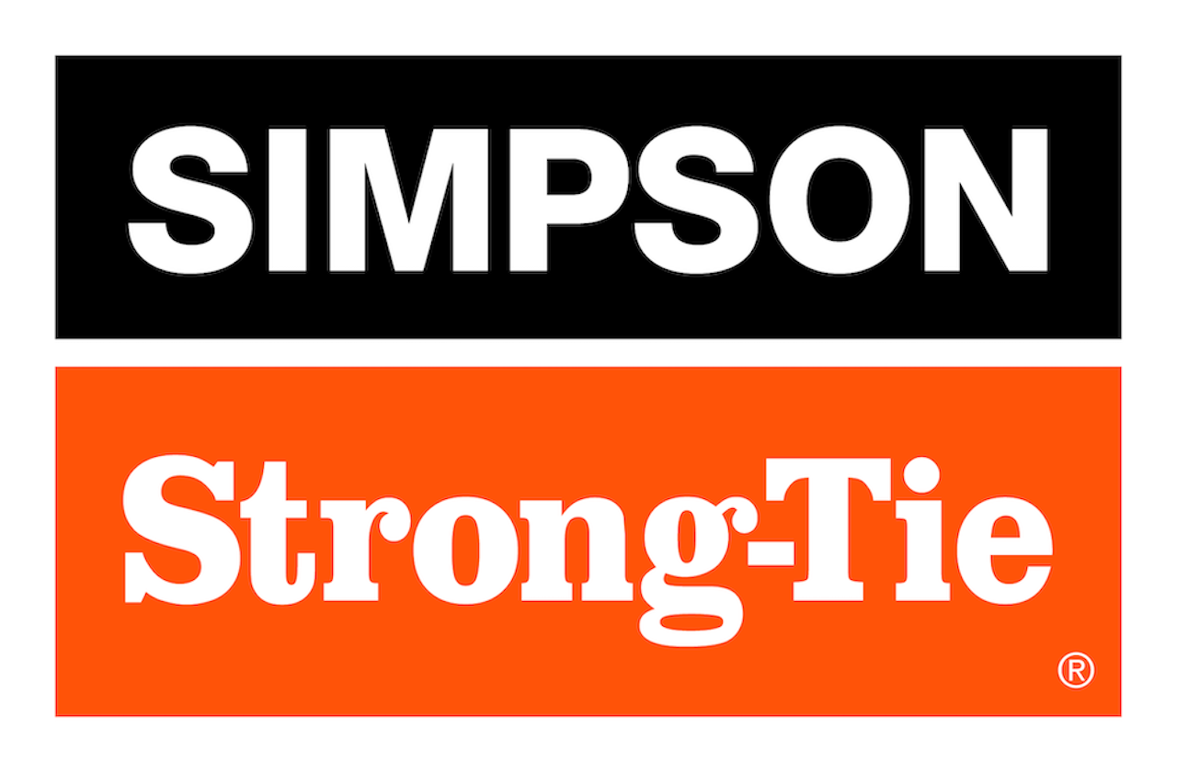

FOR IMMEDIATE RELEASE For More Information:
April 1, 2026 Jesse Russell
jrussell@strongtie.com
925-557-5324

Simpson Strong-Tie Introduces Timber-SET™ Epoxy Adhesive
for Glued-In Rods in Mass Timber Projects

Pleasanton, Calif. — Simpson Strong-Tie, the leader in engineered structural connectors and building solutions, introduces Timber-SET™ epoxy gel, the first ICC-ES evaluated epoxy adhesive for anchoring threaded rod in glulam beams and columns. Timber-SET provides reliable, concealed connections throughout a mass timber structure and can be used for steel-to-wood, column-to-column, column-to-foundation, beam-to-column and beam splice connections.

Timber-SET develops high bond strength to wood substrates and provides a stiff load-transfer medium critical for structural anchorage. Its gel viscosity supports effective encapsulation of threaded rods while minimizing voids and limits adhesive flowing out of the hole during horizontal installations.

In addition, the Timber-SET thixotropic formulation allows adhesive to flow under pressure, and its neutral gray color minimizes potential for staining exposed timber.

“Timber-SET offers good working time for installation and strong adhesion under dry wood conditions, making it well-suited for structural timber anchorage applications,” said Michael Weinert, senior product manager for Simpson Strong-Tie. “For a total glued-in rod solution, install Timber-SET with Simpson Strong-Tie threaded rods, centering and retaining caps, dispensing and cleaning tools, and Strong-Drive® structural screws.”

Timber-SET is approved for five rod diameter options: 1/2", 5/8", 3/4", 7/8" and 1". It comes in 32-ounce dual cartridges.

For more information, visit www.strongtie.com.

About Simpson Strong-Tie Company Inc.
Simpson Strong-Tie is the world leader in structural solutions — products and technology that help people design and build safer, stronger homes, buildings, and communities. As a pioneer in the building industry, we have an unmatched passion for problem solving through skillful engineering and thoughtful innovation. Our structural systems research and rigorous testing enable us to design code-listed, value-engineered solutions for a multitude of applications in wood, steel, and concrete structures. Our dedication to pursuing ever-better construction products and technology and to surrounding our customers with exceptional service and support has been core to our mission since 1956. For more information, visit strongtie.com and follow us on Facebook, Twitter, YouTube and LinkedIn.

###

