

Biuro prasowe better. gaming agency
bettergamingagency.prowly.com

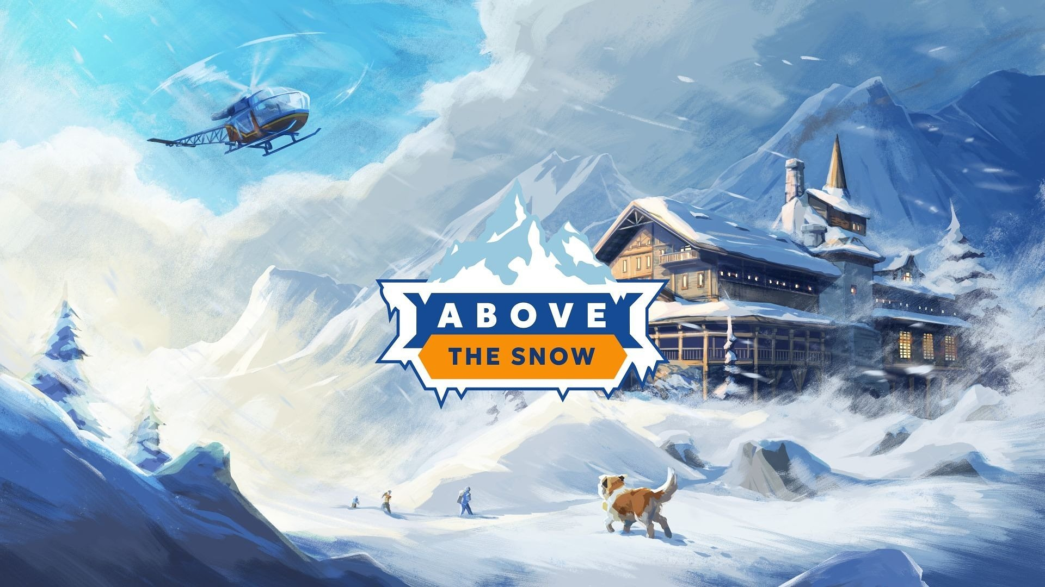

Ready for an expedition to the heart of the Alps? Above the Snow launches on April 23

The path requires some effort, but what awaits you is a warm fireplace, hot chocolate, and a fluffy St. Bernard named Brutus - everything surrounded by breathtaking scenery.

Developers from an independent studio, Above the Desk, bring their passion for the mountains to life in a game that captures both the charm of the Alps and the thrill of mountain trekking, along with the challenges of running a mountain lodge in extreme conditions. Above the Snow will launch on Steam on April 23. To celebrate the release date announcement, the creators have released a new trailer along with a special video featuring mountaineering legend Ed Viesturs.

The best views are from the top of the mountain – check out the latest trailer ahead of Above the Snow’s launch

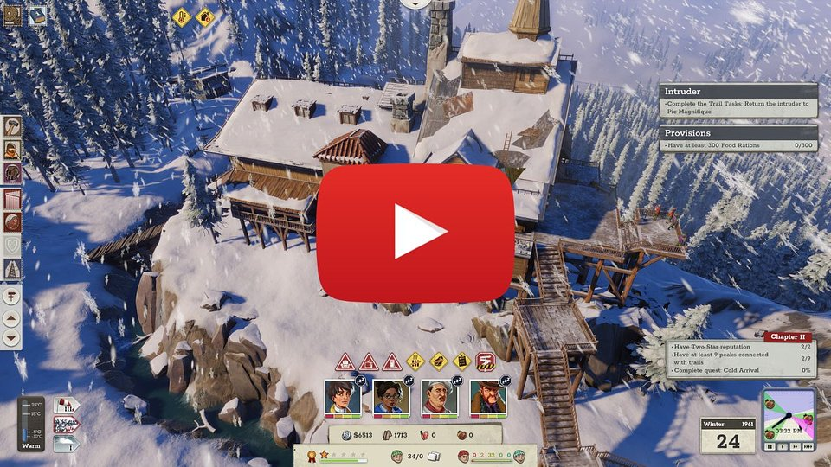
https://www.youtube.com/watch?v=EkWjDNHAKnw

Above the Snow should capture the attention of not only fans of strategy and tycoon-style games but also mountain lovers and mountaineering enthusiasts. Among the characters you’ll meet during the narrative campaign are Marek Kamiński – the Polish mountaineer who was the first in the world to reach both poles without outside assistance – and Ed Viesturs – the American climber who has summited all 8,000-meter peaks without supplemental oxygen and completed the Crown of the Himalayas. The game also features licensed gear and accessories from brands like Cortazu, Fjordfiesta, and Heywood Wakefield, as well as vehicles from the 1960s.

Above the Snow – check out a short video with Ed Viesturs

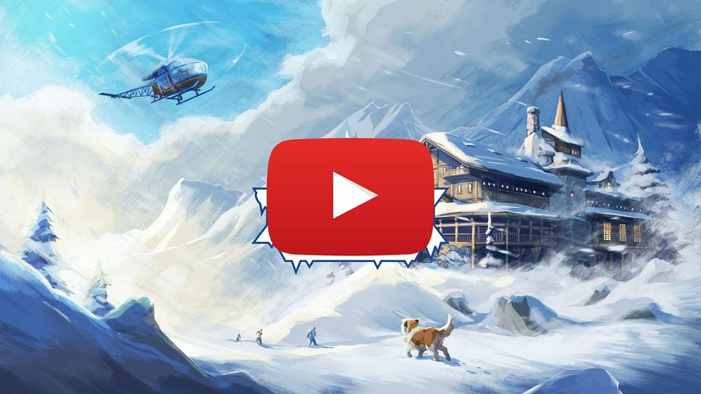
https://youtube.com/shorts/sohUfR-Bkjk?feature=share

Gameplay revolves around running a high-altitude mountain lodge, making it a cozy and safe haven for tired travelers seeking rest, company, or shelter. You’ll need to make sure visitors choose your lodge by carefully managing aspects such as temperature, food, comfort, and the entertainment available on site.

Creating an exceptional mountain lodge will be possible thanks to a crew of resourceful characters led by the player. The key to success will be teamwork, coordination, and complementing each other’s skills, so that every staff member can make the most of their talents. All of this unfolds under the calm and watchful gaze of the gentle dog Brutus, ensuring that Above the Snow remains a peaceful and relaxing adventure.

It’s amazing how powerful video games can be as a storytelling medium, and I’m glad I could support the team with my experience and insights. Setting the game in the 1960s is such an exciting choice, since that was when mountaineering really started to take off. I think the team has captured the spirit of that era perfectly. I also hope that the lodges you’ll be building soon are the kind of places you’d want to stay in yourselves.

- Marek Kamiński

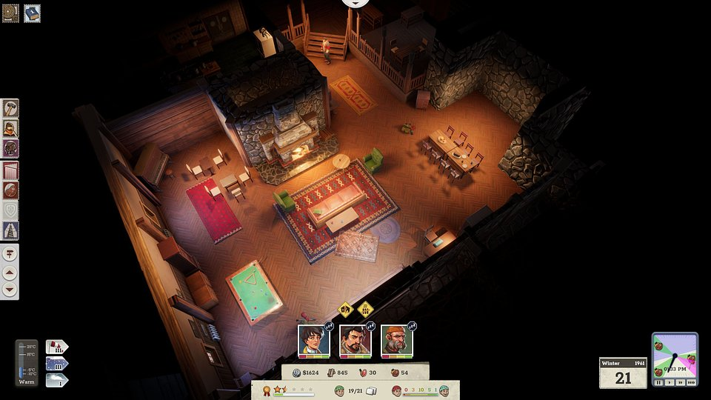

But it’s not all about the beautiful views – an important part of running the lodge is managing its finances. Happy and satisfied guests are more likely to return, and as your place’s reputation grows, it will attract even more travelers. The additional income will allow you not only to improve the interior but also to expand the entire infrastructure. Every upgrade makes your lodge more attractive and, even more importantly, safer.

The fun doesn’t end at taking care of the facilities – players will also be able to chart their own trails through the Alps. Designing and creating routes means customizing challenges to fit the guests’ skills and preferences, like including camp spots, avoiding dangerous areas, or leading paths to summits, ski slopes, historical sites, and other destinations.

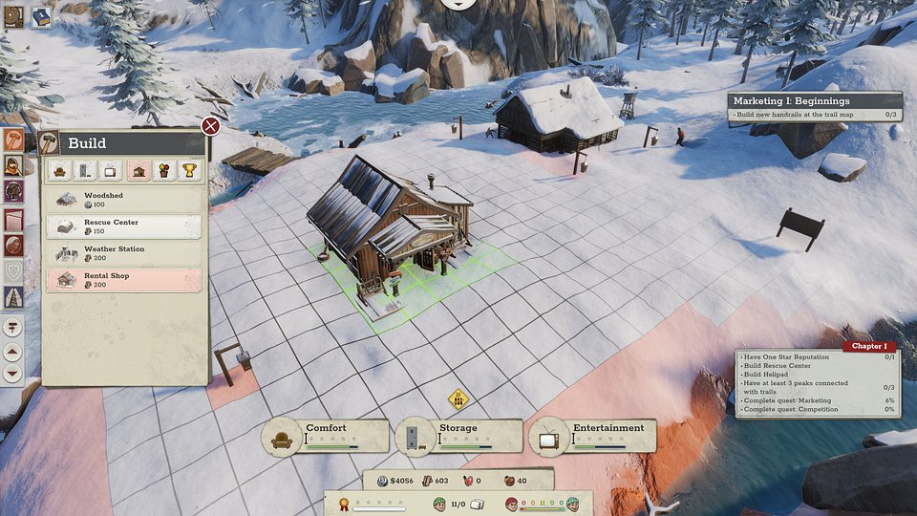

Above the Snow – key features:

⛰️ First footprint in the snow – Above the Snow is a narrative-driven tycoon game that lets you manage a mountain lodge. It’s a perfect fit for both strategy fans and lovers of mountain hiking.

⛰️ Postcard from the summit – imagine a mountain game without breathtaking scenery – impossible, right? Vast, impressive landscapes, combined with detailed graphics allow you to feel the power and beauty of the mountains.

⛰️ Create your second home – build, decorate, and manage. All to make your lodge renowned and attract climbers seeking both relaxation and adventure.

⛰️ Lead the way – create safe trails that lead climbers to the most beautiful vistas or the hardest-to-reach peaks.

⛰️ Alps in the 60s – use gear and vehicles from that era to chart trails, run rescue missions, and transport supplies.

⛰️ Take it a deep breath – the developers at Above the Desk are creating a game that blends light economic challenges with a rich narrative layer. Their stories will be best enjoyed under a warm blanket, with a mug of hot chocolate.

Above the Snow is set to launch on April 23, and anyone intrigued by the idea of running their own mountain lodge can already add the game to their wishlist on Steam and try out the demo. For more details, visit the game’s profile on X.

The full press kit is available HERE.

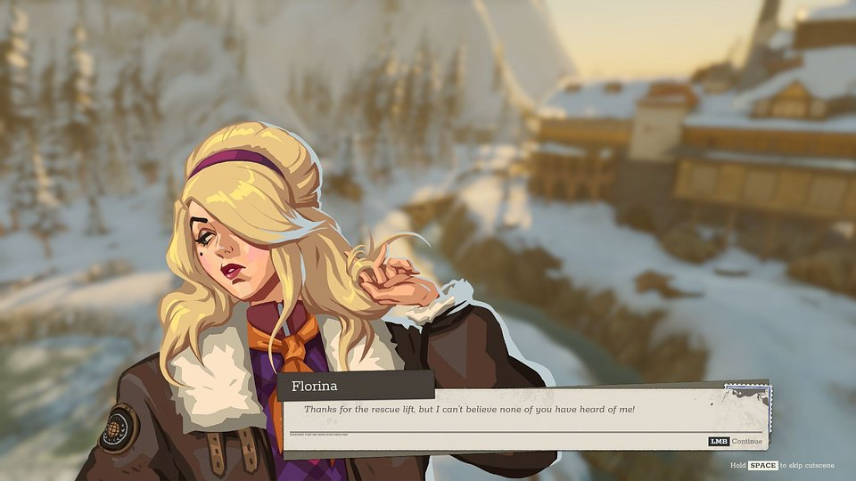

About Above the Desk:

Above the Desk is an independent game studio built by a small but passionate team founded by Michał Wasiak, an industry veteran, and a mix of seasoned industry veterans and bold new talent. We believe that this blend of perspectives, skills, and creative energy is our greatest strength. Our mission is to craft games that stand out with original ideas, engaging mechanics, and a sharp sense of humor. We don’t cut corners – we focus on originality, quality, and fresh takes on familiar formulas.

