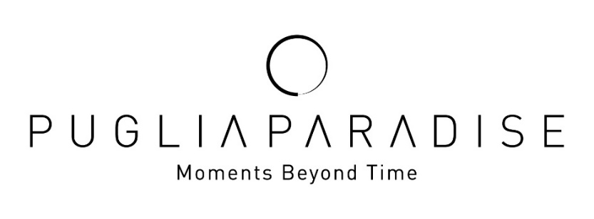

Puglia Paradise strengthens its positioning in the quiet luxury segment with a hospitality model that is increasingly human, relational and experiential.

Puglia Paradise, a professional management brand for trulli and villas in Puglia, closes 2025 with significant results that confirm the strength of its business model and its distinctive positioning in the quiet luxury segment.

In the year just ended, Puglia Paradise recorded a +26% growth in bookings thanks to the strong performance of the villas already in its portfolio. This result consequently led to further growth and expansion in 2026 with four new properties under management: Villa Maggio, Trullo Regiorgio, Trullo in Cima and Casale La Cupa are now part of the Puglia Paradise portfolio, bringing the total number of units to 34 in the Valle d’Itria, among the iconic destinations of Ostuni, Alberobello, Martina Franca and Monopoli.

The additional experiences and extra services offered by Puglia Paradise recorded a 56% increase, accounting for approximately 10% of total revenue. Among the most requested activities, boat excursions and private chef dinners confirmed how carefully curated, authentic local experiences are key to attracting high-quality guests with significant spending power.

“Looking ahead to 2026, Puglia Paradise aims to consolidate its development path and further strengthen the brand’s identity, increasingly oriented toward a concept of hospitality defined by “Moments Beyond Time”, original and memorable experiences designed to leave a lasting impact. The goal is to continue expanding the experiential offerings, enhancing value added services, and solidifying Puglia Paradise’s position as one of the leading references in quiet luxury in Puglia and within the international high end hospitality scene,” says Massimo Valentini, Founder of Puglia Paradise.

These results and this vision have led Puglia Paradise to confirm the investments made in 2025, taking a significant step in the evolution of the group’s experience ecosystem with the launch of “Moments at Sea,” the new business unit operating in 2026 dedicated to sea experiences. This includes the introduction of the private boat PIA, a handcrafted Sorrentine gozzo, which will sail between Savelletri and Taranto for exclusive excursions lasting three to seven hours, as well as seasonal activities such as Dolphin Watching. The initiative represents a new potential growth driver, with an estimated contribution of around 5% of total revenue, and is fully integrated into the company’s digital systems, with bookings manageable directly through the app and the Guest Angel service.

Growing Numbers in Digital
In 2025, Puglia Paradise reached 2 million users globally through digital marketing, confirming the brand’s international reach and its ability to attract new potential guests. The website recorded over 150,800 unique visitors, of whom 15,140 returned multiple times, demonstrating a consistent and growing interest in the offering. User engagement was particularly significant, with a rate of 47.7% and over 71,900 visitors checking availability and prices, a clear indicator of high-quality, purchase-oriented traffic, confirming the effectiveness of the digital strategy and the brand’s international relevance. Puglia Paradise’s SEO activities led to a 38% year-over-year growth in organic traffic and a 30% increase in keywords appearing on the first page of search engines, confirming the brand’s online visibility.

The Key Figure of the Guest Angel
71% of reviews mentioned the names of the Guest Angels. This confirms how human connection, availability and personalized care are central elements of every Puglia Paradise stay. The Guest Angel is the emotional heart of the brand, a dedicated person who makes the experience unique and memorable. With deep local knowledge of the area, an international perspective and familiarity with the destination as well as the villa and its services, the Guest Angel ensures that every detail is taken care of, turning each moment into a soft, enjoyable and memorable experience.

Puglia Paradise Markets
Throughout 2025, Puglia Paradise welcomed over 1,900 guests from around the world, helping to consolidate Puglia’s reputation as a leading international luxury destination.
On the international market front, the United States and the United Kingdom remain key sources: in 2025, American guests accounted for 25% of the total and UK guests 22.9%, standing out as the most loyal and enthusiastic segment of the Puglia Paradise experience. Italy follows with 8.9%, and the Australian market shows growing numbers at 5.8%.

Puglia Paradise’s Socio-Environmental Commitment
Puglia Paradise continues to strengthen its commitment to environmental and social responsibility. In the heart of Salento, the area most affected by the “Xylella fastidiosa” epidemic, which devastated over 21 million olive trees, the company has been running a reforestation project for years in collaboration with Olivami, an association dedicated to safeguarding Apulian olive cultivation. In 2025, 200 resilient olive trees were planted and for 2026 another 200 new trees are planned, including 150 in Salento and 50 at a managed villa, contributing concretely to the protection of the territory and landscape. These initiatives aim to regenerate local landscapes, support Apulian farmers and absorb approximately 50 tons of CO₂ per year, offsetting emissions generated by guest travel and the company’s operational logistics.

CONTACTS
PUGLIA PARADISE
Foro Buonaparte 59, 20121, Milano, Italy
info@pugliaparadise.com
www.pugliaparadise.com
Instagram: @puglia.paradise
Facebook: @pugliaparadise

For Press Requests and Personalized Interviews
OGS PR and Communication
Via Koristka 3, Milano 20154
+ 02 3450610 - info@ogscommunication.com
www.ogscommunication.com

Visit HERE the dedicated Puglia Paradise newsroom

