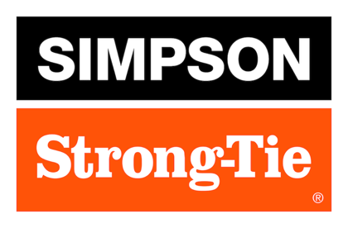

FOR IMMEDIATE RELEASE For More Information:
February 10, 2026 Jesse Russell
jrussell@strongtie.com
925-557-5324

Simpson Strong-Tie to Feature New Products, Equipment
and Giveaways at the 2026 International Builders’ Show

Pleasanton, Calif. — Simpson Strong-Tie, the leader in engineered structural connectors and building solutions, will once again be a part of Design & Construction Week as an exhibitor at the 2026 International Builders’ Show. During this year’s show, being held February 17–19 in Orlando, Florida, the company will showcase a range of products, solutions and software tools.

At Booth W3201 in the Central Hall, Simpson Strong-Tie will feature its core engineered structural connectors, screws and building solutions as well as provide a sneak peek at upcoming new product launches, including the new Strong-Wall® high-strength steel shearwall, light-duty anchors and Outdoor Accents® black connectors. Visitors can demo the EasyFrame™ automated marking system EasyCut saw along with digital solutions residential software.

“As one of the industry’s premier events, the International Builders’ Show offers Simpson Strong-Tie an unrivaled opportunity to meet with current, new and prospective customers and to identify how our engineered solutions can meet builders’ critical challenges and make a real difference in today’s home construction,” said Nate Johnston, VP of National Accounts for Simpson Strong-Tie. “We look forward every year to making those key connections and growing mutually beneficial relationships across the supply chain, from partners to dealers to contractors.”

Other highlights during the show:

- Booth visitors can enter to win one of 100 Quik Drive® Project Pro™ screw driving tools. (See staff member for full rules and eligibility details.)
- Each day of the show, the booth will host episodes of the company’s Strong Conversations podcast, featuring guest panelists and in-house experts discussing best building practices, industry trends and more. The podcasts will be available on the Strong Conversations YouTube channel over the course of the year.
- Jemery Gilstrap, MS, PE, executive vice president of innovation at Simpson Strong-Tie, will be a panelist for “The Blueprint: How Innovation-Driven Design & Construction Is Reimagining Attainable Housing,” an educational “Super Session” that will be held Thursday, February 19, from 8:30 a.m.–10:00 a.m. Attendees will learn how innovation-driven design and construction can transform the attainable housing conversation, including adaptable approaches for creating efficient, desirable homes and communities that align with buyer needs, market realities and builder business goals.

For more information, visit www.strongtie.com.

About Simpson Strong-Tie Company Inc.
Simpson Strong-Tie is the world leader in structural solutions — products and technology that help people design and build safer, stronger homes, buildings, and communities. As a pioneer in the building industry, we have an unmatched passion for problem solving through skillful engineering and thoughtful innovation. Our structural systems research and rigorous testing enable us to design code-listed, value-engineered solutions for a multitude of applications in wood, steel, and concrete structures. Our dedication to pursuing ever-better construction products and technology and to surrounding our customers with exceptional service and support has been core to our mission since 1956. For more information, visit strongtie.com and follow us on Facebook, Twitter, YouTube and LinkedIn.

###

