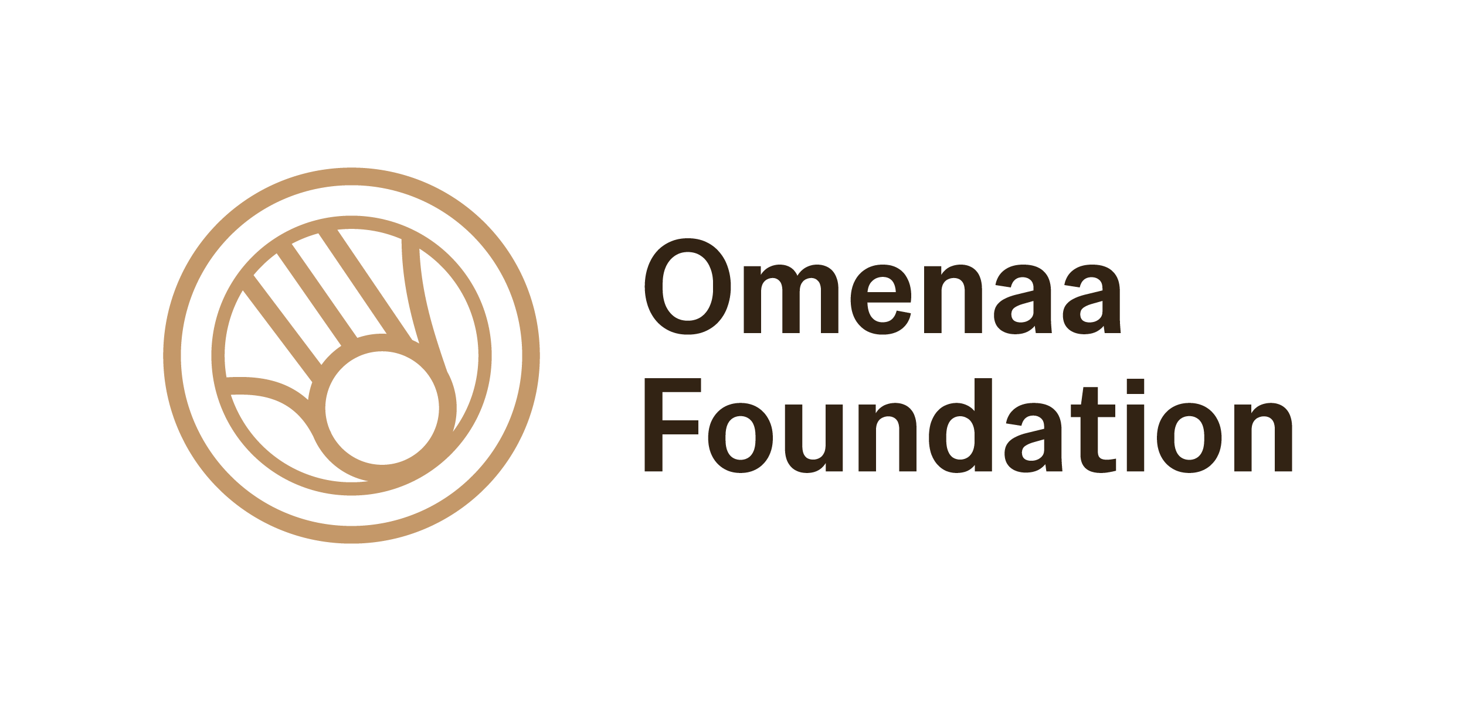
OMENAA MENSAH AWARDED THE INTERNATIONAL TITLE OF GLOBAL WOMAN OF IMPACT
San Francisco – Super Bowl, Philanthropy, and Global Impact
Born to a Ghanaian father and Polish mother, Omenaa Mensah has built a bridge between Africa and Europe through philanthropy, education, and cultural collaboration. During one of the world’s most influential sporting and cultural moments — the Super Bowl — she was honored with the prestigious Global Woman of Impact Award, presented by Off The Field.
The award ceremony took place in San Francisco during the Super Bowl Charity Fashion Show, on the official stage of Off The Field — an organization operating at the intersection of sport, philanthropy, culture, and education.
This marks the first time in Off The Field’s 25-year history that the distinction has been awarded to a woman from outside the United States. The recognition underscores not only the global scale of Mensah’s work, but also the growing international voice of African-rooted leaders shaping modern, inclusive philanthropy. The moment carries additional symbolism in the centennial year of Black History Month, highlighting the contributions of leaders of African heritage to global social progress.
“This award is a symbol for every girl who has ever been told she doesn’t deserve something, yet found the determination to keep going. When I was six years old, my father told me I would have to work twice as hard to prove my worth. Honestly, I never imagined that one day I would be standing here before you. Thank you for this recognition — it gives me even more strength to continue, because I believe we are building a community of people who truly care. And people who succeed carry a responsibility to support those in need.” — said Omenaa Mensah while accepting the award.
The distinction recognizes more than 12 years of intensive humanitarian and development work led by Mensah across continents. Her impact includes:
- Tangibly improving the living conditions of over 2 million people
- Supporting the rescue and education of more than 400 children in Ghana through the Kids Haven School initiative
- Co-creating nearly 200 social projects through the Philanthropic Consortium
- Founding TOP CHARITY, now Europe’s leading philanthropic platform, which in five years has mobilized nearly PLN 150 million from entrepreneurs and partners for social, educational, and humanitarian causes
Presenting the Global Woman of Impact Award at the Super Bowl to a Polish-Ghanaian philanthropist from Central and Eastern Europe symbolizes a powerful shift: philanthropy is no longer regionally defined — it is globally connected, culturally inclusive, and increasingly shaped by leaders with African heritage.
The Global Woman of Impact Award honors women demonstrating continuous social commitment, leadership, and measurable change at both local and global levels. Past recipients include Robin Roberts, Kathy Ireland, Gayle Benson, Keisha Lance Bottoms, Marlo Thomas, Nina Vaca, and Janice Bryant Howroyd — highly respected figures across media, business, sports, and politics.
Alongside Mensah, Off The Field recognized a diverse group of changemakers from culture, health, sport, and social activism:
- Ashanti received the Women of Impact – Culture Catalyst Award for her long-standing influence on global popular culture and for inspiring women through music and artistic expression
- Sara Hood was honored with the Danielle Beverly Courage Award for her advocacy supporting children with special needs and families facing health challenges
- April Simpkins received The Resilience Impact Award for her work promoting mental health and supporting women affected by loss
- Gilead Sciences was presented with The Wellness Impact Award for innovation and contributions to global public health
The wide spectrum of honorees reflects Off The Field’s belief that social impact unites philanthropy, culture, sport, business, and health.
Honoring Omenaa Mensah during the Super Bowl Charity Fashion Show — an event bringing together leaders from sports, fashion, and global business — symbolically connected these worlds, demonstrating that meaningful social impact is becoming an integral part of the world’s most visible cultural stages.
_______________________________
Media contact: Justyna Komorek, justyna.komorek@omiimage.com, +48 534 108 802
______________________________________
About Off The Field NFL Wives Association
Off The Field is the official organization uniting the wives and partners of NFL players, with a presence in more than 30 cities connected to the American football league. For 25 years, Off The Field has brought women together around philanthropy, family support, mental health advocacy, and strengthening local communities, while building a powerful sisterhood that fosters both personal and professional development.
The organization runs national and local programs focused on child safety, girls’ equality in sport, mental well-being, and education and career readiness. Between 2024 and 2025, Off The Field surpassed $1 million in charitable giving, supporting more than 100 nonprofit organizations across the United States.
One of its key recent initiatives is Road to LA 2028, a program preparing young girls for active participation in sport in the lead-up to the Los Angeles Olympic Games. Off The Field programs also include water safety and child protection education, the development of girls’ flag football, mental health support, and crisis and mentoring programs for young women.
Off The Field NFL Wives Association is widely recognized as one of the most influential philanthropic platforms connected to the NFL, bridging sport, culture, and social responsibility while promoting women’s leadership at local, national, and international levels.

2026 Award Honorees
- Elise Kim (Bay Area) – Community leader and activist supporting women’s empowerment and social initiatives beyond the world of sport.
Off The Field Women of Impact Award
- Sara Hood – Mother of two sons, born in a refugee camp in Sudan. After surviving a heart attack at 23, she became a passionate advocate for health awareness and the rights of children with special needs, promoting her “Lovestyle” philosophy.
Danielle Beverly Courage Award
- April Simpkins – Advocate for women who have lost partners to suicide, supporting those experiencing grief and promoting mental health awareness. Award presented jointly with Daniel H. Gillison Jr., CEO of NAMI.
The Resilience Impact Award
- Gilead Sciences – Global biopharmaceutical company focused on innovation in public health, particularly in infectious diseases and community well-being.
The Wellness Impact Award
- Naomi Le – Recognized young leader in girls’ flag football, distinguished by both athletic talent and leadership at the high school level, promoting sport among young women.
Future of Sport Leadership Award
- Ashanti – American singer, songwriter, and actress; a pop culture icon known for multi-platinum albums and her lasting influence on R&B and pop music.
Women of Impact – Culture Catalyst Award
- Janiece Evans Page – Executive Director of TIDES, a philanthropic organization advancing social justice, equity, and systemic change.
Community Impact Award
- Jaylon Smith – American NFL linebacker and 2019 Pro Bowl athlete, combining his sports career with business and entrepreneurial ventures.
Wealth Builder Award

Previous Women of Impact Award Honorees
- Robin Roberts – Iconic American broadcaster and long-time host of Good Morning America, one of the most recognizable television journalists in the United States
- Kathy Ireland – Former supermodel turned billionaire entrepreneur and global business leader, founder of one of the world’s largest lifestyle brands
- Gayle Benson – Owner of the New Orleans Saints (NFL) and New Orleans Pelicans (NBA), one of the most influential women in professional sports ownership
- Keisha Lance Bottoms – Former Mayor of Atlanta and prominent national political figure in the United States
- Marlo Thomas – Actress, producer, and philanthropist, long associated with major social campaigns and one of the most respected figures in socially engaged American pop culture

