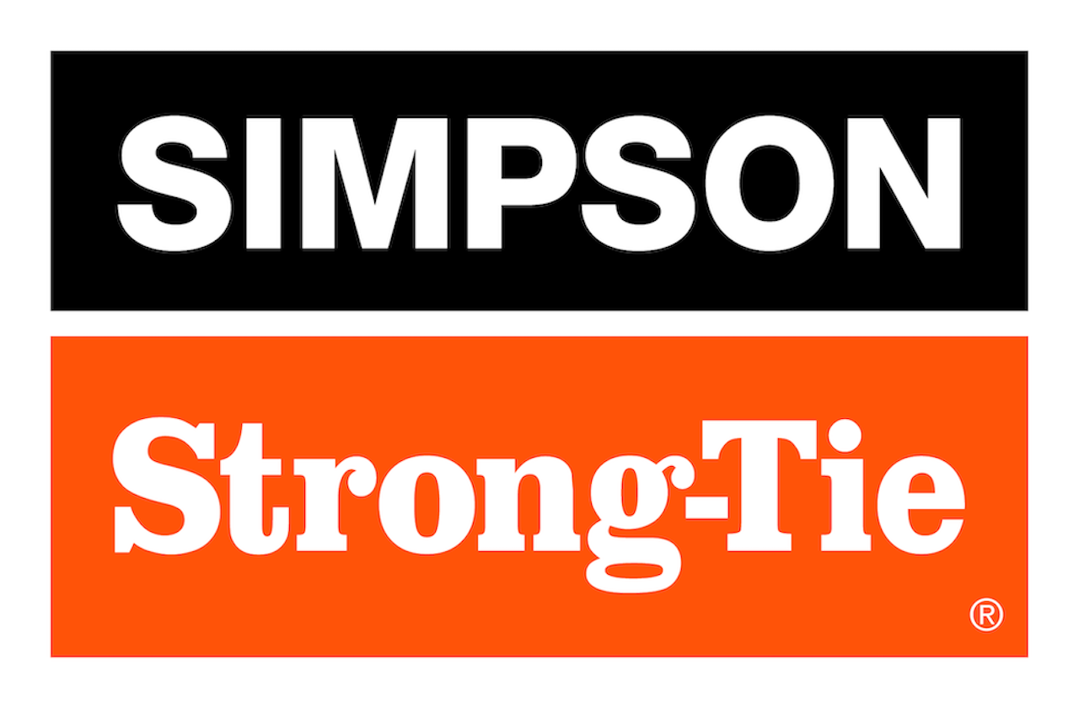

FOR IMMEDIATE RELEASE For More Information:
January 30, 2025 Jesse Russell
jrussell@strongtie.com
925-557-5324

Simpson Strong-Tie Expands Line of Retrofit Bolts for Concrete and Masonry

Pleasanton, Calif. — Simpson Strong-Tie, the leader in engineered structural connectors and building solutions, is extending its lineup of RFB retrofit bolts with new diameters and additional lengths in Grade 36 rod, as well as launching Grade 55 and 105 and Stainless Steel 304 and 316. The precut and pre-cleaned threaded rods come fully assembled with nut and washer to save time on the jobsite while providing seamless anchoring, when paired with anchoring adhesives, into existing concrete and masonry.

What sets the RFBs apart is the clear marking of their product specs: Each end of the threaded rod is stamped with rod length in inches (for 1/2” diameters and greater) and color-coded to indicate the grade or type of steel for quick and easy identification. When used with a Simpson Strong-Tie adhesive, they offer a complete engineered anchoring system.

“Any field engineer or specifier who has ever struggled to verify anchor specs post-installation will appreciate how our RFB retrofit bolts are stamped and color coded on both ends, saving time on the job while providing peace of mind during inspections,” said Jerry Miller, associate product manager for Simpson Strong-Tie. “And now the line is even more versatile, with a full range of threaded rods designed for seamless anchoring into existing concrete and masonry.”

The expanded lineup of RFB retrofit bolts now comes with a 3/8” diameter option, as well as new shorter lengths for the 1/2”-, 5/8”- and 3/4”-diameter bolts. These sizes are all available in multiple steel grades, each with its specific color coding, to meet various capacity needs:
- Grade 36 (carbon steel, zinc or hot-dipped galvanized, aka HDG): Blue. The go-to for standard-duty versatility.
- Grade 55 (carbon steel, zinc): Yellow. For boosted strength when needed.
- Grade 105 (carbon steel, zinc or HDG): Red. Heavy-duty power.
- Type 304 (stainless steel): Burgundy. Corrosion resistance for most external environments.
- Type 316 (stainless steel): Light blue. Ultimate corrosion resistance for exposure to moisture or chemicals.

The line also includes 7/8” and 1” diameters in zinc-plated carbon steel.

For more information, visit www.strongtie.com.

About Simpson Strong-Tie Company Inc.
Simpson Strong-Tie is the world leader in structural solutions — products and technology that help people design and build safer, stronger homes, buildings, and communities. As a pioneer in the building industry, we have an unmatched passion for problem solving through skillful engineering and thoughtful innovation. Our structural systems research and rigorous testing enable us to design code-listed, value-engineered solutions for a multitude of applications in wood, steel, and concrete structures. Our dedication to pursuing ever-better construction products and technology and to surrounding our customers with exceptional service and support has been core to our mission since 1956. For more information, visit strongtie.com and follow us on Facebook, Twitter, YouTube and LinkedIn.

###

