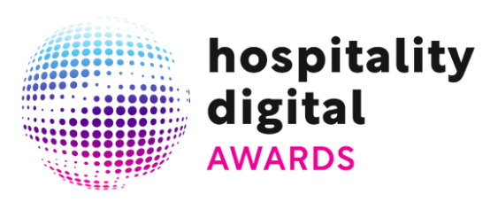

PRESS CONFERENCE

29/01/2026

Hospitality Digital Awards 2026: the winners of the second edition announced in Milan.

The second edition of the Hospitality Digital Awards concluded on January 28 at the nhow Hotel in Milan. The awards were created to promote digital innovation in the hospitality sector. The evening, hosted by Eugenia Pronzati, host and founder of The Blue Corner Media, honored a highly diverse range of organizations selected from 250 candidates from across Italy. From luxury boutique hotels to mountain resorts, from camping villages to historic residences, the awards highlighted a wide variety of locations and market positions spanning from Lake Garda to the Amalfi Coast, passing through the peaks of Trentino and reaching the heart of Puglia. The event was conceived and organized by Teamwork Hospitality and Hotelperformance.

During the ceremony the winners of the eight competing categories were announced. The award for Best Online Reputation Management went to Capitolo Riviera in Genova Nervi, praised for building an authoritative image through constant monitoring and luxury visual storytelling. The award for Best Social Campaign was given to La Dolce Vita Orient Express, which succeeded in creating an immersive and sensory narrative starting from a complete digital absence. Manna Mountain Resort in Trento received the award for Best Use of Artificial Intelligence thanks to the use of multilingual virtual assistants and advanced profiling while a Special Mention in the same category was awarded to i-SUITE Hotel in Rimini for having integrated AI across its business processes for the past two years.
The evening continued with the award for Best Omnichannel Strategy which was assigned to Smart Hotel Napoli for its fluid architecture capable of breaking down barriers between direct channels and OTAs. Masseria Panareo in Otranto triumphed in the Best Direct Booking Strategy category for transforming local identity into a powerful driver of disintermediation. In terms of technical performance Relais Rossàr in Costermano sul Garda won Best Website Performance by achieving a conversion rate of 5.6%, while Casa Orti in Arco, Trento, received the award for Best Web Design thanks to refined aesthetics and the skillful use of immersive video and audio. Finally, the Originality Award was presented to Olympic SPA Hotel in San Giovanni di Fassa for breaking conventions with a proposal that combines iconic architecture and place-based wellness.

The event was enhanced by the intervention of Simone Puorto, a “technophilosopher” and AI expert, who outlined the macrotrends that are reshaping the travel sector.

Regarding the vision of the awards, the organizers emphasized that the decision to create these Awards comes from the belief that hospitality is not just about rooms or numbers but about people, values and relationships. Mauro Santinato, president of Teamwork Hospitality, explained that today social media and digital tools are not simply means of communication but the place where a company’s identity takes shape and expresses care for guests and employees. Emanuele Nardin, managing director of Hotelperformance, added that the goal is to give visibility to those who use digital tools in an authentic and responsible way, showing that communication can be a strategic, human and ethical tool capable of growing the entire sector.
The success of the initiative was supported by prestigious partners such as Blastness, Heylight, Base Comunicazione, BWH Hotels Italy, Weforguest, Hoteldoor, Blinkup, Hotel Cube, MyForecast, Fairmas, Bemyguest, Brainy, Brandnamic, Globres and Slope.

