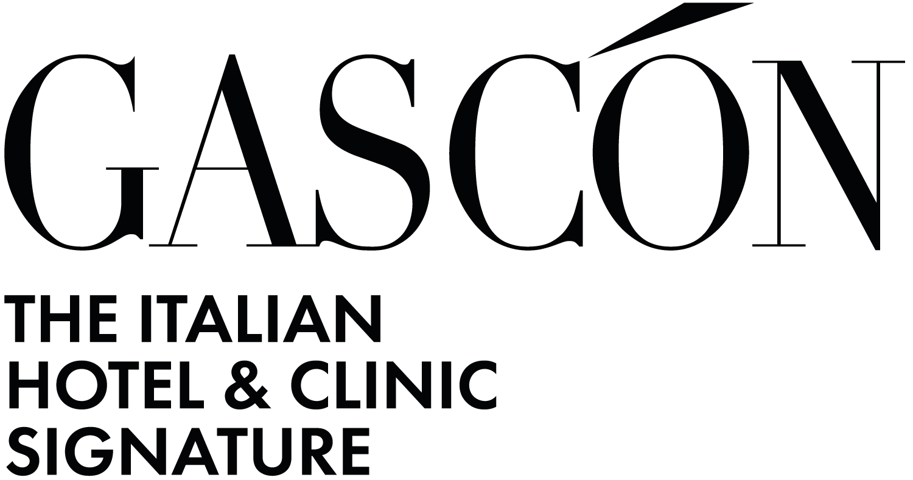

The Hotel International au Lac: a project that blends tradition and innovation
The Hotel International au Lac is an iconic building in the hospitality sector. Located in Lugano, in the heart of the Canton of Ticino, the property is managed by a family now in its fourth generation and represented an exciting challenge for the Gascón Group.
For this project, the client’s request to the architectural firm was to preserve the hotel’s historical identity while integrating innovative and functional design elements to create spaces that combine tradition and innovation.
The intervention by Gascón Group began with a major structural transformation. The building of the Hotel International au Lac was completely emptied, preserving only the perimeter walls. This allowed the firm to introduce state-of-the-art systems and modern technologies, carefully integrating these innovations into the historical architectural context.
ROOMS
Gascón Group’s vision for this project was to create spaces that evoke emotion and tell a story. The design of the rooms was conceived to invite guests to lift their gaze toward a clear and distinctive feature: the decorated ceiling, a detail that establishes a silent dialogue with the building’s history. The refined furnishings, high-quality fabrics, and carefully selected color palette chosen by the studio offer a perfect blend of classic charm and contemporary comfort.
The new rooms and renovated spaces designed by Gascón Group fully reflect not only the client’s vision but have also won over the tastes and expectations of the guests, who describe their stay as “unique” and “unforgettable” in their reviews. The meticulous attention to detail, the exclusive atmosphere, and the perfect balance between past and present expressed through the design have been particularly appreciated, confirming the success of the renovation.
Meeting deadlines was a key aspect of this project. Thanks to rigorous work planning, the architectural firm managed the entire process efficiently, ensuring the hotel’s reopening within the scheduled timeframe while maintaining the highest quality standards.
AWARDS AND RECOGNITION
The restyling of the Hotel International au Lac has received major international recognition, including the prestigious World Luxury Hotel Award for excellence in hospitality and the Swiss Hospitality Award for best restoration. These awards attest to the value of the project and its ability to combine innovation with respect for historical heritage.
The restoration project of the Hotel International au Lac stands as a virtuous example of renewal in the hospitality sector, demonstrating how tradition and modernity can coexist harmoniously. With this project, Gascón Group strengthens its position as a benchmark in the field of luxury hospitality.

GASCÓN GROUP SA – ARCHITECTURE STUDIO
Lugano Headquarter:
Via Carlo Frasca, 3 – Lugano, Switzerland
+41 (0) 91 910 97 50
info@gascon.ch
www.gascon.ch

Montreux Headquarter:
Avenue des Alpes, 72 – Montreux, Switzerland
+41 (0) 21 961 10 66
info@gascon.ch
www.gascon.ch

Milano headquarters:
Corso Venezia, 23 – Milan, Italy
+39 02 8128 30 84
info@gascon.ch
www.gascon.ch
For press inquiries and interviews:

OGS PR & COMMUNICATION
Via Koristka 3, Milan - Italy
+39 023450610
info@ogscommunication.com
www.ogscommunication.com
press.ogscommunication.com

