Contact: Steven MacEwan
media@nsf.org

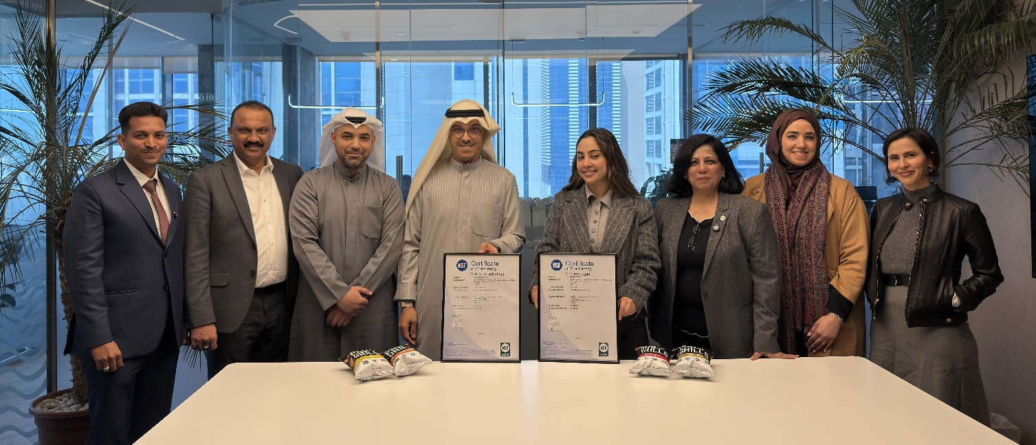
Pictured from left to right: Mohammed Ali Khan - Quality Head, Raj Nicholas - Chief Finance Officer, Ahmed Al Haidar - General Manager, Mohamad Al Najdi - Chief Executive Officer, Sara Boodai - Board Member, Jyoti Bhasin - NSF Managing Director (India & Middle East), Nadia Al Enezi - HR Director, Amal Shawqui - Product and Marketing Manager.
Cruncho Chips First to Earn Dual NSF Vegan and Cruelty-Free Certification
New certification sets standard for ethical, vegan-friendly products amid rising global demand

DUBAI, United Arab Emirates — Jan. 27, 2026 — Cruncho Chips, a Kuwait-based snack innovator, has become the first company worldwide to secure both Vegan and Cruelty-Free certification under NSF’s newly launched Protocol 543. This dual certification offers food brands a credible, science-backed path to meet the growing consumer demand for ethical and vegan products.
The global vegan food market is projected to grow to more than $37 billion in 2030, with an annual growth rate of 10.63%. In the Middle East and Africa, the vegan food market is expected to exceed $2 billion by 2030. According to recent NSF research, 63% of consumers now check sustainability factors, such as ethical sourcing, when making food choices, and more than half pay closer attention to product labels than they did five years ago.
“Achieving the first dual certification under NSF Protocol 543 helps us meet growing consumer demand for products that align with their ethical values,” said Mohammed Ali Khan, Quality Head, Cruncho. “This certification gives our customers verified confidence in our commitment to sustainable and cruelty-free practices.”
“NSF’s Protocol 543 certification provides companies a rigorous, science-based standard to meet surging consumer expectations,” said Carey Allen, Director of Product Claims at NSF. “This dual certification offers a credible, third-party solution from NSF that is recognized and trusted by consumers to simplify purchase decisions aligned with their values. The certification mark makes it easier to find trusted vegan and cruelty-free options in food, dietary supplements, cosmetics, personal care, and household products. Cruncho Chip’s achievement provides a roadmap for manufacturers seeking to differentiate their products in the rapidly expanding market for ethically aligned products.”
NSF Protocol 543 certification requires manufacturers to meet stringent requirements across multiple areas. For Vegan Products certification, ingredients, processing aids, and food-contact packaging materials cannot be derived from animals or contain any animal ingredients. Animal testing is prohibited at any stage of product development, and companies must implement supply chain verification with NSF Vegan Compliance Plans and Standard Operating Procedures.
The Cruelty-Free Certification component ensures that ingredients, processing aids, and certified products are not tested on animals. Companies must establish NSF Cruelty-Free Compliance Plans with Standard Operating Procedures addressing traceability, recall, and complaint handling, along with ongoing compliance monitoring through technical reviews.
The certification is available globally in three options: NSF Vegan, NSF Cruelty-Free, and NSF Vegan and Cruelty-Free, enabling manufacturers to select the certification level that best aligns with their product portfolio and market positioning.
---ENDS---
About NSF
NSF is an independent, global services organization dedicated to improving human health for more than 80 years by developing public health standards and providing world-class testing, inspection, certification, advisory services and digital solutions to the food, water and wellness products industries. NSF has 40,000 clients in 110 countries and is a World Health Organization (WHO) Collaborating Center on Food Safety and Water Quality.

For more information on NSF, visit nsf.org.

About Cruncho Chips
Prolife is the GCC’s first protein‑infused snack brand, redefining mindful snacking by offering a cutting‑edge portfolio of high‑protein and nutrient‑enriched snacks across multiple categories. Our diverse range—from protein puffs and pea‑based chips to collagen‑infused snacks and kids’ vitamin‑boosted treats—delivers bold flavor with purposeful nutrition. Prolife offers a truly guilt‑free snacking experience across markets throughout the GCC designed to meet the growing demand for functional foods

Notes to editors
Cruncho Chips is the first company to achieve dual certification as both Vegan and Cruelty-free under NSF Protocol 543; however, Michele's Granola was the first company to obtain Vegan Certification (only) under P543.

