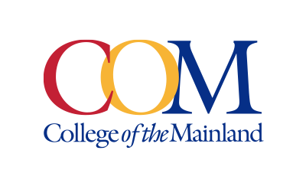
Marketing and Public Affairs Department

Contact:
Miles Shellshear, Communications Specialist, (409) 933-8690 or mshellshear@com.edu
Jose Salazar, Senior Communications Specialist, (409) 933-8923 or jsalazar18@com.edu

Written by: Miles Shellshear, Communications Specialist

NEWS RELEASE
January 20, 2026

College of the Mainland Hosts January Information Session on Dual Credit and Tuition-Free College Opportunities

College of the Mainland (COM) will host the COM Dual Credit Advantage & Opening Doors Promise Scholarship Information Session on Thursday, Jan. 29, 2026, from 6–7:30 p.m. at the COM Conference Center. The event is designed for high school students and families interested in getting a head start on college while saving time and money.

During the session, attendees will learn how students can earn early college credits through COM’s Dual Credit and Collegiate High School (CHS) programs. Presenters will explain how the CHS program allows students to graduate from high school with both a diploma and an associate degree, while Dual Credit courses enable students to earn college and high school credit simultaneously.

Guests will also receive information about key affordability programs, including the Financial Aid for Swift Transfer (FAST) program, which allows qualified low-income students to take college courses at no cost, and the Opening Doors Promise Scholarship, which enables eligible students to attend COM tuition-free for up to two years after high school.

“Expanding access to affordable higher education is central to COM’s mission,” said Michelle Brezina, vice president for Student Affairs and Enrollment Management. “Through programs like Dual Credit and Collegiate High School, students can begin their college journey early, and initiatives like FAST and the Opening Doors Promise Scholarship help remove financial barriers along the way.”

Attendees will learn about course options, financial aid opportunities and support services, and will have the chance to ask questions during a panel discussion featuring current COM Dual Credit and CHS students and faculty who will share their firsthand experiences.
COM’s Dual Credit and Collegiate High School programs help students accelerate their academic pathways, develop college-level skills, access campus resources and transition smoothly from high school to college.

RSVP and join us for our information session on Thursday, January 29, from 6-7:30 p.m. at the COM Conference Center to learn more about your eligibility and make your plan to register for the upcoming spring semester.

Photo: Graphic advertising the Jan. 29 Dual Credit Advantage Information Session

Contact:
Jose Salazar, Senior Communications Specialist, (409) 933-8923 or jsalazar18@com.edu
Miles Shellshear, Communications Specialist, (409) 933-8690 or mshellshear@com.edu

College of the Mainland is a learning-centered, comprehensive community college dedicated to student success and the intellectual and economic prosperity of the diverse communities we serve. Taxing districts include the independent school districts of Dickinson, Hitchcock, Santa Fe and Texas City/La Marque. Its service area includes League City, Friendswood, Kemah, Bacliff and San Leon.

