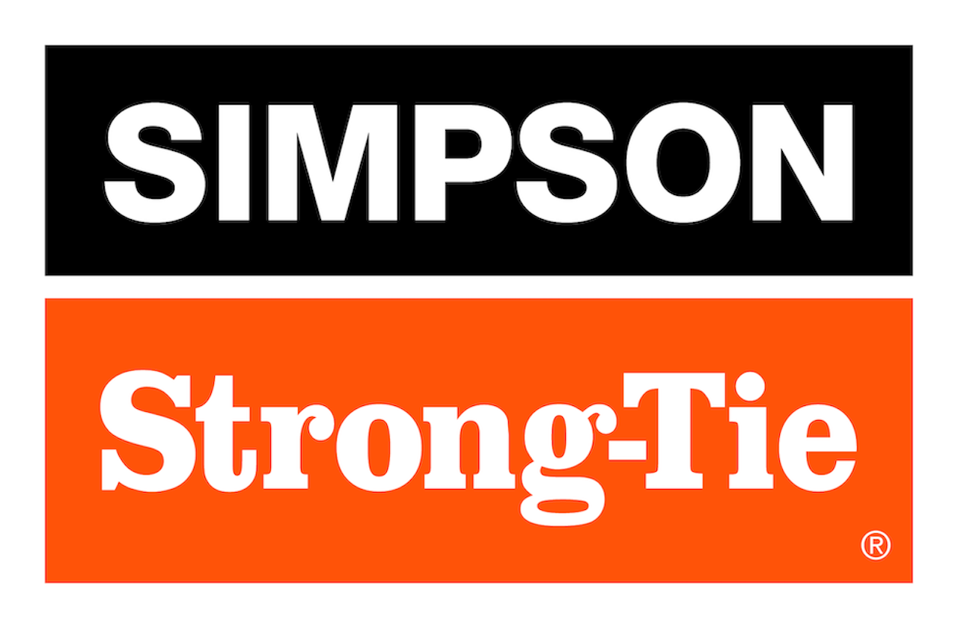

FOR IMMEDIATE RELEASE For More Information:
January 15, 2026 Jesse Russell
jrussell@strongtie.com
925-557-5324

Simpson Strong-Tie Celebrates Grand Opening of New, 500,000-Square-Foot Manufacturing Facility in Gallatin, Tennessee

Pleasanton, Calif. — Simpson Strong-Tie, the leader in engineered structural connectors and building solutions, marked the grand opening of its newest manufacturing plant, located in Gallatin, Tennessee, with a ribbon cutting, celebration and tours on Thursday, January 15, 2026.

The 500,250-square-foot, $125 million facility will test and manufacture a range of anchors, fasteners and Quik Drive® fastening tools. The facility opened with 227 employees, including machine operators, maintenance technicians, heat treat techs, and process and product engineers, and is expected to create an additional 20 jobs in 2026.
“Simpson Strong-Tie is excited to open our state-of-the-art facility in Gallatin, enhancing our ability to serve our customer base and strengthening our distribution network while delivering even greater value and product innovation,” said Mike Olosky, CEO of Simpson Strong-Tie. “This manufacturing and training facility is unlike any other in the construction industry, featuring end-to-end fastening production under one roof with the latest equipment and technology. We’re proud to expand our presence in Tennessee, a state with a growing, vibrant population, a skilled workforce and a supportive business environment.”

The January 15 grand opening celebration gathered Simpson Strong-Tie leaders, valued partners and customers, and local politicians including Gallatin Mayor Paige Brown.

“Simpson Strong-Tie has a tremendous history in Gallatin. For more than 60 years, they’ve provided good jobs for our citizens and produced products that power construction around the world,” said Brown. “Our city is most fortunate that Simpson Strong-Tie worked hard to locate their new, expanded facility in Gallatin. We are grateful for their investment here and the outstanding culture they represent, as it is a reflection of the types of companies that we are proud to have in Gallatin.”

To learn more, visit www.strongtie.com.

About Simpson Strong-Tie Company Inc.
Simpson Strong-Tie is the world leader in structural solutions — products and technology that help people design and build safer, stronger homes, buildings, and communities. As a pioneer in the building industry, we have an unmatched passion for problem solving through skillful engineering and thoughtful innovation. Our structural systems research and rigorous testing enable us to design code-listed, value-engineered solutions for a multitude of applications in wood, steel, and concrete structures. Our dedication to pursuing ever-better construction products and technology and to surrounding our customers with exceptional service and support has been core to our mission since 1956. For more information, visit strongtie.com and follow us on Facebook, Twitter, YouTube and LinkedIn.

###

