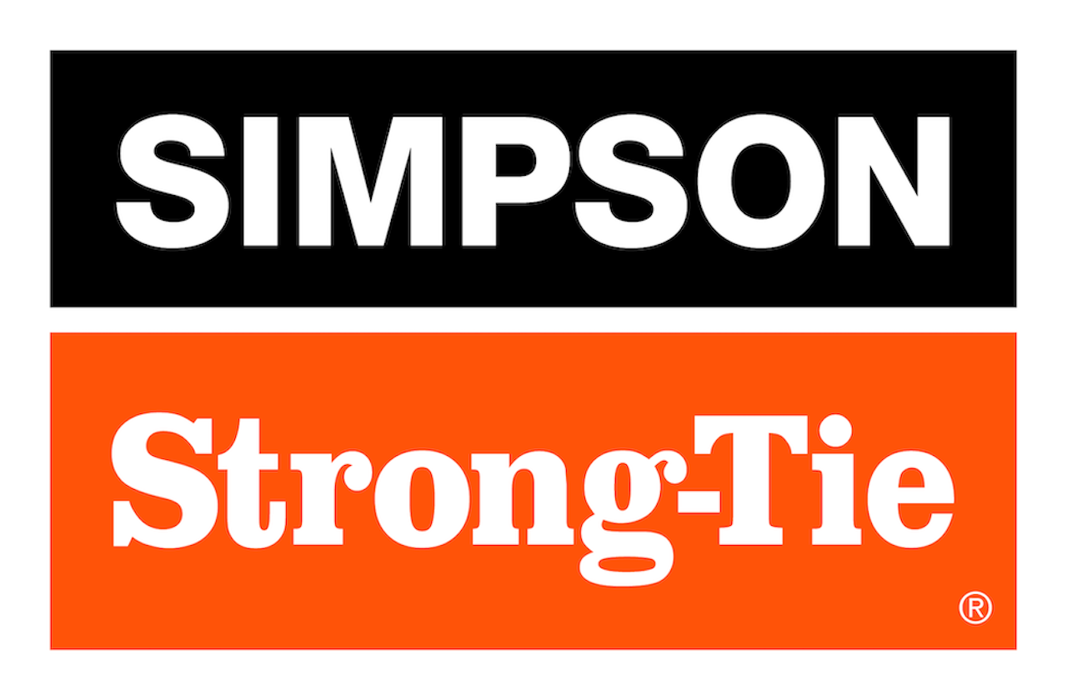

FOR IMMEDIATE RELEASE For More Information:
December 17, 2025 Jesse Russell
jrussell@strongtie.com
925-557-5324

Simpson Strong-Tie Launches
Concrete Crack Repair Kit for Larger Pro Projects

Pleasanton, Calif. — Simpson Strong-Tie, the leader in engineered structural connectors and building solutions, is expanding its line of structural injection epoxies with a new contractor kit, CI-LVPO-KT. Previously, the company’s structural injection solution only came either in bulk gallons for use with metered dispensing equipment on large commercial projects or in small DIY-friendly kits (the Crack-Pac® injection epoxy). The new CI-LVPO-KT offers contractors and advanced DIYers the convenience of the Crack-Pac kit with the necessary materials for a commercial-grade structural concrete repair solution.

CI-LV™ low-viscosity structural injection epoxy is a two-component, high-modulus, high-solids, moisture-tolerant epoxy specially designed for filling concrete cracks and for increasing the bond between freshly placed repair mortars or concrete mixes and existing concrete. The epoxy chemically bonds with the concrete to provide a structural repair while sealing the crack from moisture and protecting rebar in the concrete from corrosion. CI-LV comes in side-by-side cartridges dispensed through a static mixing nozzle that ensures the precise combination of each component.

“Our CI-LV low-viscosity structural injection epoxy has long been trusted for crack repair and concrete bonding in large commercial projects, but it wasn’t convenient for residential contractors with more occasional needs. This new kit hits that sweet spot between commercial jobs and one-off DIY projects while delivering the same reliable performance,” said Shea Roche, senior product manager for Simpson Strong-Tie.

Each CI-LVPO-KT package offers enough adhesive and accessories to repair about 30 feet of concrete. The kit comes with four cartridges of CI-LV low-viscosity structural injection epoxy and two cartridges of CI-PO™ paste-over and structural repair epoxy, as well as flush-mount injection ports, corner-mount/drilled-in injection ports, injection fittings and mixing nozzles. It’s also available in a CI-LVPO-KT-TL kit that includes an ADT30S manual dispensing tool.

CI-LVPO-KT meets the requirements of ASTM C881 & AASHTO M235, Type I/II, Grade 1, Class B and ASTM C881 & AASHTO M235, Types I/IV and II/V, Grade 1, Class C. It’s moisture tolerant and can be used on dry and damp surfaces; freeze/thaw resistant; nonshrink; and resistant to oils, salts and mild chemicals. Its low surface tension allows the material to effectively penetrate narrow cracks.

For more information, visit www.strongtie.com.

About Simpson Strong-Tie Company Inc.
Simpson Strong-Tie is the world leader in structural solutions — products and technology that help people design and build safer, stronger homes, buildings, and communities. As a pioneer in the building industry, we have an unmatched passion for problem solving through skillful engineering and thoughtful innovation. Our structural systems research and rigorous testing enable us to design code-listed, value-engineered solutions for a multitude of applications in wood, steel, and concrete structures. Our dedication to pursuing ever-better construction products and technology and to surrounding our customers with exceptional service and support has been core to our mission since 1956. For more information, visit strongtie.com and follow us on Facebook, Twitter, YouTube and LinkedIn.

###

