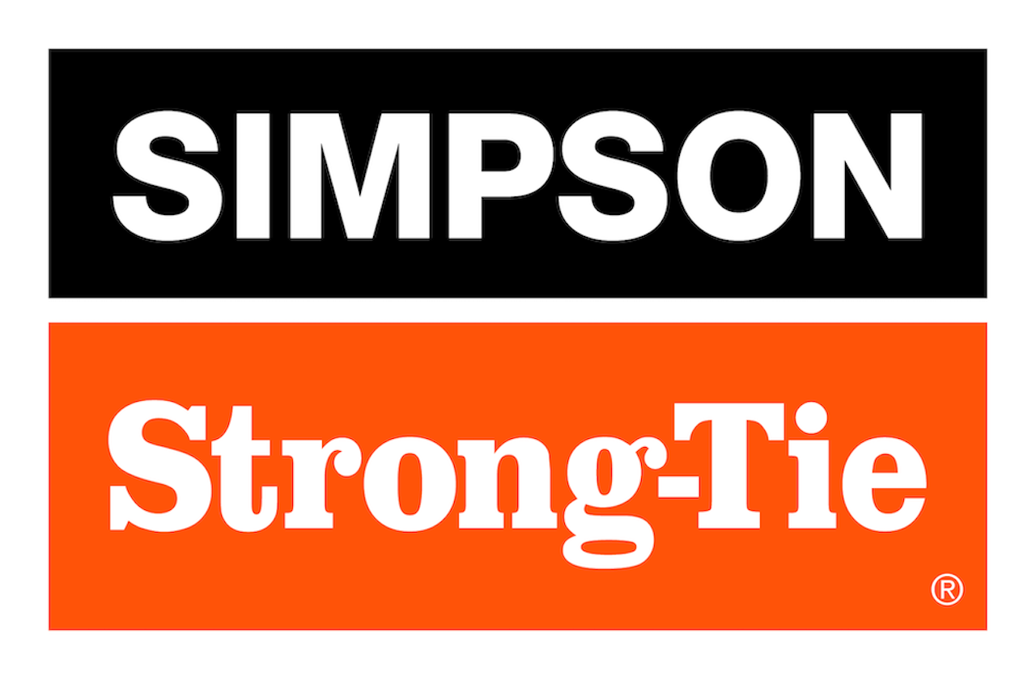

FOR IMMEDIATE RELEASE For More Information:
December 11, 2025 Jesse Russell
jrussell@strongtie.com
925-557-5324

Simpson Strong-Tie Introduces PFUD™ Post Frame Undersaddle Hangers for Easier, Faster Layout

Pleasanton, Calif. — Simpson Strong-Tie, the leader in engineered structural connectors and building solutions, is simplifying post frame construction with the launch of two PFUD™ undersaddle hangers. The hangers feature a two-sided design so that one hanger supports ceiling joists on each side of a truss instead of requiring a separate face-mounted hanger for each joist. The continuous seat fits snugly under the truss’s bottom chord, automatically aligning parts vertically for an easier, faster layout. For single-side applications, installers simply bend and separate the hanger along the perforations to create two face-mounted options.

“PFUD undersaddle hangers are extremely versatile, streamlining installation to reduce connector layout labor costs by half versus using two face-mounted hangers,” said Randy Daudet, group product manager for Simpson Strong-Tie. “At the same time, the hangers offer greater reliability and load capacity than toenailed ceiling joists.”

The hangers are fully tested and code listed. They’re load rated for joist tension forces, so they’re ideal with ceiling panels acting as diaphragms or for bottom-chord truss bracing.

Two options are available: The PFUD24 fits one-ply trusses, and the PFUDS24 fits two-ply trusses.

For more information, visit www.strongtie.com.

About Simpson Strong-Tie Company Inc.
Simpson Strong-Tie is the world leader in structural solutions — products and technology that help people design and build safer, stronger homes, buildings, and communities. As a pioneer in the building industry, we have an unmatched passion for problem solving through skillful engineering and thoughtful innovation. Our structural systems research and rigorous testing enable us to design code-listed, value-engineered solutions for a multitude of applications in wood, steel, and concrete structures. Our dedication to pursuing ever-better construction products and technology and to surrounding our customers with exceptional service and support has been core to our mission since 1956. For more information, visit strongtie.com and follow us on Facebook, Twitter, YouTube and LinkedIn.

###

