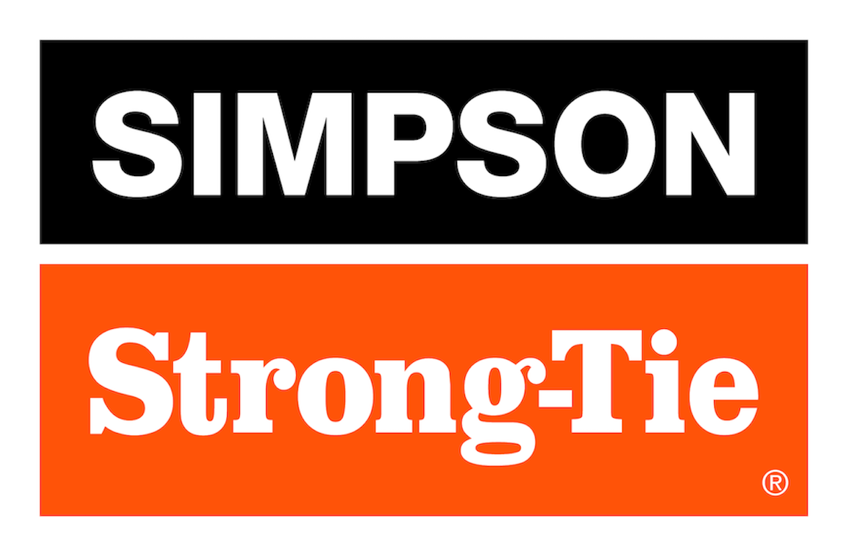

FOR IMMEDIATE RELEASE For More Information:
December XX, 2025 Jesse Russell
jrussell@strongtie.com
925-557-5324

Simpson Strong-Tie Introduces Strong-Bond™, a Fast-Curing, Coloring-Changing Anchoring and Bonding Adhesive

Pleasanton, Calif. — Simpson Strong-Tie, the leader in engineered structural connectors and building solutions, has launched Strong-Bond™, a fast-curing adhesive for everyday anchoring and repair of concrete, masonry and stone. Strong-Bond features innovative Color Cure™ technology, which dispenses blue then changes to gray when cured for efficient, guesswork-free installation. Its fast-set formulation cures quickly across a wide range of temperatures, from 104°F (in as little as 20 minutes) down to 14°F (in approximately four hours).

“Strong-Bond not only simplifies installation with fast cure times and easy prep, it shows you when it’s ready: Blue is wet, gray is set,” said Shea Roche, senior product manager for Simpson Strong-Tie. “Whether you’re fixing large cracks, anchoring threaded rod into concrete, securing handrails or bonding decorative stone, Strong-Bond delivers professional results every time.”

Strong-Bond adhesive can be used in both wet and dry conditions. It comes in a 10.1-fluid-ounce cartridge for dispensing with a traditional caulking tool.

For more information, visit www.strongtie.com.

About Simpson Strong-Tie Company Inc.
Simpson Strong-Tie is the world leader in structural solutions — products and technology that help people design and build safer, stronger homes, buildings, and communities. As a pioneer in the building industry, we have an unmatched passion for problem solving through skillful engineering and thoughtful innovation. Our structural systems research and rigorous testing enable us to design code-listed, value-engineered solutions for a multitude of applications in wood, steel, and concrete structures. Our dedication to pursuing ever-better construction products and technology and to surrounding our customers with exceptional service and support has been core to our mission since 1956. For more information, visit strongtie.com and follow us on Facebook, Twitter, YouTube and LinkedIn.

###

