
bettergamingagency.prowly.com

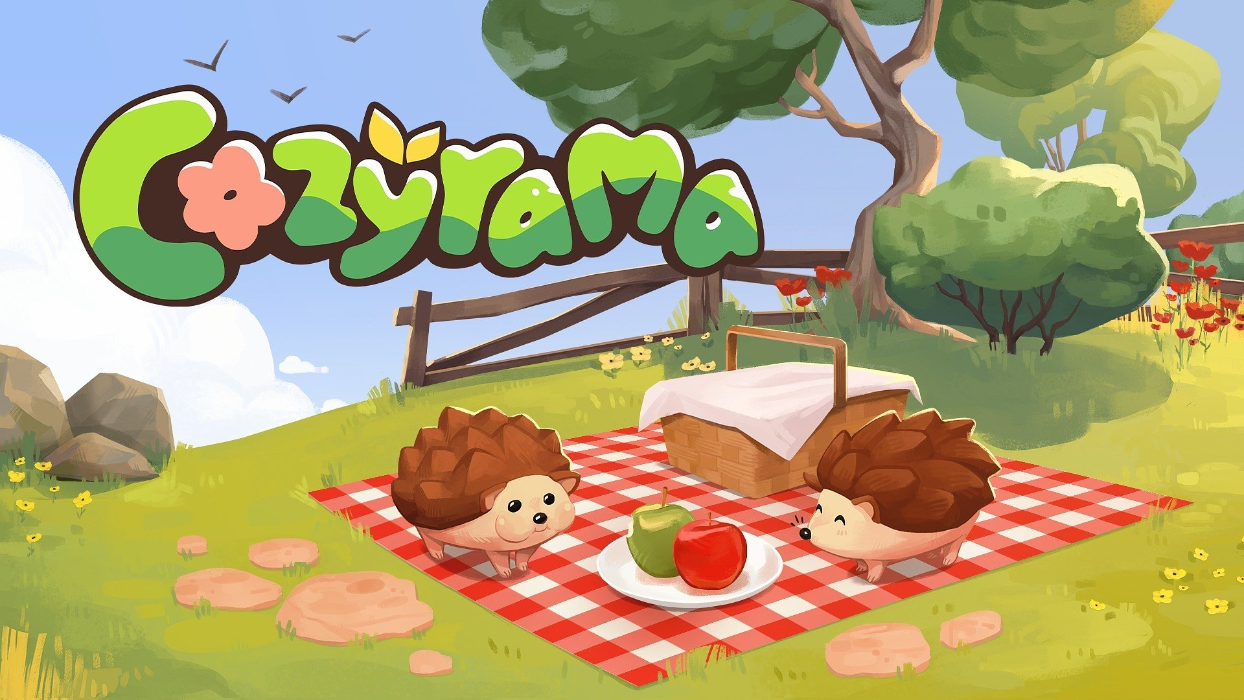

Get ready to relax! Charming Cozyrama launches today

Prepare a mug of hot chocolate, light a candle, and wrap yourself in a warm blanket to enjoy a cozy moment.

The creators of House Flipper 1 & 2 – Frozen District – together with Sandwich Games and Tutel Games, are excited to announce that Cozyrama – wholesome sandbox about creating charming dioramas – is available on Steam now. Check out the launch trailer to see the possibilities this little game offers for the price of 9.99 USD | 8.49 EUR.

Cozyrama – watch the launch trailer


https://youtu.be/K9nISl6nEpI

Cozyrama is a title that lets you catch a second breath while creating cute dioramas. It’s a game without leaderboards, goals that dictate how you play, or pressure from competitors. You are an artist, the game is your canvas, and your imagination takes the lead. Build houses, gardens, and even miniature settlements filled with details, including interactive animals that bring your creations to life. To encourage player creativity, the developers have included a variety of themes such as Garden, Asian, Oasis, Farm, and Aquatic.

True relaxation begins with balance – this guided the creators of Cozyrama. The game combines a wide range of options for creative building and decorating with an intuitive tool system that even builders taking their first steps in this genre can easily handle. This golden balance was achieved thanks to the support of thousands of beta-testers, whose feedback helped shape the game.

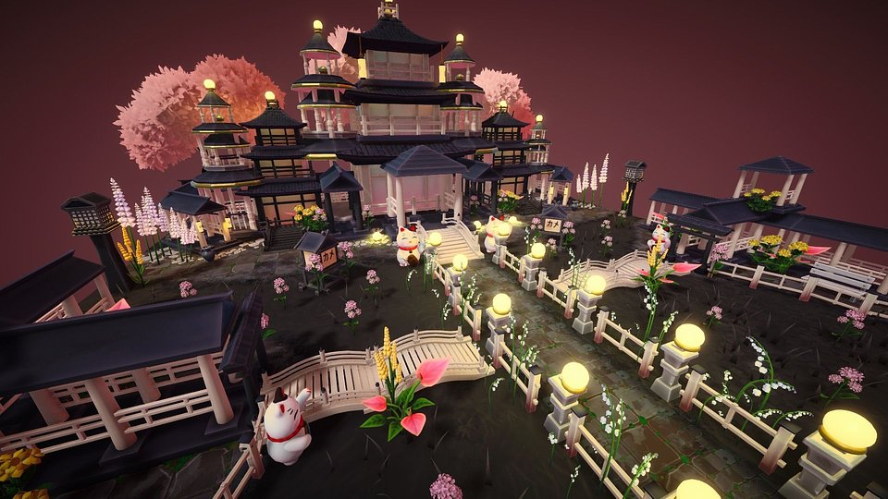

The fun doesn’t stop with what the developers have provided. Integration with mod.io allows players not only to share their diorama projects but also to create custom items using a special Item Creator. This opens up endless opportunities for creative expression.

Cozyrama – key features:

● Escape into a beautiful world – create dioramas at your own pace, perfecting every detail without stress or competition.

● Happy medium – intuitively designed tools let both beginners and experienced diorama builders fully enjoy all the customization options.

● Old MacDonald Had a Farm – bring your dioramas to life with cute animals and pet them to fully enjoy this wholesome experience.

● Create and share – present your creations thanks to integration with mod.io. Share your designs and let people admire or even customize your projects. Moreover, the Item Creator allows you to create your own items for building and decorating dioramas.

PRESS KIT

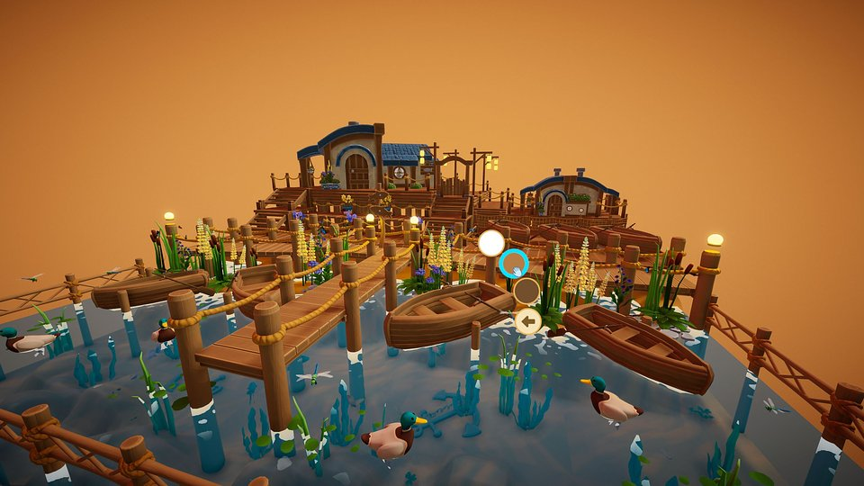

Cozyrama is now available on Steam, priced at 9.99 USD / 8.49 EUR. During the launch period, the game is available with a 10% discount. To learn more about the project, visit its TikTok and Instagram, and join the community Discord server.

