TECHNICAL SPECIFICATIONS
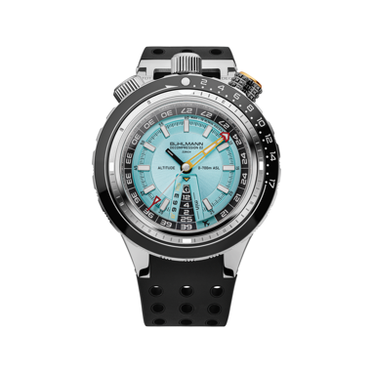
Bühlmann Decompression 02
Druckkammer Limited Edition
RRP 4’300€ / 3’990CHF

Reference BD02.S300.DK.R

Functions Hours, minutes, seconds, decompression stops timing, total dive time timing, fly-no-fly indicator

Movement Sellita SW300 Swiss made self-winding mechanical movement, 3.6mm thick, 25 jewels, Beat Rate 28,800 bph. Frequency 4 Hz

Case Brushed and polished stainless steel 4 parts, 5° inclined case with a decompression timing safety bezel and a total dive time safety bezel
Ceramic bezel with Superluminova X1 luminous numerals
Diameter: 48.5 mm, Height: 17,20 mm, Lug-to-Lug width: 58.5mm
Anti-reflective convex sapphire crystal
Water-resistant up to 57.7 ATM/575m/1900ft
Helium valve
Concave engraved screwed case-back
Engraved and see-through screwed case back

Dial Top dial: “Druckkamer” blue top dial with sunburst finishing and
Rhodium X1 superluminova coated applied indexes and hands
Turning Bottom dial: Black matt printed with the Bühlmann decompression table (17 dive profiles). Ovesized minutes hand

Strap Black rubber fine adjustment strap with flexible joint at the 12 o’clock lug. Additional extension for dive suit fitting. Pin buckle

Limited edition Limited edition of 575 pieces

