

Biuro prasowe better. gaming agency
bettergamingagency.prowly.com

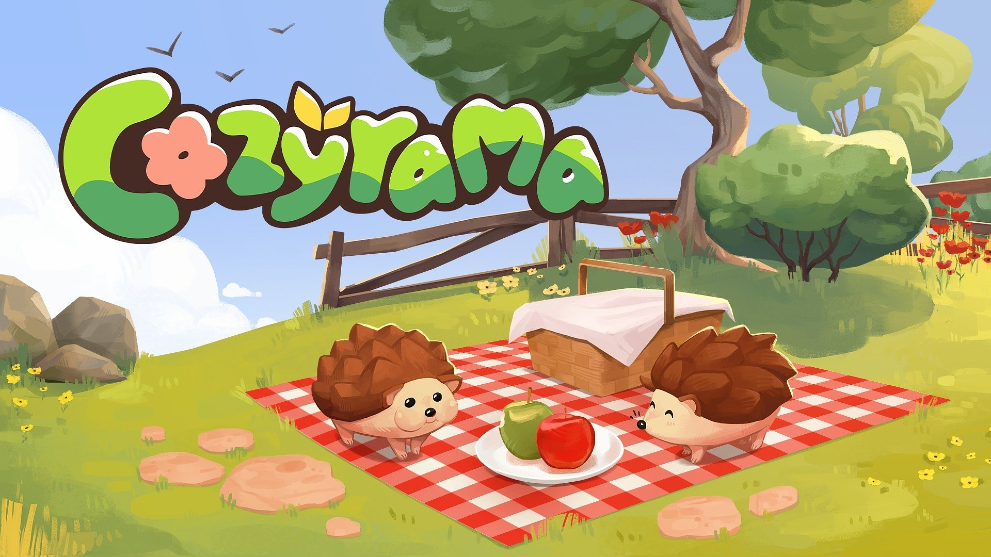

Cozyrama – a cute sandbox – will spread its charming vibes on December 11th

Soon, you will be able to unleash your imagination and create the most beautiful dioramas.

The creators behind House Flipper 1 &amp; 2 – Frozen District – together with Sandwich Games, are excited to announce that Cozyrama, a wholesome and relaxing game about creating adorable dioramas, will launch on Steam on December 11th. A playground for almost endless tiny creations is priced at 9.99 USD | 9.99 EUR, and all imaginative minds can already try the demo.

Cozyrama – watch the release date trailer


https://youtu.be/94L0NAT8e0g

Cozyrama is a peaceful diorama builder where players design enchanting 3D dioramas filled with life, colour, and charm. Starting with a blank canvas, players can craft their perfect mini world at their own pace - no timers, no competition, just a stress-free experience. A single sprout can grow into a magical home with colorful blossoms, hanging lanterns, and tiny wandering animals. The dioramas can also be brought to life with cute animals that can be interacted with and petted at any time.

The creators of Cozyrama set out to achieve a balance between the wide range of customization options and the intuitiveness of the available tools. This was made possible, in part, thanks to feedback from thousands of beta testers, who helped simplify the controls to the maximum.

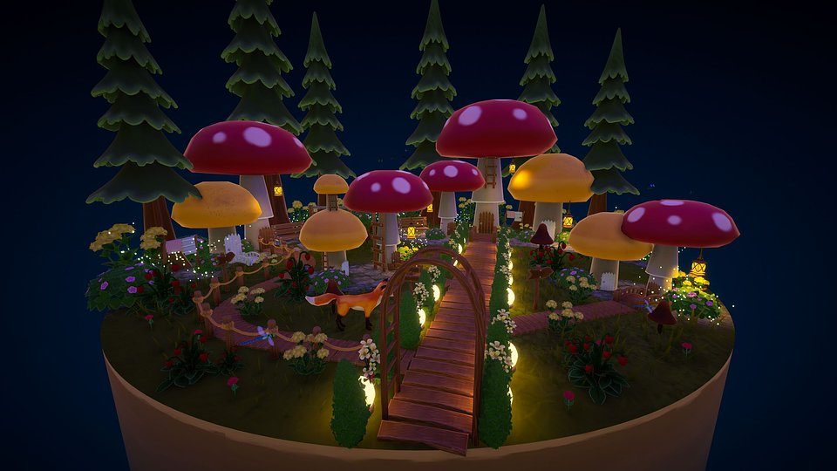

For those who don’t have a thousand ideas at their fingertips or feel overwhelmed by endless possibilities, Cozyrama offers Journey Mode, a gentle, guided way to create dioramas. It features a series of thoughtfully crafted models where players can follow simple steps and discover new inspirations along the way. For veterans, there are countless possibilities for editing dioramas, with a variety of biomes and themes to explore, including styles such as Garden, Asian, Oasis, Farm, and Aquatic. All of this comes in a stylized, colorful look, creating an inviting space to unwind and let imagination flourish.

Cozyrama – key features:

● Escape into a beautiful world – create dioramas at your own pace, perfecting every detail without stress or competition.

● Old MacDonald Had a Farm – bring your dioramas to life with cute animals and pet them to fully enjoy this wholesome experience.

● With a little help – a special Journey Mode guides players step by step to craft charming dioramas, revealing all the possibilities.

● Create and share – present your creations thanks to integration with mod.io. Share your designs, letting people admire or even customize your projects.

PRESS KIT

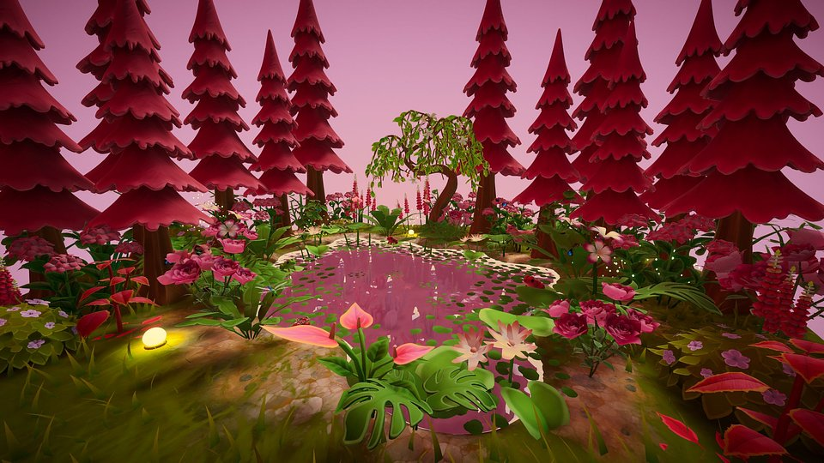

Cozyrama is coming to Steam on December 11th, and all interested players can already wishlist the game and try the demo. The game is priced at 9.99 USD | 9.99 EUR. To learn more about the project, visit its profile on TikTok and Instagram, and join the community server on Discord.

