

Biuro prasowe better. gaming agency
bettergamingagency.prowly.com

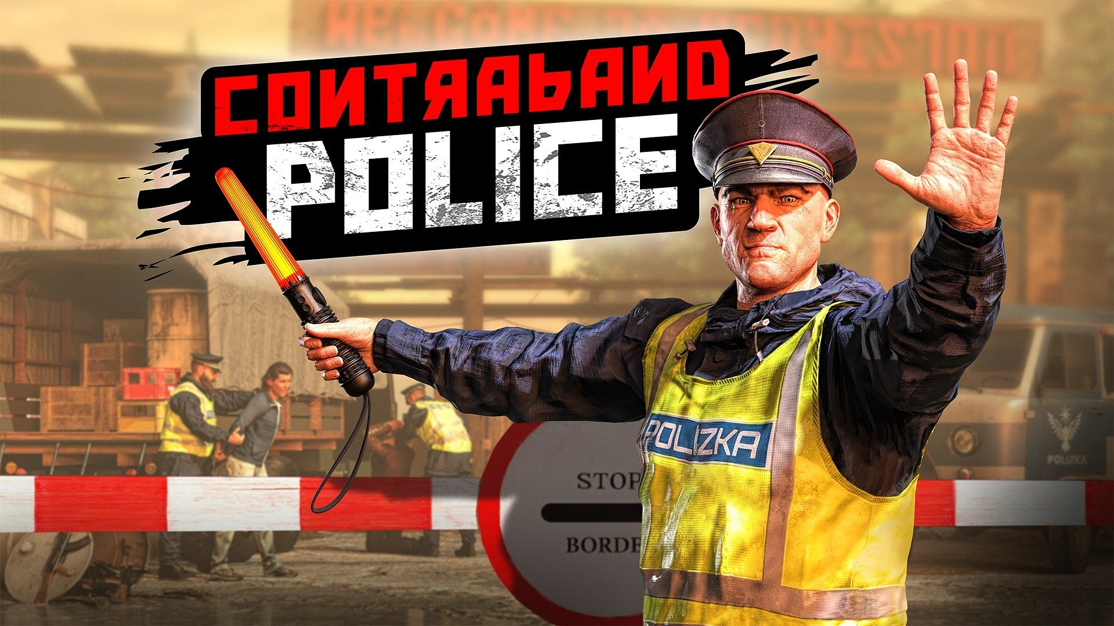

Duty calls! Contraband Police has opened the borders for PlayStation 5 and Xbox Series S/X

Almost 1.5 million copies sold and over 1,400 reviews on Steam, with an impressive 95% positive rating! Contraband Police is now available on PlayStation 5 and Xbox Series S/X. Step into the mountainous region of Karikatka and take charge of one of the most dangerous border crossings in the world – fate of the Akaristan People’s Republic lies in your hands. To celebrate the console release, the developers at Crazy Rocks and publisher PlayWay have prepared a special launch trailer.

Contraband Police – watch the launch trailer

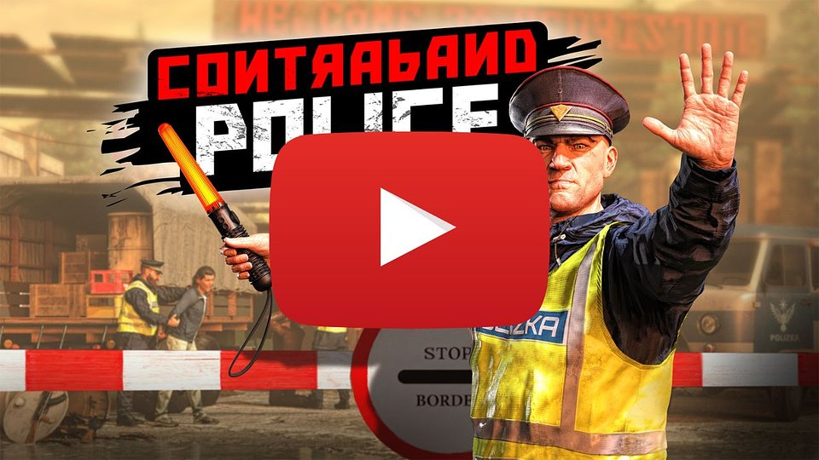
https://youtu.be/Foc_UAQ8HIQ

Contraband Police launched on PC in March 2023, and since then the game has evolved significantly – expanding with new mechanics, modes, weapons, and items, as well as numerous improvements that enhance the overall gameplay experience, including upgraded visuals. Many of these upgrades were developed in close collaboration with a passionate community of fans, whose feedback and ideas helped shape the experience. The console version includes all of these updates.

From November 7, fans can pre-order the exclusive Collector’s Edition, which comes with:

● Hand-painted 20 cm figure
● Smuggler’s crate-shaped box
● In-game map poster
● Acaristani flag
● Duty handbook
● Game logo magnet
● Exclusive DLC content
● Base PC (Steam) version of the game with Crimson Fall DLC

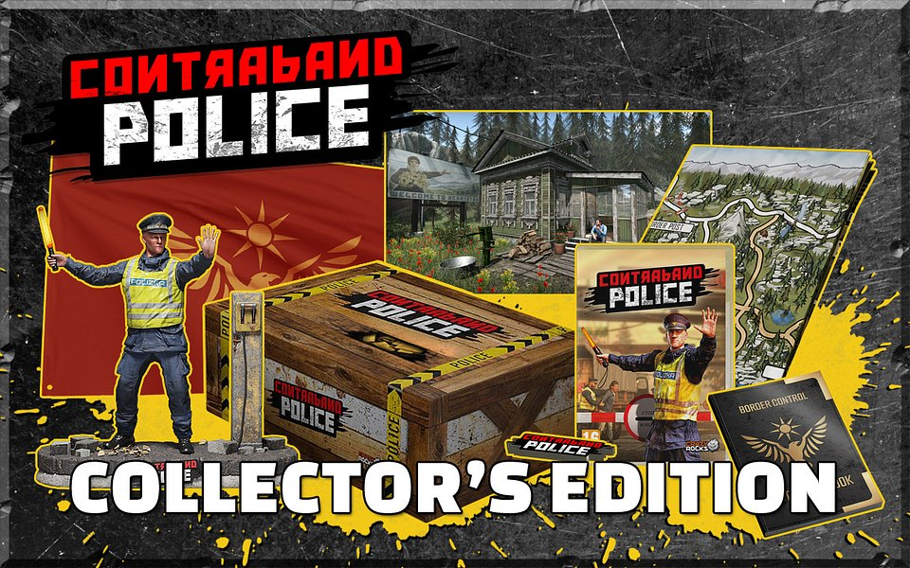

Starting today, November 7, Contraband Police is available on PlayStation 5 and Xbox Series S/X. To stay up to date with the latest news about the game, we invite you to join the community on Discord and follow PlayWay’s official profiles on X and Facebook.

PRESS KIT

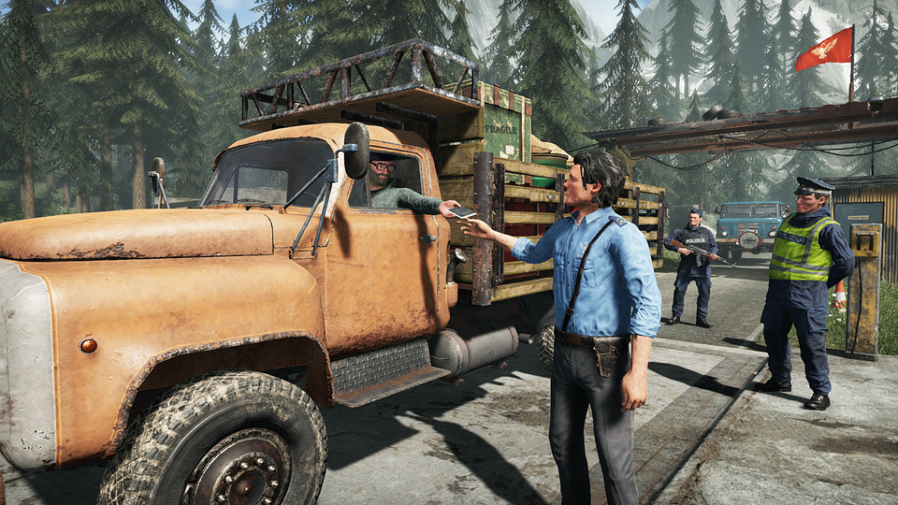

More about Contraband Police

In Contraband Police, you play as a border inspector in a communist country set in the 1980s. It’s a place where crime, corruption, and smuggling are part of everyday life. It’s your responsibility to maintain order and detect even the smallest irregularities among those crossing the border. Every passport, piece of luggage, or vehicle may hide dangerous secrets or illegal goods, and it’s up to you to uncover them and deliver proper consequences depending on the offense.

As an inspector, you can’t expect an easy service – smugglers will constantly surprise you with increasingly sophisticated methods, and you’ll need to rely on your wit, experience, and tools to expose their lies. Fortunately, you’re supported by intelligence services and an arsenal of equipment that helps with inspections and effective field operations.

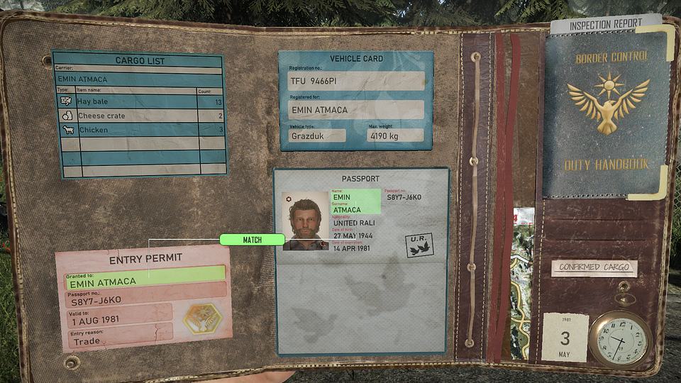

Your loyalty to the service will soon attract the attention of Oberankov’s gang – a ruthless criminal group that’s ready to do anything to maintain control over smuggling routes and eliminate anyone who stands in their way. Life at the border isn’t just paperwork – during chases, ambushes, and shootouts, your reflexes, equipment, and the condition of your outpost will determine your survival.

Success is rewarded with additional resources that can be used to upgrade your facilities, vehicles, and gear. The better you perform your duties, the more respect you earn — and the best officers will gain access to the fastest and most heavily armed patrol vehicles in all of Acaristan.

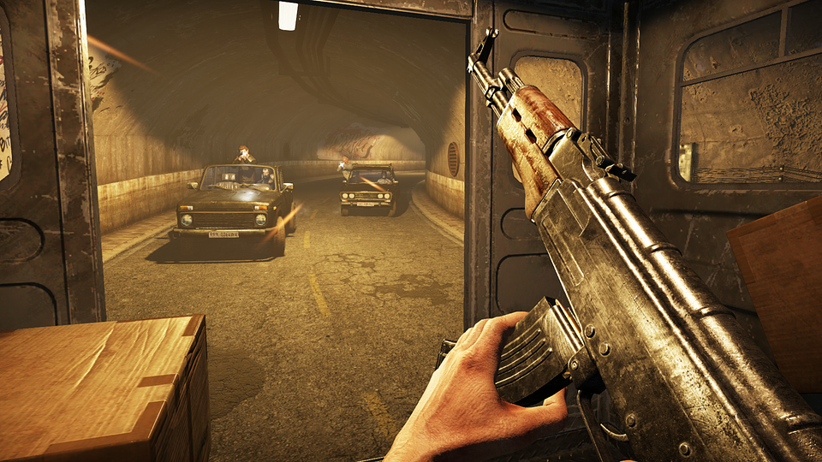

Contraband Police - key features:

● Rookie on duty - as a young cadet from an officer school, you are assigned to work at a border checkpoint in a remote region. Entry into the Acarist People's Republic is strictly regulated by the party, so every move you make will be monitored.

● May I see your documents? - everyone must show valid documents. The absence of any signature or stamp equals lack of permission to cross the border. Be careful not to be fooled by the tricks used by smugglers.

● What's in the box? - With the support of the intelligence, you will receive clues that will help you detect illegal cargo hidden in various places. A wide range of tools will allow you to identify prohibited contraband.

● Brutal extremity - during your work, you will come into contact with criminals who will stop at nothing. Your outpost is a constant target of attacks from the Oberankov gang, so you must be prepared for bloodshed.

● Police pursuits - cases can take an unexpected turn. Someone didn't stop for an inspection? Jump into a squad car and start the chase. Don't forget to maintain the vehicle in good condition, as it will make your job much easier.

● This is your land! - Upgrade and expand your outpost with the funds earned from doing a good job. Always be prepared to take sudden action or solve a criminal puzzle. Support your comrades and thwart the Blood Fist rebels.

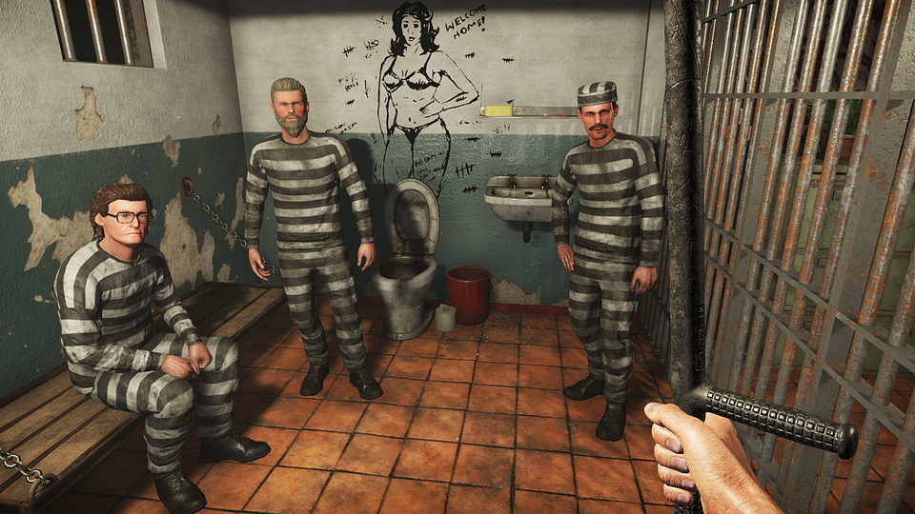

About Crazy Rocks
Crazy Rocks is a dedicated team of video game enthusiasts who have been creating high-quality 3D productions since 2015, focusing on modern visuals and deep interactivity. The Warsaw-based studio was founded by Stanisław Gromadowski, and since 2017 it has been part of the PlayWay S.A. group. In 2023, the team released its biggest project to date – Contraband Police – which was met with widespread acclaim from players and sold nearly 1.5 million copies on PC.

About PlayWay
PlayWay was founded in 2011 in Poland. The company is a producer and publisher of games developed in cooperation with around 70 subsidiary studios as well as numerous internal and external teams. The PlayWay Group’s biggest successes include Car Mechanic Simulator seriers, House Flipper series, Thief Simulator seriers, Crime Scene Cleaner, and Contraband Police.

