
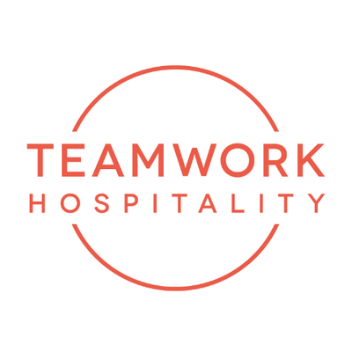

Luxury Hospitality Conference:
the fifth edition in Milan confirmed as a great success

The Luxury Hospitality Conference, organized by Teamwork Hospitality and chaired by Mauro Santinato, took place on October 30, 2025, at the Meliá Hotel in Milan, confirming for the fifth consecutive year its role as Italy’s leading event dedicated to luxury hospitality.
It was a remarkable success, with over 1,060 registered participants, 83 speakers, 52 partner companies, and 15 media partners.

The event offered a full day of learning and discussion, providing industry professionals with the opportunity to spot emerging trends, understand the evolution of demand, explore new approaches, and outline the future perspectives of the luxury hospitality segment.

“We are thrilled with the outstanding success of yesterday’s Luxury Hospitality Conference at the Meliá Hotel. With over 1,060 participants and the presence of high-profile international speakers, it proved to be an event of great significance for the industry. Not only did we highlight upcoming trends and challenges in luxury hospitality, but we also created valuable opportunities for dialogue and networking among professionals from around the world.” - Mauro Santinato, president of Teamwork Hospitality.

The event brought together general managers, investors, owners, tour operators, travel designers, destination managers, journalists, and hospitality enthusiasts, offering them the chance to exchange ideas and hear from some of the most respected national and international experts.

The conference featured panel discussions and seminars across three conference rooms, engaging numerous speakers, including renowned professionals from luxury hotels and chains, CEOs of international brands, and Michelin-starred chefs.

During the event, several highly relevant topics were addressed. The discussions covered Innovation & Trends, featuring insights and in-depth analyses from leading entrepreneurs and industry experts; Travel Experience, explored through the lens of travelers’ evolving needs, increasingly focused on authentic and personalized experiences; and Luxury Design, which included case studies on the creation of exclusive spaces. Sessions on Marketing & Communication provided an opportunity to discuss effective strategies for attracting and retaining clients through compelling brand storytelling.
The conference also delved into the impact of human capital in luxury hospitality, reflecting on how to attract top talent, foster leadership, and manage teams effectively. The luxury dining and wine experience segments featured testimonials and contributions from Michelin-starred chefs.
There were also discussions on emerging technologies and the use of artificial intelligence, as well as analyses of the new digital traveler profile and developments in Luxury Retail.

During the event, THRENDS, a consulting firm specializing in data analysis and business intelligence for the Hospitality Real Estate sector, presented the 2025 edition of the “Luxury Hospitality Report.” The report, now in its fifth year, monitors the Italian luxury hospitality segment, providing data and insights on volumes, hotel chains and brands, revenues, profit margins, transactions, and CapEx.

The atmosphere of the day was enriched by the olfactory signature “Essenza Luxe”: a bespoke fragrance, meticulously crafted and created exclusively for the event, which offered participants a truly unique and immersive sensory experience.

About us
Teamwork Hospitality, based in Rimini, is one of the key players in the hospitality industry, specializing in consulting and training for professionals in the sector.
Led by President Mauro Santinato, Teamwork Hospitality is recognized as a reliable and experienced partner, capable of delivering tailor-made services designed to achieve the highest standards in quality, customer satisfaction, and business profitability.

Contact information
LUXURY HOSPITALITY CONFERENCE
info@luxuryhospitalityconference.it
www.luxuryhospitalityconference.it

TEAMWORK HOSPITALITY
Rimini - Via Macanno 38 Q
Ph. +39 0541 57474
info@teamworkhospitality.com
www.teamworkhospitality.com

Public Relations and Press Office
OGS PUBLIC RELATIONS & COMMUNICATION
Milano - Via Koristka 3
Ph. +39 02 3450610
www.ogscommunication.com
info@ogscommunication.com
press.ogscommunication.com

