

Biuro prasowe better. gaming agency
bettergamingagency.prowly.com

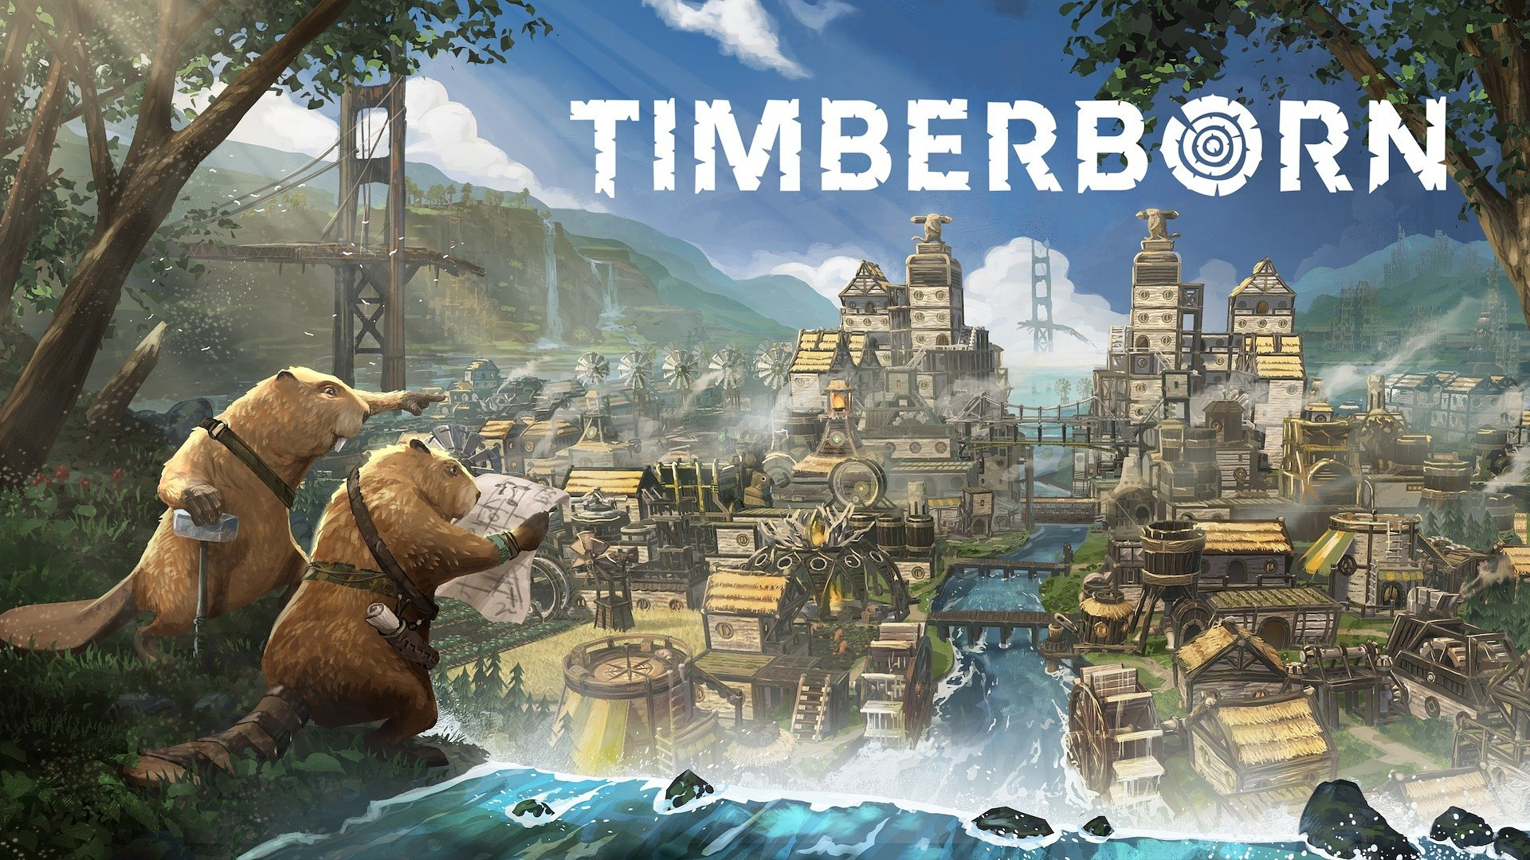

Beavers are sharpening their teeth for the full release of Timberborn. The experimental 1.0 build is now live!

The acclaimed city-building game Timberborn will soon leave Early Access and launch on PC (Steam, GOG, Epic Games Store). Version 1.0 brings plenty of new beaver-centric content, and all players who own the game can already try the experimental 1.0. build. To celebrate this occasion, the developers have shared a new teaser.

Timberborn – watch the new teaser

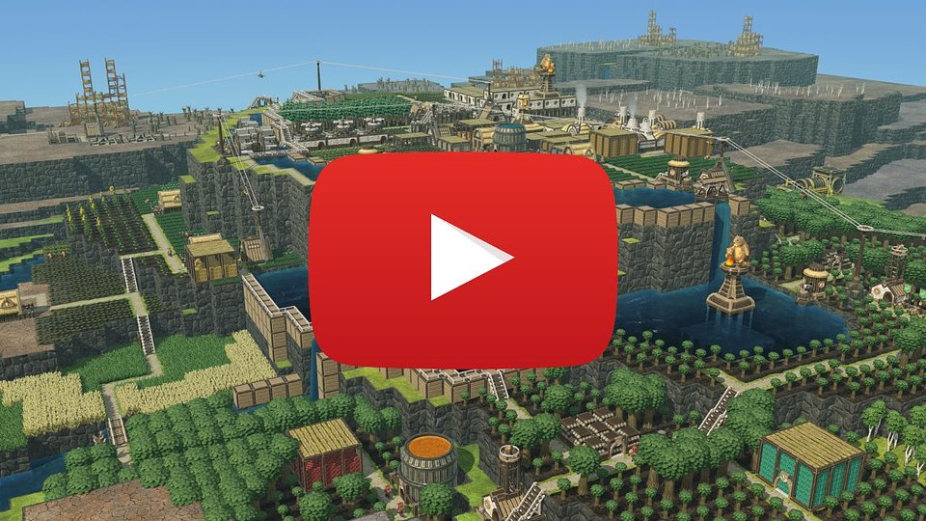
https://www.youtube.com/watch?v=zQPk63aHyXw

Over the four years that Timberborn spent in Early Access, the game received seven major updates and countless smaller ones, each shaped together with the community. Version 1.0 is the next milestone in the beavers’ evolutionary journey toward world domination. For the game’s full release, the developers embrace the community’s creativity and user-generated content.

The 1.0 update enriches the world with new interactive objects, such as geothermal fields that serve as an additional source of energy, and unstable cores – dangerous remnants of humanity that explode and reshape the landscape. The new sources of water offer extra ways of playing with the game’s 3D water physics, and with reserve storage, all kinds of resources can be used in the map editor. To showcase the unconventional gameplay loops the new features enable, two maps were added to the game, aptly named Pressure and Oasis.

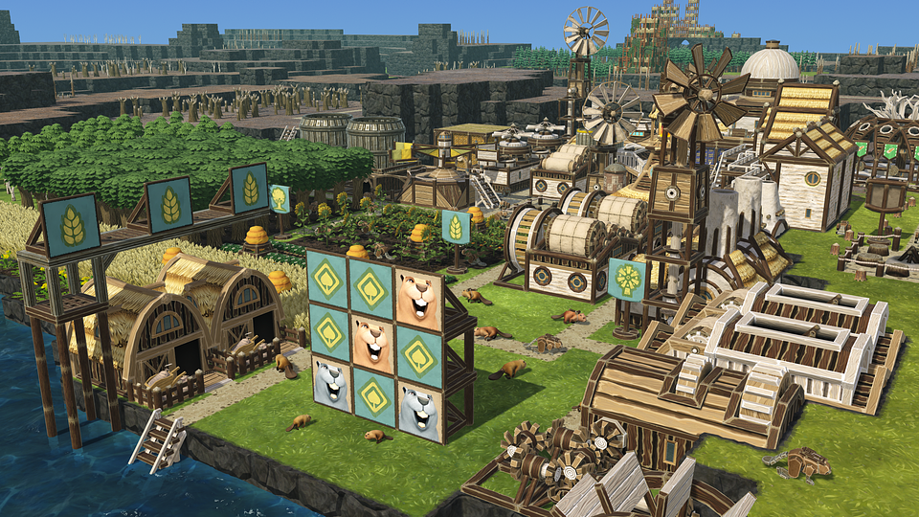

In Timberborn 1.0, the developers have made modding the game easier than ever, thanks to the addition of mod templates. The full release tweaks the game’s visuals and brings numerous quality-of-life improvements, including building duplication. Several in-game additions requested by players were added, such as spiral stairs and customizable banners.

These innovations are now live on the game’s experimental branch, available to owners of the game on Steam, GOG, and Epic Games Store. Setting the stage for Timberborn’s full release, the experimental 1.0 build will receive further changes and additions based on the feedback from the players.

The full list of changes in the first experimental 1.0 build can be found in the latest patch notes post. LINK

Timberborn 1.0 Experimental - features

● New interactive map objects
● Unconventional maps: Pressure and Oasis
● Spiral Stairs and Banners
● Upgraded modding pipeline
● Tweaked visuals
● Building duplication and other QoL tweaks

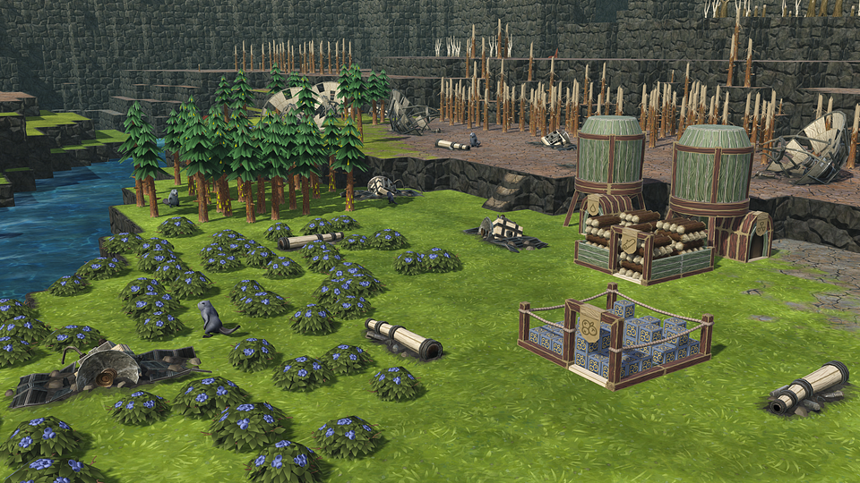

More about Timberborn

Timberborn is a colony-building simulator that combines engineering, water management, and wood as an all-purpose building material. In this world, humanity has vanished, and the main species on a planet damaged by extreme climate change are beavers. Players take control of one of two factions: the nature-loving Folktails or the industrious Iron Teeth. Each faction has its own unique identity, buildings, and gameplay mechanics.

To survive in this voxel post-apocalyptic world, players must prepare their colonies for recurring droughts and waves of toxic waste. By using both natural water sources and artificial irrigation systems, players can keep the soil fertile and their settlements safe. The game’s vertical architecture, detailed 3D water physics, and the ability to freely terraform the terrain add to the sandbox feel.

Timberborn launched in Early Access on September 15, 2021, and has since sold over 1 million copies on PC via Steam, GOG, and Epic Games Store. The full version is coming soon, and players can already try out the 1.0 update through the experimental build. To stay up to date and learn more, visit the official Timberborn website, follow the studio on X and YouTube, and join the community on Discord.

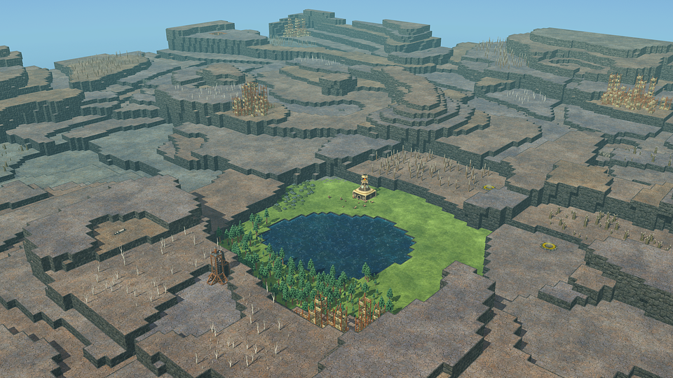

About Mechanistry

​Mechanistry is an independent Polish studio developing its debut title, Timberborn – the beaver-themed city-builder. The game was a huge success right from its launch in Early Access on September 15, 2021. Since then, it has sold over 1 million copies while maintaining an overwhelmingly positive rating on Steam.

