**FOR IMMEDIATE RELEASE  
  
Taiwan Selects 21 Global Innovators to Drive Health Innovation in “2025 Go Healthy with Taiwan”**

**รูปภาพประกอบด้วย ข้อความ, ภาพหน้าจอ, เว็บไซต์, หน้าเว็บ

เนื้อหาที่สร้างโดย AI อาจไม่ถูกต้อง**

*The 21 Semifinalists for the “2025 Go Healthy with Taiwan” competition.*

**Bangkok, October 2025** – Taiwan’s "2025 Go Healthy with Taiwan" campaign has selected 21 semifinalists from 638 proposals across 55 countries, showcasing the campaign’s global momentum and Taiwan’s growing leadership in health technology. The selected innovators—ranging from AI-driven fitness platforms to smart medical drones—come from Argentina, Germany, Kenya, the United States, and beyond, showcasing solutions that merge global health needs with Taiwan’s advanced tech capabilities.

Commissioned by the International Trade Administration (TITA), Ministry of Economic Affairs (MOEA) and executed by the Taiwan External Trade Development Council (TAITRA), the campaign was launched to promote and cultivate international collaboration by highlighting Taiwan's holistic health solutions and high-quality products. It specifically invited governments, enterprises, institutions, and organizations worldwide to submit innovative proposals that leverage Taiwan’s world-class expertise to improve global well-being.

The "2025 Go Healthy with Taiwan" campaign focused on three strategically critical sectors where Taiwan leads: fitness and sports tech, cycling, and smart healthcare. The 21 selected proposals highlight Taiwan's extensive technological scope, offering innovative solutions to urgent global health challenges that range from utilizing smart bikes for elderly cognitive health to deploying drones for remote medical supply delivery.

Across the Fitness and Cycling sectors, finalists are transforming physical activity into intelligent health platforms powered by Taiwanese technology. The Fitness & Sports Tech entries focus on accelerating performance and prevention, including Idealabs Inc.'s markerless biomechanics platform, svexa's personalized longevity analytics, and Piscina Natural SRL's AI-driven pool health management. Building on this synergy, the Cycling finalists leverage Taiwan's global leadership to tackle key areas: Healthy Aging, Urban Wellness, and Targeted Outreach solutions for everything from childhood obesity to wellness tourism.

Within the Smart Healthcare category, finalists are deploying Taiwanese technology to transform global health, focusing on immediate impact and future care. Solutions span life-saving logistics—like medical drone delivery from Thailand and securing wartime hospital networks by the Charitable Fund "Medical Innovations"—to pioneering patient monitoring. Advanced solutions feature non-invasive smart beds for sleep and dementia risk detection by Diamond Light Source Ltd. Crucially, accessible diagnostics are a focus, including remote cervical cancer screening by WIT Technology and a low-cost AI imaging platform by Neural Labs Africa. This cohort also features innovations in preventive care like anti-infection device coatings by LipoCoat BV and solar-powered wearables by Perovskia Solar AG.

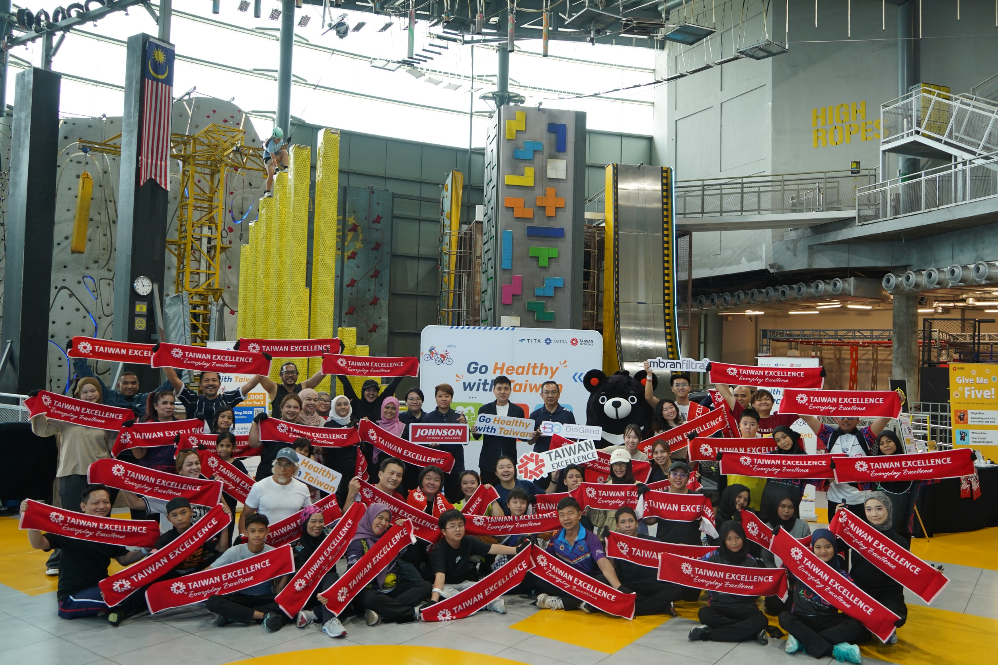 *Taiwan Launches the '2025 Go Healthy with Taiwan' Campaign Worldwide to Boost Wellness Innovation.*

The campaign's overwhelming success—exceeding its target of 638 submissions—is a testament to its global appeal. TITA Deputy Director General Susan Chi-Chuan Hu called the initiative "a global invitation to collaborate." At the same time, TAITRA Executive VP Joe Chou noted that the high engagement "demonstrates that Taiwan has become a key player in the health technology sector."

With the finalists to be announced in mid-November, the top teams will be invited to Taiwan for the Grand Finals on 9 December 2025. Three winning teams will be selected, with each receiving a prize of US$30,000.

Who will lead the next wave of global health innovation? Follow the Grand Finals this December in Taiwan to find out.

For more information, please visit the official campaign website at [gohealthy.taiwanexcellence.org](http://gohealthy.taiwanexcellence.org/).

For press inquiries, please contact

Ms. Pailin Tangsinpoonchai (Mhee)

Mobile: +66817504630

E-mail: [mee@ysisasiagroup.com](mailto:mee@ysisasiagroup.com)

Public Relations Consultant - 2025 Go Healthy with Taiwan

**About Taiwan Excellence**

Taiwan Excellence Awards were launched by the Ministry of Economic Affairs (MOEA), Taiwan, R.O.C. in 1993. All products carrying this symbol have been selected for specific Taiwan Excellence Awards based on their excellence in R&D, design, quality, and marketing through a rigorous selection process. Therefore, they symbolize exquisite, innovative Taiwanese products. Selected by the government, the award-winning entries represent the epitome of Taiwanese industrial prowess and the perfect image of excellent product quality. The Taiwan Excellence symbol is recognized worldwide as it is trademarked and promoted in 106 countries and regions. www.taiwanexcellence.org for more information.

**About Organizers**

**International Trade Administration (TITA)**, established by Taiwan's Ministry of Economic Affairs, is entrusted with planning trade policies, engaging in international cooperation, and promoting economic agreements. Responsibilities include trade barrier removal, data analysis, import-export administration, and addressing trade disputes. The Administration's comprehensive role spans trade promotion, MICE industry development, and managing commodity classification. It conducts investigations on import relief and anti-dumping cases, addressing diverse facets of international trade, making it a pivotal entity in Taiwan's global economic engagement. https://www.trade.gov.tw/English/

**Taiwan External Trade Development Council (TAITRA)** is the leading non-profit, semi-governmental trade promotion organization in Taiwan. It was founded in 1970 with the aim of promoting foreign trade, and is jointly sponsored by the government, industry associations, and several commercial organizations. The organization has a well-coordinated trade promotion and information network, which consists of over 1,200 trained specialists stationed throughout its Taipei headquarters and 60 branches worldwide. In conjunction with its sister organizations, the Taiwan Trade Center (TTC) and Taipei World Trade Center (TWTC), TAITRA has created a wealth of trade opportunities through effective promotion strategies. Please visit www.taitra.org.tw