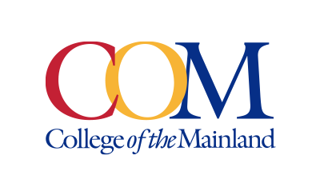
Marketing and Public Affairs Department

Contact:
Miles Shellshear, Communications Specialist, (409) 933-8690 or mshellshear@com.edu
Jose Salazar, Senior Communications Specialist, (409) 933-8923 or jsalazar18@com.edu

Written by: Miles Shellshear, Communications Specialist

NEWS RELEASE
October 17, 2025

College of the Mainland Supports Transfer Student Success in Partnership with University of Houston

(Texas City, TX) — College of the Mainland (COM) and the University of Houston (UH) are collaborating to support transfer student success for community college students pursuing four-year degrees through an innovative new transfer pathway.

The UH Next pilot program will launch in spring 2026 in UH’s College of Liberal Arts and Sciences and serve as a model for future expansion into more colleges at UH.

Students who complete their associate degree at COM will be able to take advantage of a streamlined transfer process through a new Memorandum of Understanding (MOU) with UH. The MOU helps students who apply to UH to meet the academic requirements needed for pursuing a bachelor’s degree.

“College of the Mainland is committed to creating meaningful pathways that meet students where they are and take them where they aspire to be,” said COM President Dr. Helen Brewer. “Our partnership with the University of Houston ensures that commitment extends well beyond our campus and offers our students a seamless transition to university after COM.”

Close collaboration between advisors from COM and UH will help students navigate transfer requirements, align coursework and manage the varying institutional policies. Four-year degree maps developed with input from COM and other Houston-area community college advisors will help maximize credit transfer and keep students on track for graduation.

“This new development in our partnership with the University of Houston reaffirms our commitment to students achieving their educational goals,” said Vice President for Academic Affairs Dr. Heather Rhodes. “Thanks to this collaboration, students pursuing a bachelor’s degree at UH after completing their associate degree here at COM will have a clear path to accomplish those goals.”

The partnership exemplifies COM’s commitment to expanding access and affordability of college for our community and supports our students in their continued pursuit of education.

Photo: Students walking in between classes on campus.

Contact:
Jose Salazar, Senior Communications Specialist, (409) 933-8923 or jsalazar18@com.edu
Miles Shellshear, Communications Specialist, (409) 933-8690 or mshellshear@com.edu

College of the Mainland is a learning-centered, comprehensive community college dedicated to student success and the intellectual and economic prosperity of the diverse communities we serve. Taxing districts include the independent school districts of Dickinson, Hitchcock, Santa Fe and Texas City/La Marque. Its service area includes League City, Friendswood, Kemah, Bacliff and San Leon.

