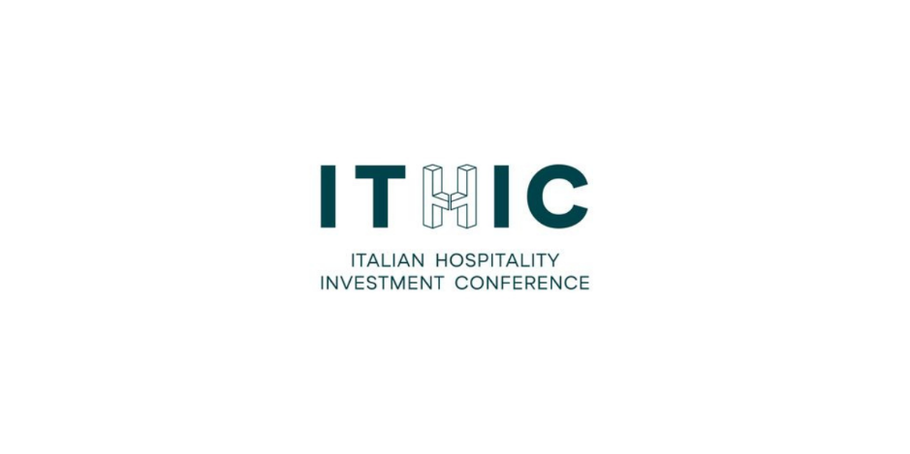

**ITHIC continues to grow: 110 high-profile international speakers and over 1,200 attendees**

*ITHIC 2025 confirms its role as a key event for hospitality investment in Italy, with record-breaking numbers for the new edition.*

The annual edition of **ITHIC** – Italian Hospitality Investment Conference – wrapped up on Friday, September 26, attracting **1,200 participants**. Organized by **Teamwork Hospitality** in collaboration with ***THRENDS***, the leading event for investment and development in the hospitality sector featured **110 speakers**, including some of the most authoritative voices in the industry, both Italian and international.

A strong international presence marked the event, with around **40% of attendees coming from abroad**, and the participation of **institutions, representatives, and government agencies** such as ICE, Invitalia, Federalberghi, the Ministry of Economy and Finance (MEF), and Cassa Depositi e Prestiti – underscoring the strategic importance of the initiative for the sector’s development. Also in attendance **were 130 partner companies**.

This year’s edition, with **CBC Coldwell Banker Commercial as Main Partner**, hosted two days of dynamic discussion through a rich program of round tables and speeches.

CEOs, operators, analysts, and economists came together to tackle complex topics, addressing the challenges and development opportunities that lie ahead in the coming years.

Some of the most prominent names in international hospitality and finance took the stage during ITHIC panels, addressing the key topics that are reshaping the future of the hospitality industry. From luxury hospitality in Italy to global outlooks, discussions covered geopolitical and economic challenges, capital market dynamics, real estate development, and emerging business models. Among the notable voices: **Walter Pecoraro**, President - Federalberghi Lazio, CEO - G&W Hotels, **Giuseppe Roscioli**, President - Federalberghi Roma, **Anne Aubrunner**, Managing Director - FMTG-Invest, **Sebastien Samoye**, Vice President Real Estate & Development – Belmond, **Richard Arnold**, Chief Development Officer - Auberge Resorts Collection, **Ludovica Rocchi**, Brand Director & Owner - R Collection Hotels. **Carlo Altomonte**, Associate Dean and Director PNRR Lab SDA Bocconi, e**Gregorio De Felice**, Head of Research and Chief Economist Intesa Sanpaolo. **Ofer Arbib**, CEO - Colliers Global Investors Italy SGR. **Paolo Barletta**, CEO - Arsenale Group, **Gloria Guevara**, Interim CEO - WTTC - World Travel & Tourism Council, **Yannick Wagner**, Deputy CDO for Europe and North Africa – Accor. **Chiara Caruso**, Head of National Tourism Fund (FNT) - CDP Real Asset SGR (CDP Group), **Christophe Beauvilain** e **Terence Backer**, News editor, Europe, Middle East & Africa - Hotel News Now / STR, **Li Zhang**, Senior Vice President - Brookfield Asset Management, **Laia Lahoz**, **Angelo Maccaferri**, **Miguel Valente Bento**, Senior Investment Manager - Corum Asset Management. **Elisabetta Fabri**, President & CEO - Starhotels Group, **Sara Digiesi**, CEO - BWH Hotels. **Adam** **Mogelonsky**, Partner Hotel Mogel Consulting Ltd., **Graziano Debellini**, Presidente - TH Group.

The seventh edition of ITHIC was set against the backdrop of **Hotel Villa Pamphili**, the Roman urban resort owned by **Aries Group**, an independent Italian hotel group active in major art and business cities across Italy.

“*2025 marks the third consecutive year of collaboration between Aries Group and ITHIC, with Hotel Villa Pamphili once again at the heart of this synergy. The event has proven to be a catalyst for visions, investments, and international partnerships, turning ideas and dialogue into concrete actions for the evolution of hospitality real estate. Through this partnership, we reaffirm our commitment to fostering valuable connections between operators and investors, promoting the development of innovative projects that can inject new energy and perspectives into the future of hospitality*,” said **Stefano de Santis, CEO of Aries Group**.

ITHIC 2025 reaffirmed its commitment to providing a high-quality environment for learning and connection, with the goal of encouraging further investment and development in the Italian hotel sector. The event positioned itself as a key moment in the calendar year, capable of shaping visions, anticipating future challenges, and defining mindsets and business models, through active collaboration with influential leaders in finance, corporate management, and business development.

[Link speaker](https://www.ithic.it/speakers/)

[Link photo](https://drive.google.com/drive/folders/1i6740RTiGbXzJcH31aHhaxaUb3jctEK3?usp=sharing)

For more information: [www.ithic.it](http://www.ithic.it)

**CONTACTS**

**About Teamwork Hospitality**

Teamwork Hospitality, based in Rimini, is a leading player in the hospitality industry, specializing in consultancy and training for professionals in the sector. Under the leadership of President Mauro Santinato, Teamwork Hospitality is known as a reliable and experienced partner, offering tailored services that help businesses achieve optimal results in terms of quality, customer satisfaction, and profitability.

**Teamwork Hospitality**

Mauro Santinato - President

Rimini - Via Macanno 38 Q

Ph. +39 0541 57474

[info@teamworkhospitality.com](mailto:info@teamworkhospitality.com)

[www.teamworkhospitality.com](https://www.teamworkhospitality.com/)

**THRENDS**

Tourism e Hospitality Analytics

Giorgio Ribaudo - Managing Director

Rimini - Via Macanno, 38 q.  
Ph. [+39 (0)5411799167](tel:+39%20(0)5411799167)

[office@thrends-italy.com](mailto:office@thrends-italy.com)

[www.thrends-italy.com](http://www.thrends-italy.com)

**About Aries Group**

Aries Group is an independent Italian hotel group active in the main art and business cities across Italy, with hotels, resorts, and residences catering to congress tourism, events (MICE), leisure, and business travel. Since 2020, the group has been developing a new hospitality project, placing the care of customers and stakeholders at its core. It offers individuals and companies extensive facilities and tailored services where innovation and a distinctively Italian style of hospitality are key features. The deep experience of the founding partners in the hospitality industry allows the group to enhance, preserve, and maintain profitable assets over time. To drive its growth, the group relies on the operational efficiency and established commercial expertise of its executive team. The current portfolio includes the Hotel Villa Pamphili Rome, Quark Hotel Milan, Living Place Hotel Bologna, and Ripamonti Residence & Hotel Milan, with four conference centers, totaling 1.640 rooms, 9.400 square meters of event space, and 65 meeting rooms.