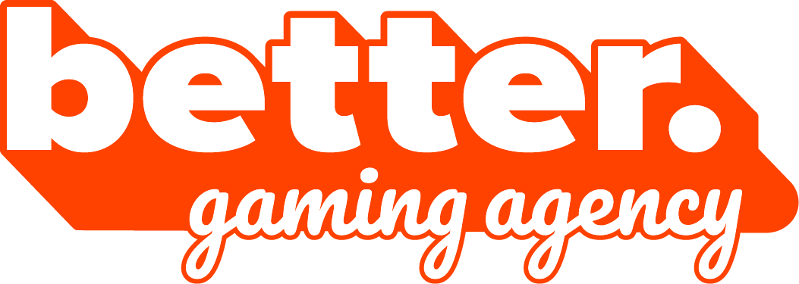

Biuro prasowe better. gaming agency

[bettergamingagency.prowly.com](http://bettergamingagency.prowly.com)

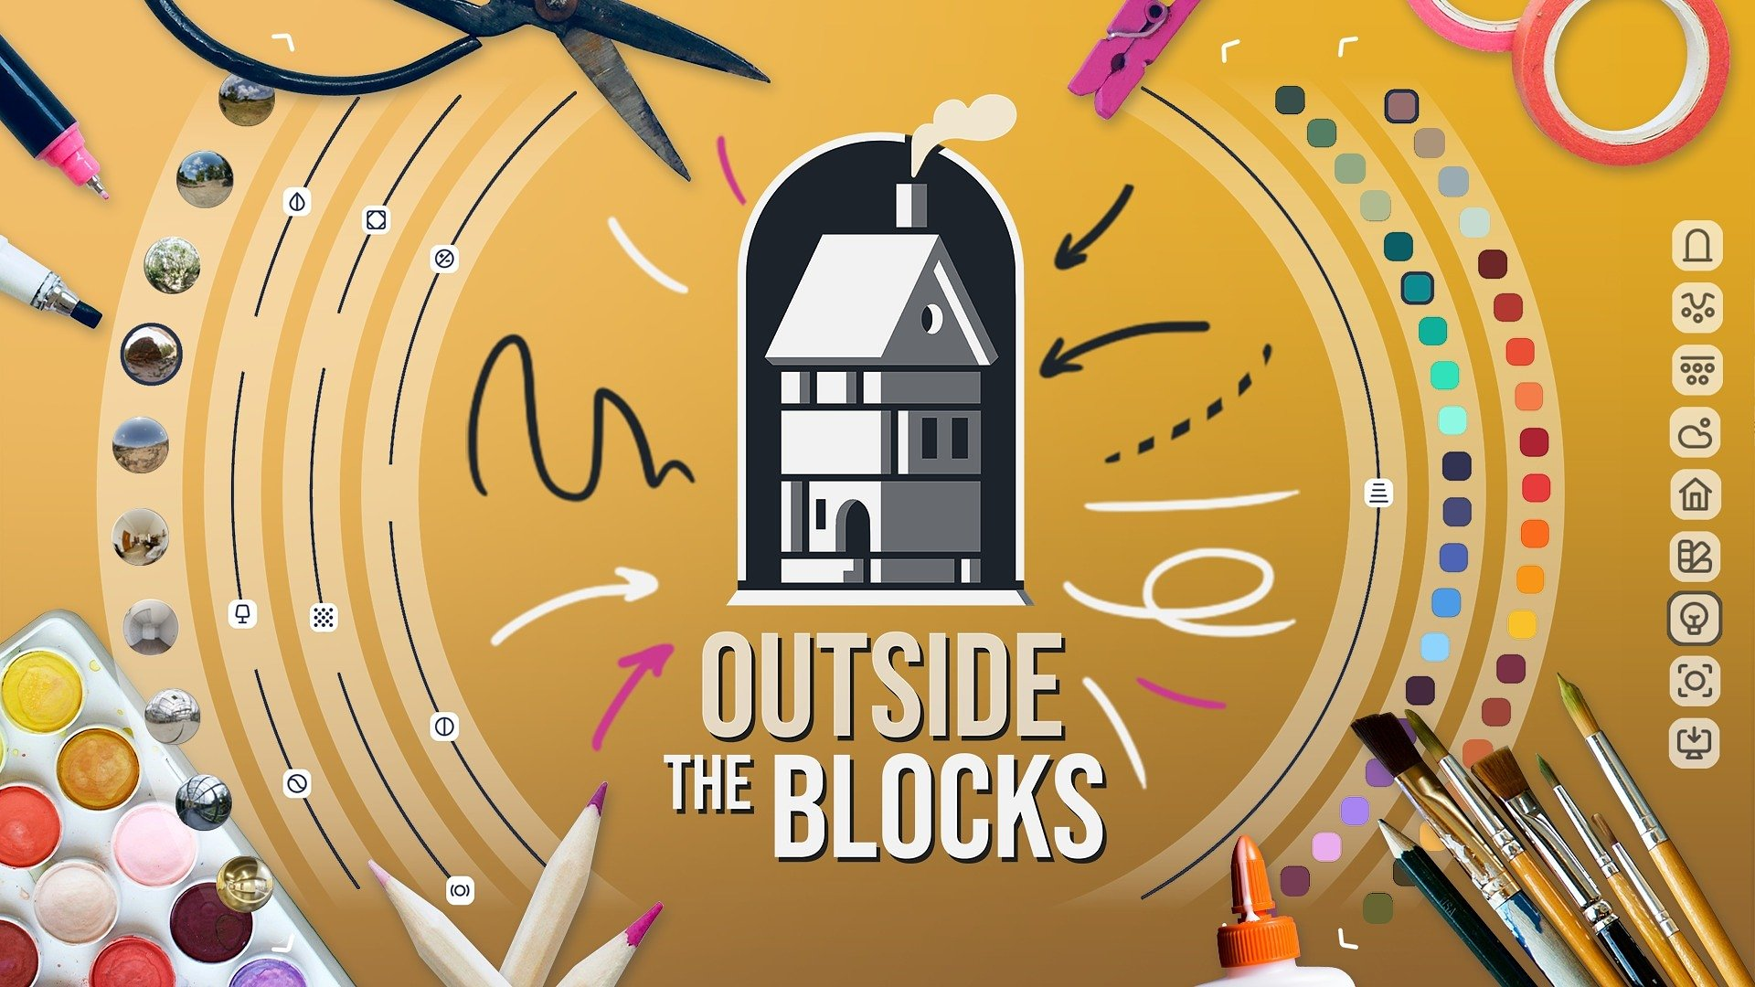

**All the beauty of the Middle Ages at your fingertips. Outside the Blocks is coming to Steam on November 4 – demo available now**

Just something beautiful – that’s the easiest way to describe [***Outside the Blocks***](https://store.steampowered.com/app/2350220/Outside_the_Blocks/), created by Michał Kubas, an independent developer from Poland. The game is coming to Steam on November 4, and players eager to try out building detailed, realistic medieval dioramas [can already check out the new demo](https://store.steampowered.com/app/2350220/Outside_the_Blocks/). ***Outside the Blocks*** lets players unleash their creativity in a simple and enjoyable way, allowing them to craft unique, atmospheric constructions and models.

**Outside the Blocks – watch the latest trailer**

[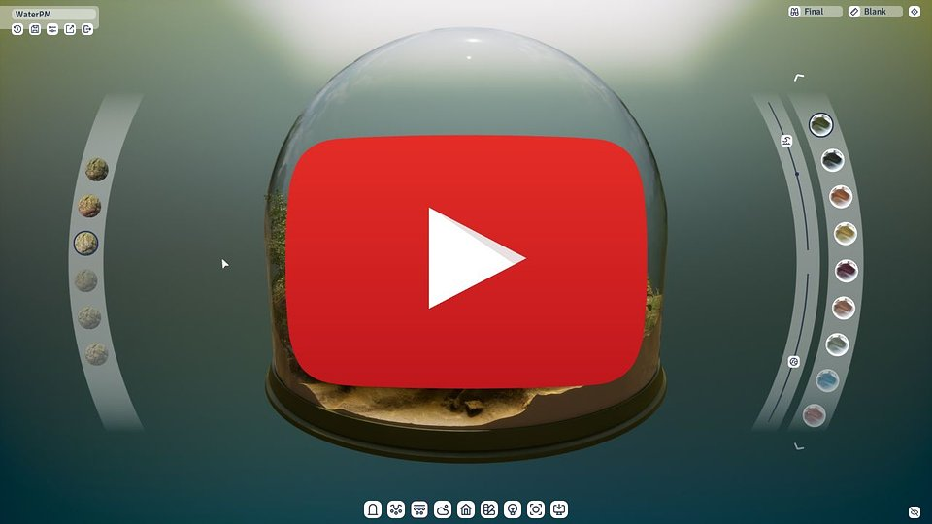](https://www.youtube.com/watch?v=7FROBpQTj58)

https://www.youtube.com/watch?v=7FROBpQTj58

***Outside the Blocks*** is a game without missions, objectives, or competition. Instead, the developer hands players a set of intuitive tools and a sandbox full of possibilities. That makes it easy to create stunning medieval-style buildings, from tiny chicken coops to majestic, intricately detailed manors, or even entire miniature villages. And it doesn’t stop there – each diorama can be brought to life with lovely animations, allowing you to fully enjoy your creation.

*Outside the Blocks demo is available again, and I can’t wait to see the amazing creations made by players this time. Since the demo was last public, I’ve improved several key mechanics, including adding the ability to undo moves. My goal is simple – to create an advanced yet easy-to-use tool that lets anyone feel like a true artist. I’m counting down to the full release coming on November 4. Get ready for even more options and possibilities that will let you fully experience the beauty of the medieval world.*

**– said Michał Kubas, creator of Outside the Blocks.**

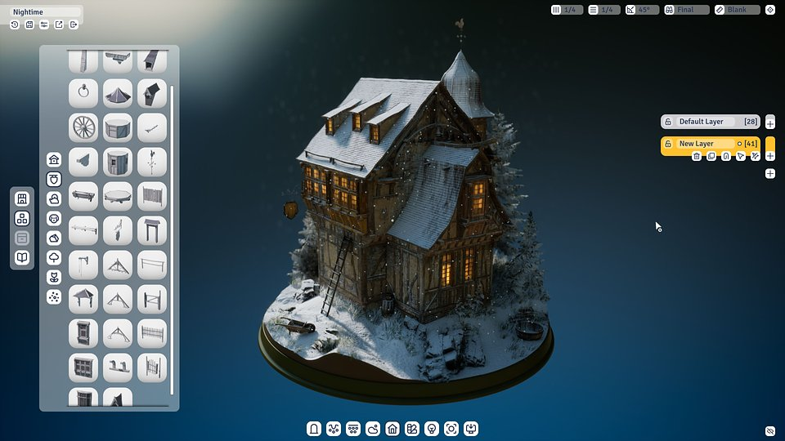

With a wide range of options, players have complete control over every aspect of their diorama – from shaping the terrain, constructing buildings and decorative elements to adjusting the weather and atmosphere. Combined with a variety of objects, materials, colors, and accessories, it offers endless opportunities to craft miniature masterpieces. Finished creations can be placed under a glass dome and captured using the advanced photo mode, making it easy to share your works with friends and the community.

**Outside the Blocks – key features:**

🎨 **Art studio for everyone** – an extensive but intuitive system for designing, building, and decorating lets both experienced designers and newcomers create miniature works of art. In Outside the Blocks the only limit is your imagination.

🏰 **Farm or castle** – play by your own rules, with no objectives, missions, or rush. Want to build a massive castle? Go for it! A mill by the river? Done! A barn with a chicken coop? A few clicks, and it’s ready. Everything is set in a consistent medieval and realistic atmosphere.

🐎 **Life captured in dioramas** – bring creations to life with lush plants, a variety of animals, weather conditions, and other elements of nature. Animations add even more realism and authenticity to every project.

🔍 **Advanced layer system** – gain full control over every element of your diorama. Precisely arrange objects, apply textures, and easily make adjustments while experimenting with different settings and layouts.

📷 **Snapshot** – capture the beauty of your creation in photo mode and share it with friends and the community. Focus on the details or showcase the charm of the entire composition.

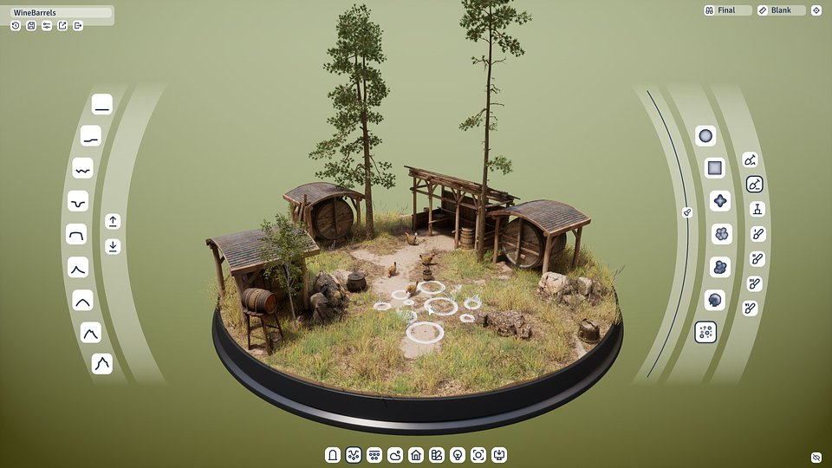

The creator, Michał Kubas, today announced that ***Outside the Blocks*** will launch on Steam on November 4, and you can [add it to your wishlist ahead of launch](https://store.steampowered.com/app/2350220/Outside_the_Blocks/). A demo is available, giving players a taste of the satisfaction that comes from creating dioramas. Follow the development progress on [Bluesky](https://bsky.app/profile/otbgame.bsky.social) and [TikTok](https://www.tiktok.com/@outsidetheblocksgame), and [join the community on Discord](https://discord.gg/anYH5Rq2).

[**PRESS KIT**](https://www.dropbox.com/scl/fo/vg2fgmin2z8avgespacm5/APkb6QoVr8LhQ4h6mstym54?rlkey=4mahobw4oundhq5fba784gyet&e=2&dl=0)

**About the developer**

Michał Kubas has been working in the video game industry for over 14 years. He began his career as a 3D artist, later gaining experience as a lead, mentor, and consultant, and now holds the position of art director at Quite OK Games. Over his career, his portfolio features both major AAA titles, including Sniper Ghost Warrior 3, Mafia III, and Dying Light 2, as well as smaller indie and mobile projects. Kubas is also a co-owner of Quite OK Games, whose debut title, Laysara: Summit Kingdom, launched in Early Access on Steam in April 2024.  
  
Outside the Blocks is his personal passion project, born from a love of medieval architecture and a desire to give players the tools to create as true artists.