

Biuro prasowe better. gaming agency

[bettergamingagency.prowly.com](http://bettergamingagency.prowly.com)

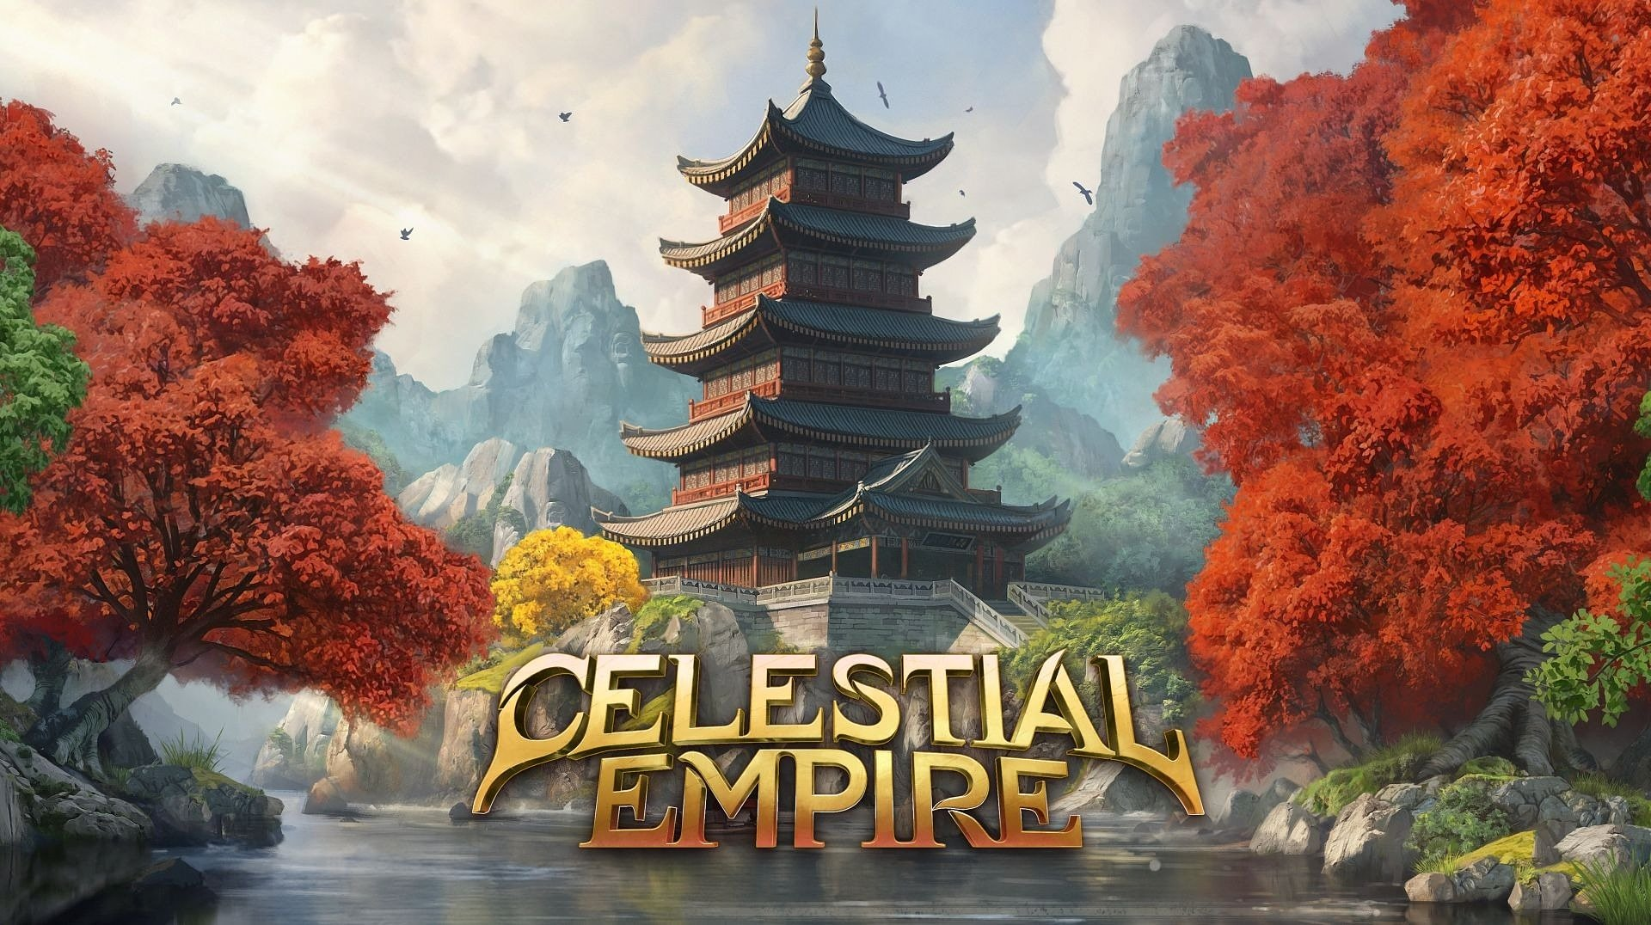

**Create your dream city and forge the power of ancient China. Celestial Empire is now available in Early Access on Steam**

***Celestial Empire*** is a city-builder where you transform a humble settlement into a place worthy of the Emperor’s visit. Design your dream city, take care of its citizens, develop production chains, and trade to bring not only prosperity to your people but also glory to your name. [***Celestial Empire*** is now available in Early Access on Steam](https://store.steampowered.com/app/1330430/Celestial_Empire/) – uncover the secrets of ancient China crafted by President Studio.

**Celestial Empire – launch trailer**

[](https://www.youtube.com/watch?v=_KVFj9t2z-Q)

https://www.youtube.com/watch?v=_KVFj9t2z-Q

Your adventure begins with your promotion to governor of a province, but there’s little time to celebrate this great success – from now on, the lives of many citizens are in your hands. Ensure their well-being, meet their needs and expectations, and the settlement will quickly start to grow. More subjects bring not only greater opportunities but also new responsibilities you must handle to prevent potential problems. With such responsibility on your shoulders, you’ll quickly see that every choice counts and has its consequences.

The architecture of ancient China is art in itself, and ***Celestial Empire’s*** Early Access includes 120 buildings from the start. This makes it easy to build your dream city on hand-crafted maps featuring fertile valleys, majestic mountains, lush forests, wide rivers, and even a divine realm hidden on floating islands. The gods hold great power in ***Celestial Empire*** – their favor aids your settlement’s development and guards your citizens against the fearsome demons called yaoguai.

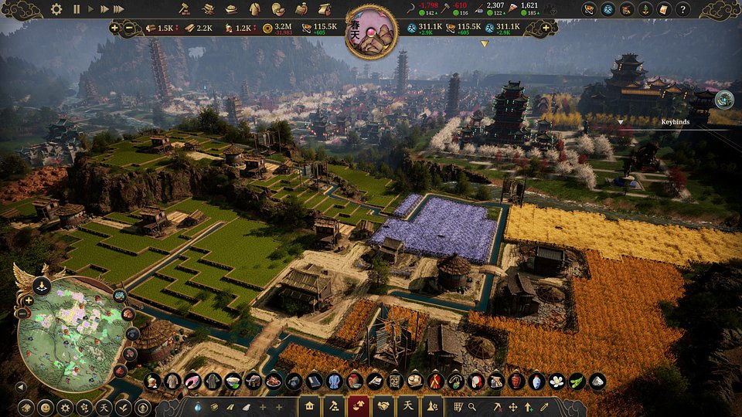

Managing a city requires juggling many tasks – from running production chains efficiently and developing new technologies to trading along the Silk Road. ***Celestial Empire*** offers a wide range of possibilities, and the challenges you’ll face depending not only on your city’s situation but also on external factors such as changing seasons and weather. Survive and thrive through harsh winters, dangerous fires, and deadly epidemics. Nature can be unpredictable, but with careful planning, disasters can be prevented before they happen.

Early Access is just the beginning, and the developers want players to be actively involved in the game’s further development – feedback and suggestions will be incorporated into future updates. President Studio expects the full version of ***Celestial Empire*** to be ready in about a year, with the development roadmap as follows:

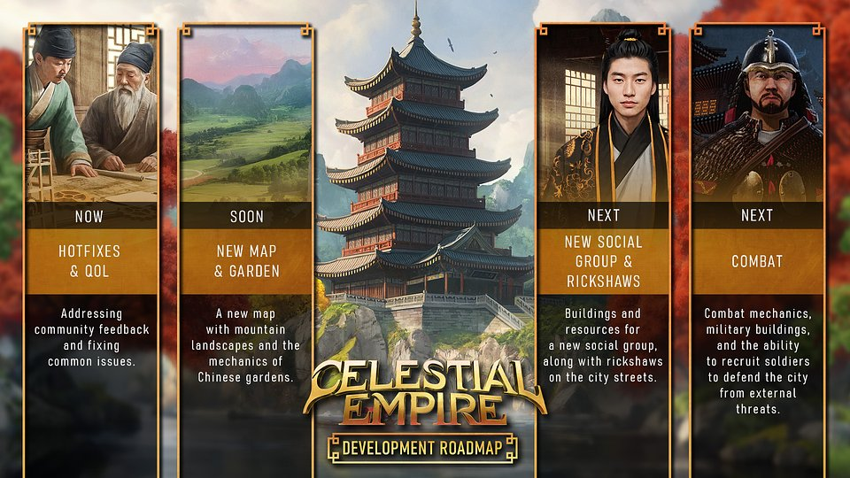

**Celestial Empire – key features:**

● **The magic of ancient China** – hand-crafted maps and over 120 buildings allow you to create unique cities. Immerse yourself in the traditions, culture, and beliefs of ancient China, with a touch of fantasy.

● **Your city must thrive** – manage production chains, transport, and storage of over 60 types of resources, which craftsmen can transform into luxury goods for your citizens.

● **Growth opens doors** – develop technologies and unlock new possibilities for your settlement. Watch as your citizens evolve from simple peasants into skilled craftsmen, scholars, and prominent figures.

● **Choices and consequences** – every action you take has a direct impact on your city and its citizens. Meet their needs and make decisions carefully to ensure your settlement’s prosperity and happiness, while avoiding conflicts.

● **Power of nature** – changing seasons bring new threats, such as harsh winters, fires, and epidemics. Survive, adapt, and plan wisely to prevent disasters.

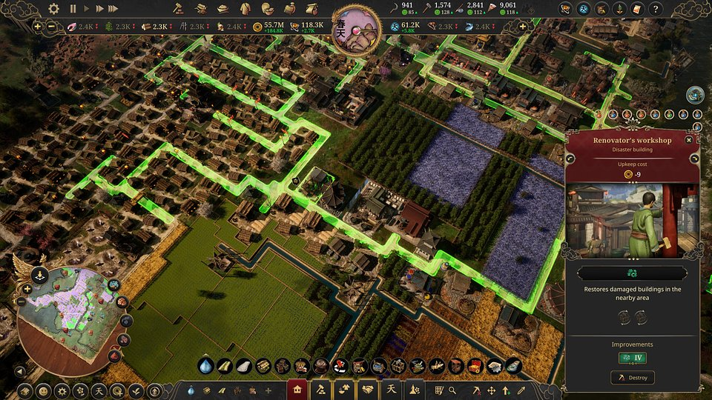

If you’re ready to take on the challenges of managing an ancient Chinese city, ***Celestial Empire*** is now [available in Early Access on Steam](https://store.steampowered.com/app/1330430/Celestial_Empire/). The game is priced at $19.99 / €19.99, and a 12% discount is available during the launch period. To keep up with further development, [add the game to your wishlist on Steam](https://store.steampowered.com/app/1330430/Celestial_Empire/), follow the profile on [X](https://twitter.com/Pres_Studio), and join the community on [Discord](https://discord.com/invite/h5eR6vbPXS).

The press kit is available [HERE](https://drive.google.com/drive/folders/1EsoTp2o2UVxaYZPgJC5qyYw8zRNI3wfv?usp=sharing).

**About President Studio**

President Studio is a game development company established in 2018 and based in Warsaw, Poland. We are the creators of Crime Scene Cleaner, which has been downloaded over 2 million times across all platforms and earned an ‘Overwhelmingly Positive’ rating on Steam. Our team consists of passionate and creative people who pour their love into making games. When designing new titles, we constantly strive to bring a unique vision to life while keeping players’ needs and expectations in mind.