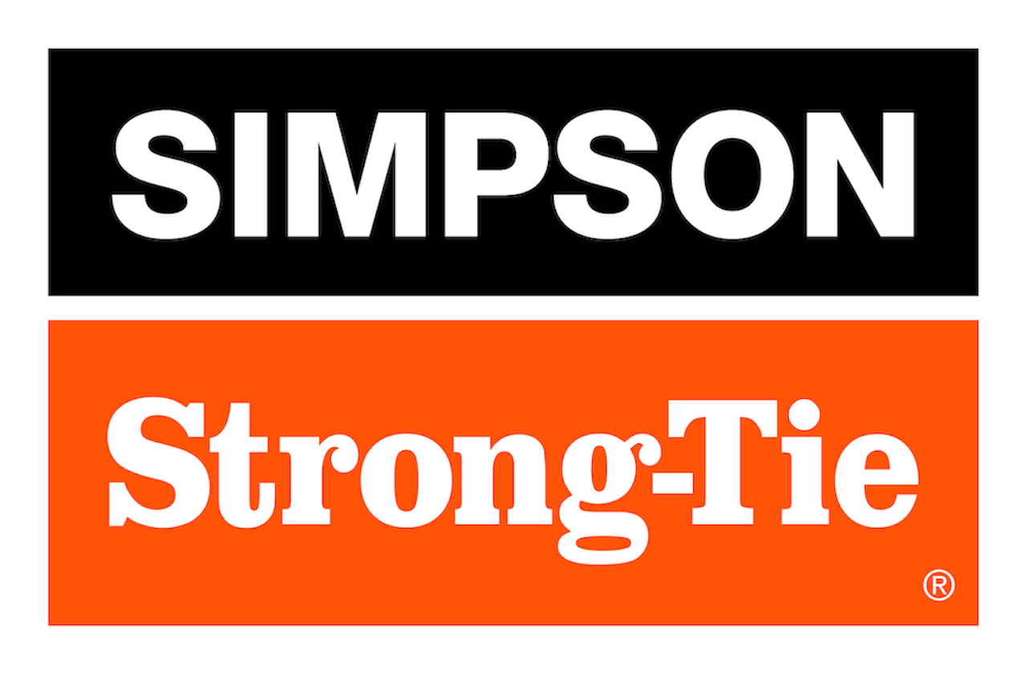

FOR IMMEDIATE RELEASE For More Information:
September 18, 2025 Jesse Russell
jrussell@strongtie.com
925-557-5324

Simpson Strong-Tie To Launch New Software, Demo Equipment and Technology Solutions at 2025 Building Component Manufacturers Conference

Pleasanton, Calif. — Simpson Strong-Tie, the leader in engineered structural connectors and building solutions, will showcase its diverse range of component manufacturing software, equipment and services at Booth 518 during this year’s Building Component Manufacturers Conference (BCMC), September 29–October 3 in Omaha, Nebraska.

During the show, attendees can browse products, demo software solutions and meet with Simpson Strong-Tie specialists. Highlights will include:

- Software solutions: Simpson Strong-Tie will introduce CS® Producer™ truss production management software. The newest addition to the Component Solutions® software suite, this cutting-edge, cloud-based software gives floor and roof truss manufacturers powerful ways to schedule and manage daily operations. Attendees also can visit our demo suite for a personal tour of CS Truss Studio™, CS Director™, CS EWP Studio™ and the iStruct® software suite.

- Innovative equipment: See demos of the Monet DeSauw DeRobo, our fully automated linear saw, and the EasyFrame™ automated marking saw, which prints precision framing layouts directly onto the framing members, helping to drive construction efficiency, accuracy and the greatest yield possible.

- Innovative hardware: Explore Simpson Strong-Tie’s leading component hardware solutions, including connectors, fasteners, and anchors.

- Technical experts: Simpson Strong-Tie’s truss design services provide a personal project manager to help guide customers through the design process using our Component Solutions Truss Studio software. Meet with our team at the show to learn how these services can be a game-changer for companies.

- Happy hour: Along with product and software demos, attendees can join the Simpson Strong-Tie team for happy hour Wednesday, October 1, at the Old Mattress Factory. Stop by the booth for details.

For more information, visit www.strongtie.com.

About Simpson Strong-Tie Company Inc.
Simpson Strong-Tie is the world leader in structural solutions — products and technology that help people design and build safer, stronger homes, buildings, and communities. As a pioneer in the building industry, we have an unmatched passion for problem solving through skillful engineering and thoughtful innovation. Our structural systems research and rigorous testing enable us to design code-listed, value-engineered solutions for a multitude of applications in wood, steel, and concrete structures. Our dedication to pursuing ever-better construction products and technology and to surrounding our customers with exceptional service and support has been core to our mission since 1956. For more information, visit strongtie.com and follow us on Facebook, Twitter, YouTube and LinkedIn.

###

