

Biuro prasowe better. gaming agency

[bettergamingagency.prowly.com](http://bettergamingagency.prowly.com)

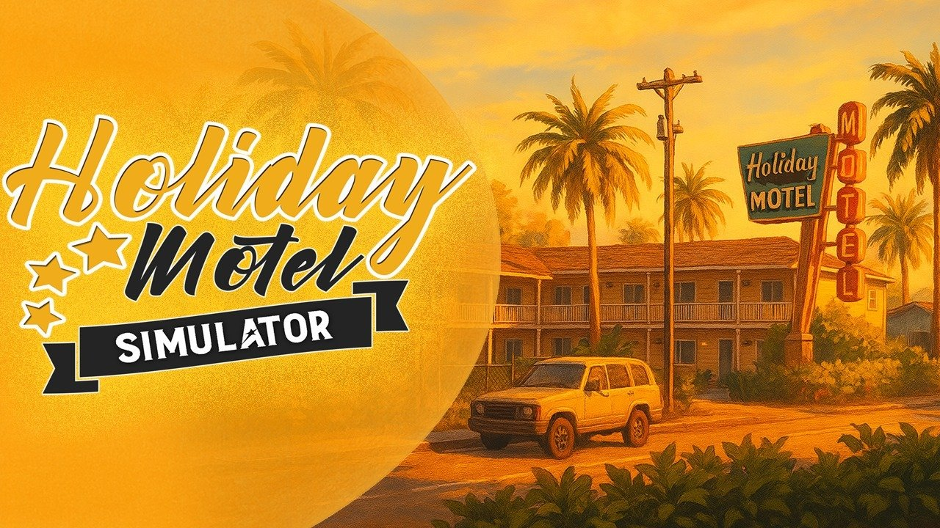

**Always sunny skies, warm waters, and chilled drinks await. Holiday Motel Simulator is now open and ready to welcome its first guests**

[**Holiday Motel Simulator** is now available in Early Access on Steam](https://store.steampowered.com/app/2812420/Holiday_Motel_Simulator/?l=polish), and Red Phoenix Interactive invites players to help shape its future. Running your own hotel in a paradise-like setting of seas and beaches could be the perfect way to extend the summer. **Holiday Motel Simulator** is priced at $14,99, and during the launch period, the game is available with a 15% discount.

**Holiday Motel Simulator – launch trailer**



https://youtu.be/gr2s6Rg2qbw

Imagine inheriting a small cottage by the shore – who hasn’t dreamed of that? In **Holiday Motel Simulator**, players get an entire resort at their fingertips – maybe a little run-down, but with a bit of scrubbing and painting, it can quickly shine again. The fun starts with cleaning, fixing damages, and replacing furniture – and you’ll be surprised how many guests can complain about small things like a leaky faucet, falling-apart cabinets, or graffiti above the bed.

A hotel isn’t just about comfy beds and clean rooms – guests expect a little fun too! It won’t be long before you’ll need to take care of extra attractions to make their stay at the paradise resort more enjoyable. Besides looking after the residents, players will also run a small shop and a beach bar. This means serving drinks and snacks to sun-soaked tourists, as well as handling more everyday tasks, like keeping everything clean and working. You’ll be surprised by what some guests can leave behind…

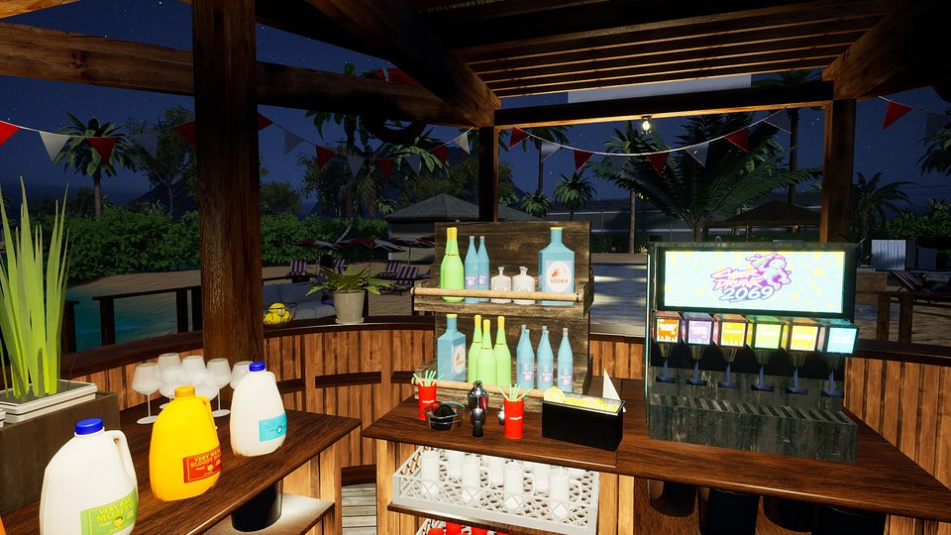

And while **Holiday Motel Simulator** leans towards relaxing gameplay rather than being a soulslike among other games in the genre, fulfilling your duties and managing the budget wisely will be essential to turn a struggling hotel into a beloved holiday destination. The task is made a bit easier by the fact that in this world, summer lasts all year round!

Early Access is just the beginning of an adventure Red Phoenix Interactive wants to experience with players. That’s why the game will be developed based on community feedback and suggestions, with regular updates planned. The full release is scheduled for 2026 and will introduce new mechanics, locations, and special events. Players who want to share their opinions with developers can do so [through the game’s Discord server](https://discord.com/invite/hvZjkKe6Ue).

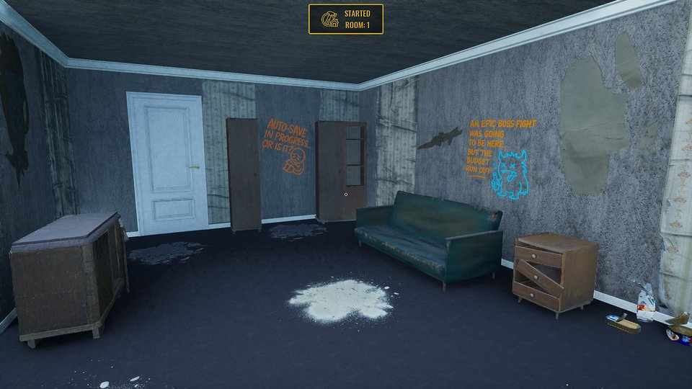

**Holiday Motel Simulator – key features:**

☀️ **Do it yourself** – start your adventure from scratch by planning and carrying out a full renovation of the property. It’s up to you whether the motel will regain its former glory and attract new guests.

🌴 **Boho style** – furnish each room so that guests with different tastes feel at home. Choose from hundreds of available furniture pieces and decorations in various styles.

⛱️ **Penny by penny** – run the motel’s shop so your guests have everything they need right at their fingertips. Manage the inventory, arrange the shelves, and earn profit from every product sold.

🍹 **More than just motel visitors** – run your own beach bar where you’ll serve refreshing cocktails and tasty snacks, all while keeping the beach and its facilities clean and inviting. These tasks bring even more chill vibes to Holiday Motel Simulator. Will your guests be happy? Find out for yourself!

🌅 **Making your dream come true** – step by step, create a special destination that will wow your guests. Manage every aspect of the motel’s business and make sure it becomes a top choice for travelers.

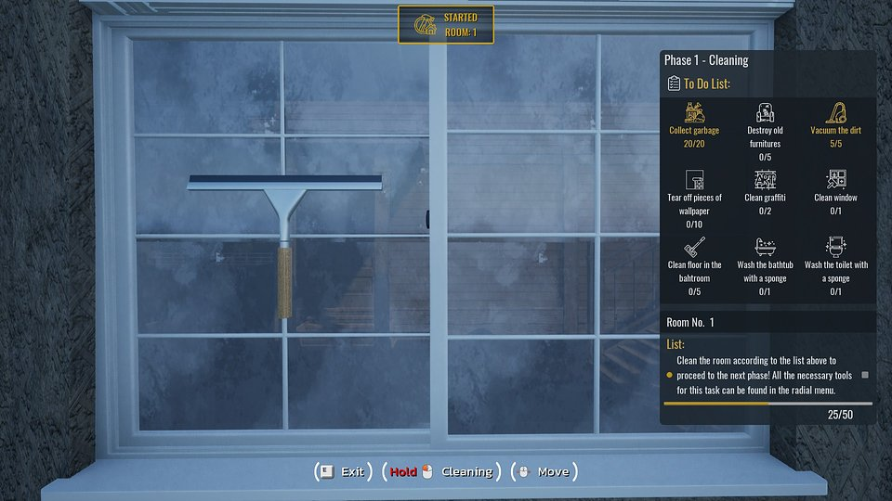

[**Holiday Motel Simulator** is now available in Early Access on Steam](https://store.steampowered.com/app/2812420/Holiday_Motel_Simulator/?l=polish). The game is priced at $14.99, with a 15% launch discount. To keep up with the game’s progress, check out its profiles on [TikTok](https://www.tiktok.com/@game_motelsim) and [X](https://x.com/HolidayMotelSim), and [join the community on Discord](https://discord.com/invite/hvZjkKe6Ue).

Press kit is available [HERE](https://drive.google.com/drive/u/4/folders/1MeBwoA8mKIhpK_k7Wsq_FyxWZXpV_f6A).

**About Red Phoenix Interactive:**

Red Phoenix Interactive is an independent studio based in Poland, born from passion and the dream of creating its own games. The team consists of people who, after gaining experience across various industries over the years, finally decided to follow their true calling. For Red Phoenix Interactive, video games are not just products but emotional stories that connect developers and gamers. In September 2025, the studio released its debut title, Holiday Motel Simulator, which is now available in Early Access on Steam