**Oasis: The Most Anticipated Comeback in Music Arrives in Mexico City**

* The band’s two performances in the city generated significant economic impact and boosted international tourism

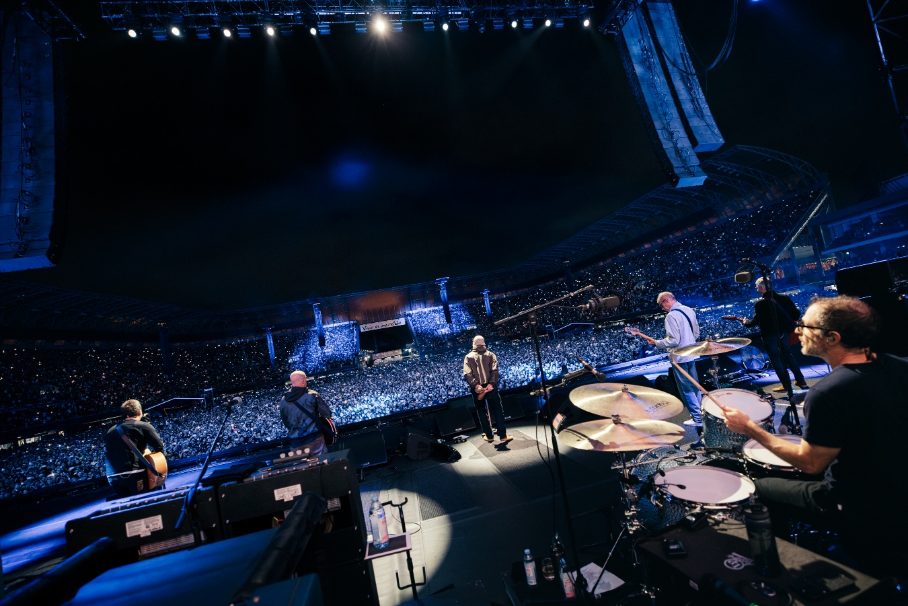

Credit: Big Brother Recordings

Few tours have generated as much anticipation as the return of Oasis with Live ’25, a tour that has sold out stadiums around the world, mobilizing millions of fans of all ages who have purchased tickets, merchandise, and even travel packages to witness the long-awaited return of the Gallagher brothers and their band to the stage.

On September 12 and 13, Oasis performed in Mexico City for the first time in more than 16 years, delivering two unforgettable concerts at the Estadio GNP Seguros. Since its renovation, the venue has become a world-class stage for the most important global tours. This comeback was not only a once-in-a-lifetime experience for fans, but also a major economic driver for Mexico’s capital.

According to the National Chamber of Commerce, Services and Tourism of Mexico City (Canaco), the shows generated an estimated 850 to 1,000 million pesos in just one weekend, thanks to the attendance of more than 130,000 people across both nights.

In terms of tourism, hotel occupancy in areas surrounding Estadio GNP Seguros reached nearly 80%. The concerts also attracted visitors not only from different Mexican states—such as Nuevo León, Jalisco, Baja California, and Yucatán—but also from the United Kingdom, the United States, Central America, and South America, with the concerts serving as the main reason for their trip.

Data from Ticketmaster Mexico shows that 50% of attendees traveled from outside Mexico City and the State of Mexico, while 10% were international fans, coming from 79 countries and more than 220 cities worldwide.

The Oasis concerts at Estadio GNP Seguros marked the first stop of the tour in a Spanish-speaking country, reaffirming Mexico City’s position as a strategic hub within the international live entertainment circuit.